I plan to statically program (html and css) my website and then implement the dynamic c# logic to it. Potentially SQL server connection as well.

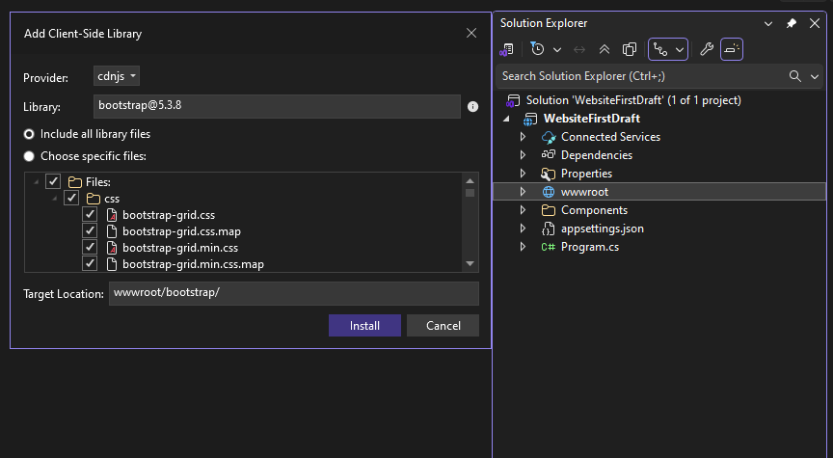

This image shows how to add the bootstrap folder to the static library (wwwroot). It contains libraries that have pre-developed style-sheets (CSS) that save the coder time from having to do it from scratch.

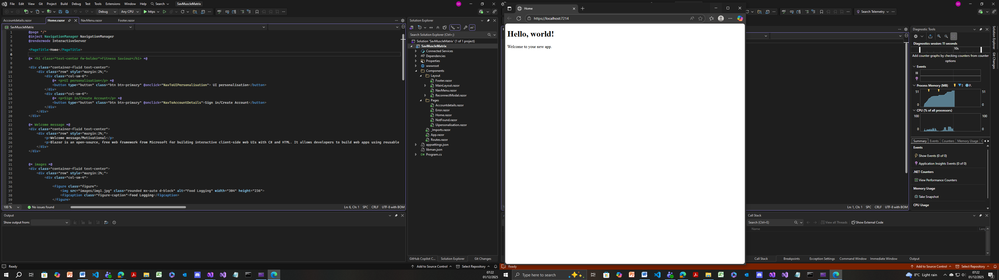

First iteration: Developing the static design of the website. Starting with the homepage. As shown, the Blazor template for the homepage. This needs to be modified into the template for my homepage.

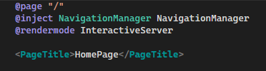

Dependency Injected the NavigationManager, allowing for navigation to other pages.

Rendered the interactive server, meaning user interface updates will occur in real time and event handlers run on the server.

Set the browser tab title to “HomePage”.

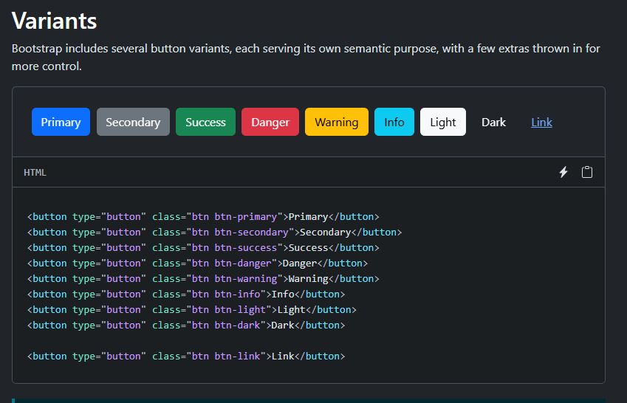

Making use of the bootstrap library. Primary button most suitable for the navigation buttons.

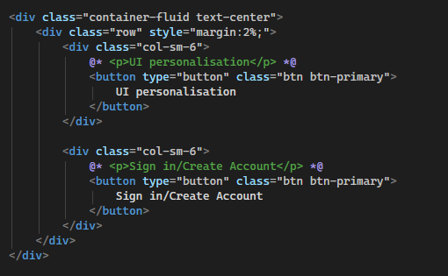

Code for the 2 buttons that take you to the ui personalisation page and the Account Details page. Classes for the div and buttons use bootstrap libraries.

.container-fluid text-center 🡪 the div container will span the full width, text inside button is centred.

.col-sm-6 🡪 this makes 2 50/50 columns.

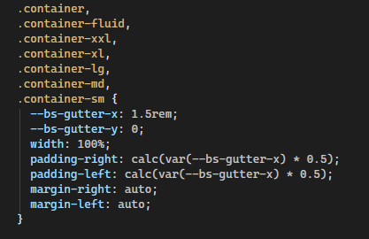

Container fluid css code within the bootstrap library.

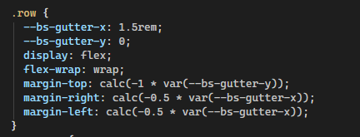

The .row class, used for the secondary div container. Makes use of css variables and functions.

.col-sm-6 {

flex: 0 0 auto;

width: 50%;

}

What the div container for the button uses.

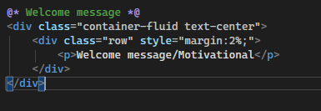

Code to add a welcome message paragraph.

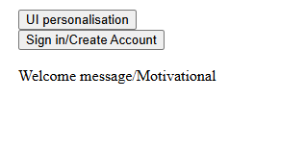

What the page looked like at this point. Problem: The css stylings from the bootstrap library were not applied to the HTML elements. Solution: I have to reference the libraries on the app.razor page in order for the stylings to be applied. This is the root entry point of the website which defines important information such as the HTML layout and bootstrap set up.

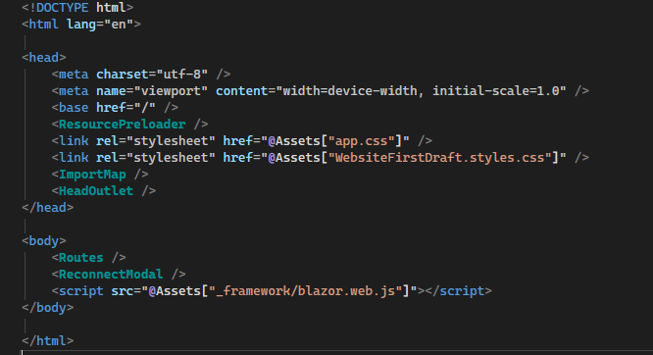

This is what the App.razor page looked like initially, the default of blazor. It links a default css stylesheet and the websites customisable css page in the head, and in the body it links the javascript framework. The issue is that it does not link the bootstrap library.

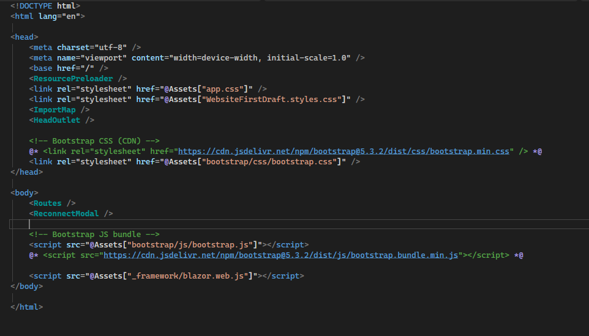

The 2 commented sections are where I have attached the bootstrap css and javascript library onto the website. I initially attempted to load bootstrap from the CDN, but I have commented this out and instead loaded it locally from the project.

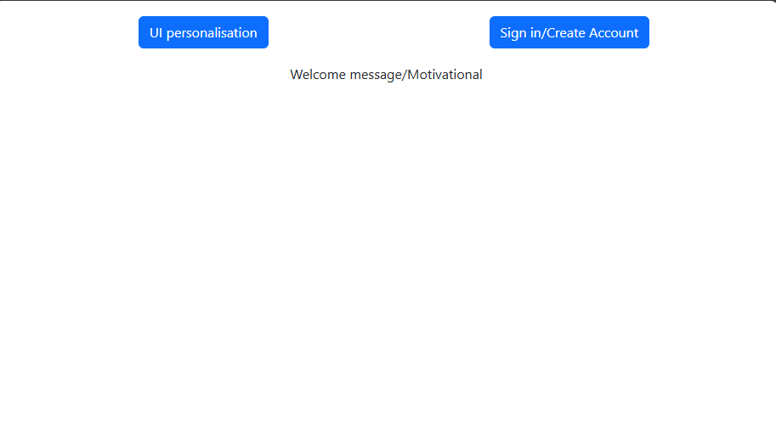

What the website looked like now. Stylings have been applied. Buttons are styled with the primary class on bootstrap, giving them a blue background and white font, slightly rounded edges. They have been spaced out, and the welcome message is now centred.

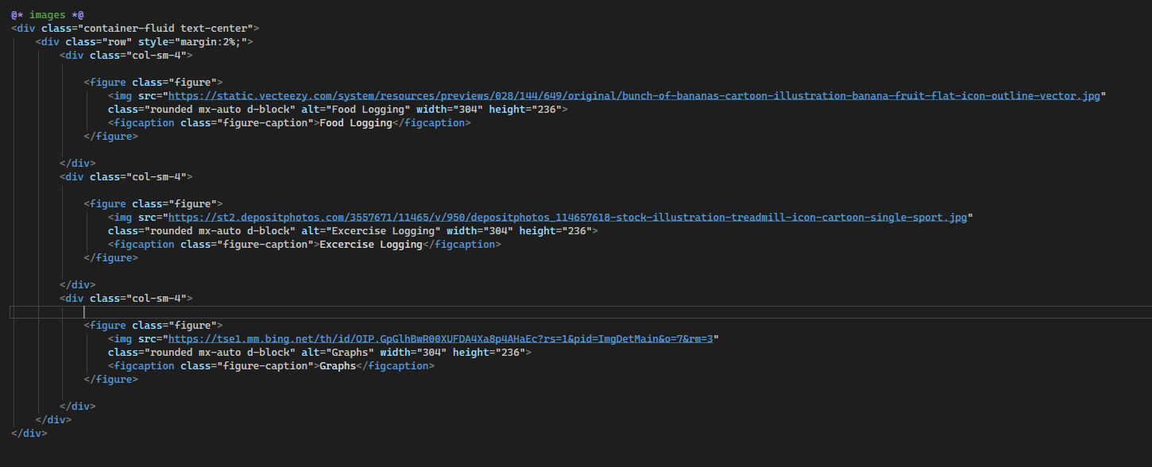

Here is the code that adds 3 images within a figure element that will allow for navigation to other pages of the website. An alt description has been used for users with visual impairment. The images chosen are simple and are designed to convey meaning in as little detail as possible. Bootstrap classes have been chosen to provide the best formatting experience for the user.

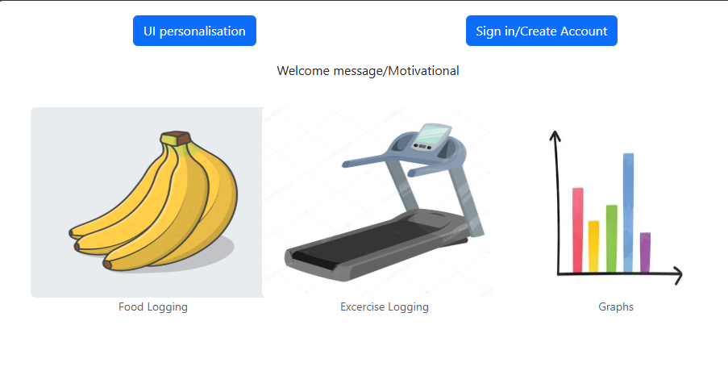 This is what the website looks like after this change.

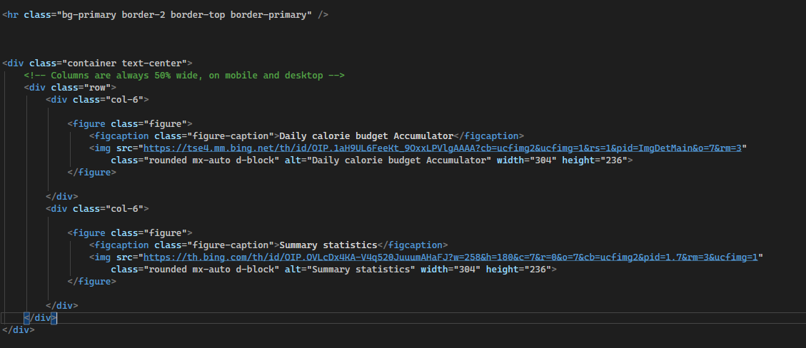

Added a hr to separate 2 components of the home page. (division). Added 1 more button hyperlink, and also summary statistics chart. Bootstrap libraries implemented.

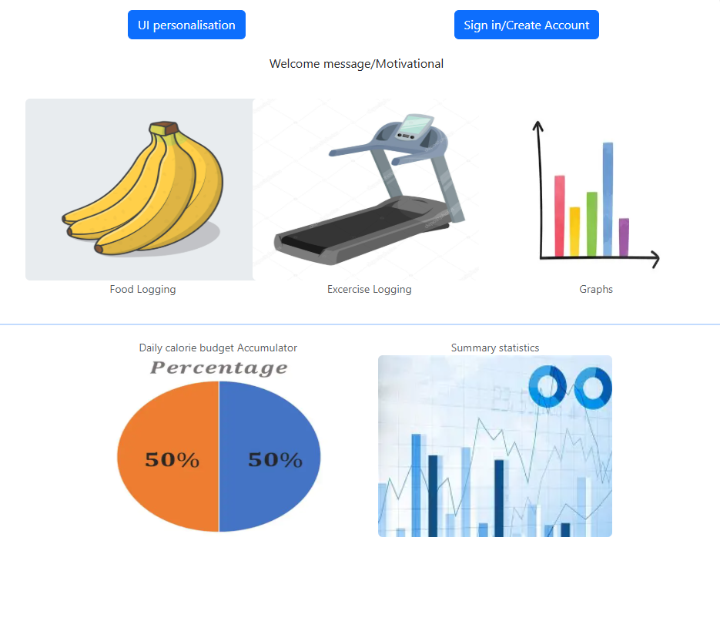

Need header and footer.

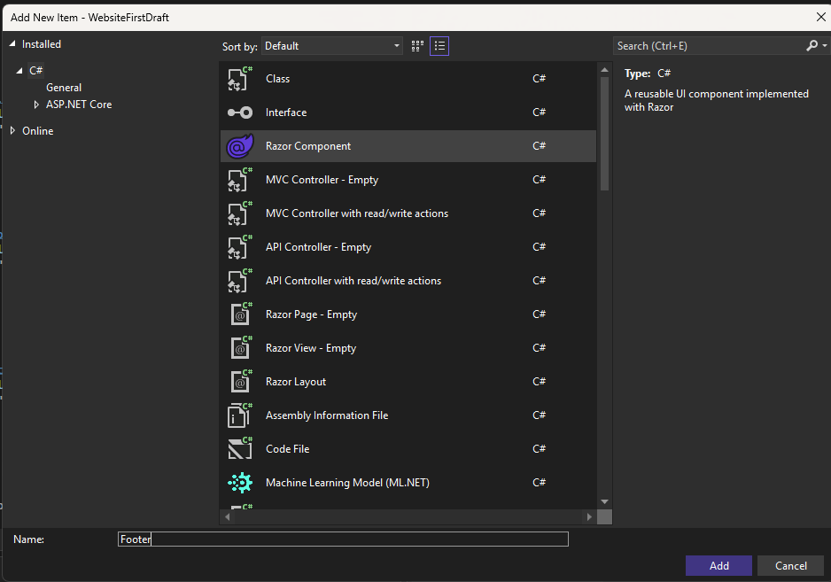

Adding a footer

Code for footer didn’t work initially. Had to add this to the main layout page.

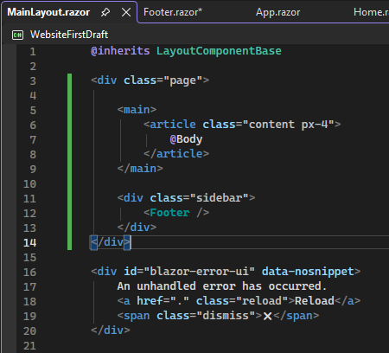



Now worked. Not visible as no text within it.

Setting up nav menu/title:

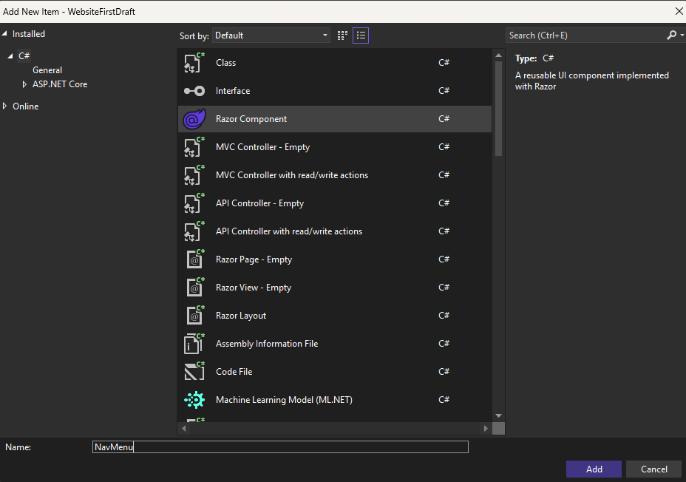

Adding nav menu razor component.

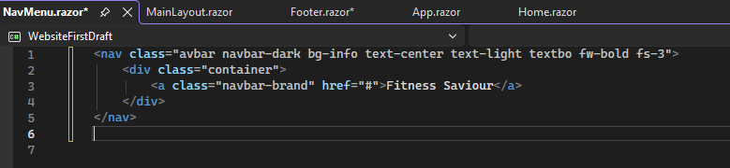

Code within NavMenu. Holds the title within a header.

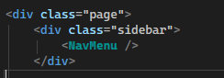

Adding navmenu onto the main layout page.

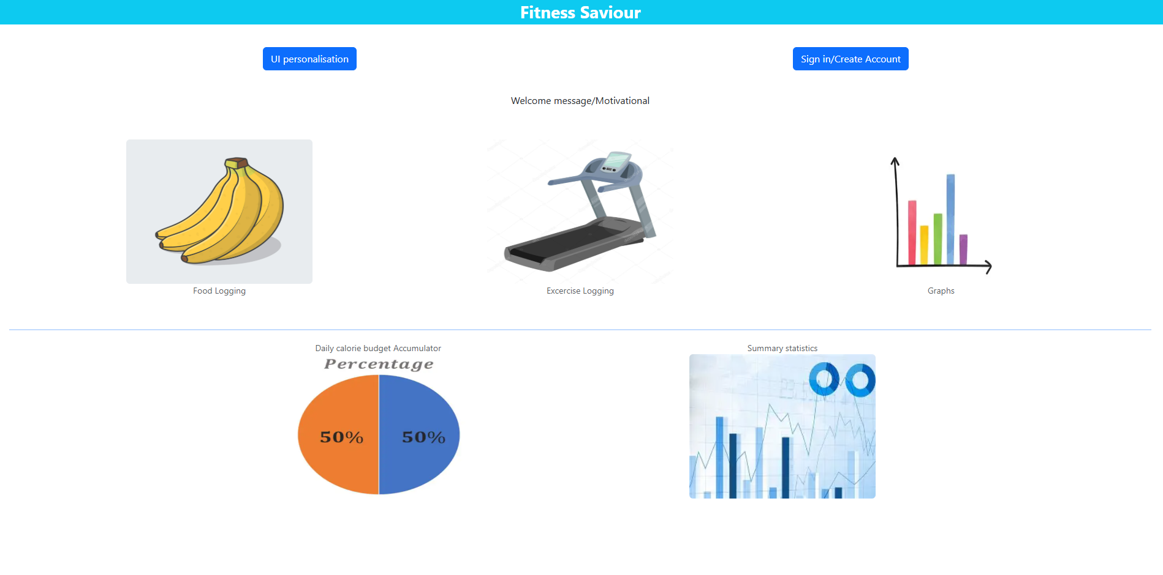

First draft of homepage complete. Updates will be made later e.g images used for hyperlinks, making features interactive. But static implementation complete.

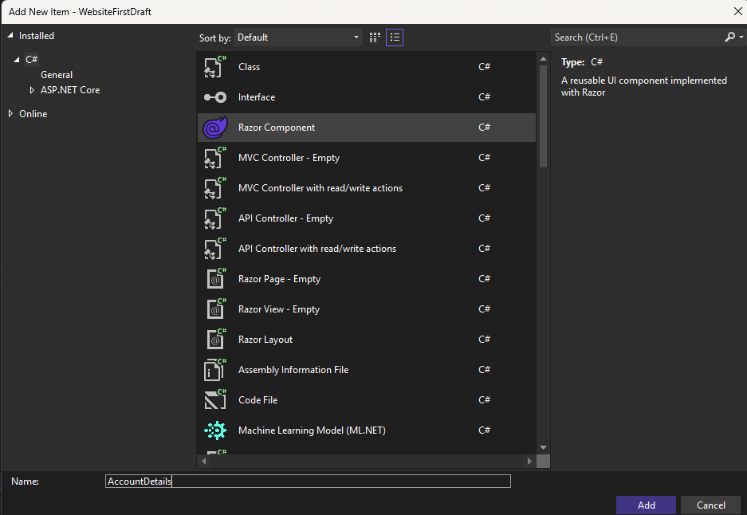

Creating the account details page.

Realising that in order for me to view the changes to this page from the client side, I need to set up some sort of navigation to it from the home page. Solution: creating the hyperlink to the associated button.

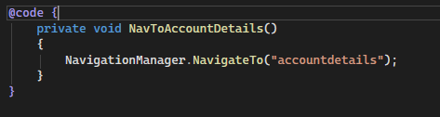

Code entered into the home.razor page. Creates a method that navigates to the account details page.

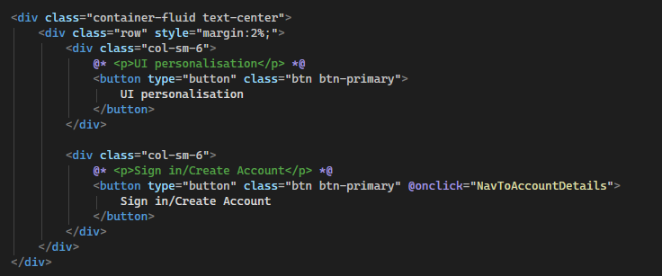

Modifying existing code. This is the code for the 2 buttons on the top of the homepage. Added interactivity to the sign in button, upon clicking the user will be directed to the accountdetails page.

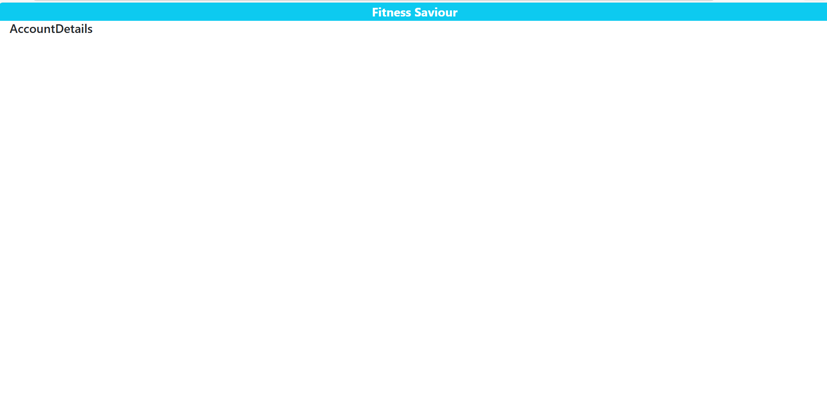

Upon clicking button, navigated to this. Success.

Now, time to code the account details page.

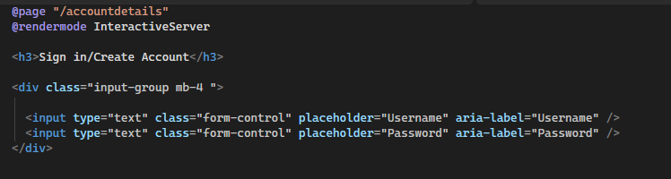

Added 2 text boxes that accept input for username and password. Aria label for accessibility.

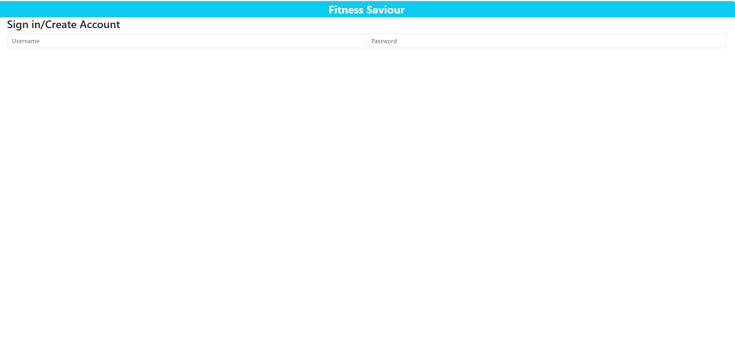

Not centred the way I want it to be. Shouldn’t be next to each other; one above and one below.

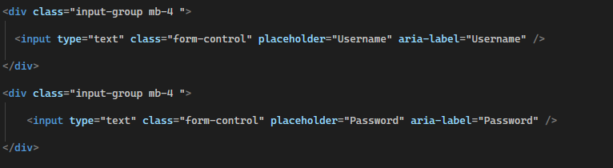

Separated them into 2 different divs.

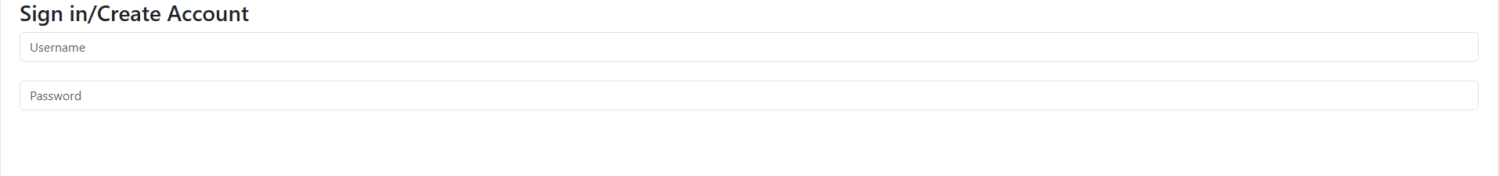

Successfully formatted that correctly. Too wide though, need to reduce the width and make them both centred.

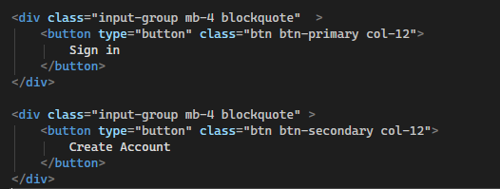

Code for the sign in and create account buttons. Primary vs secondary button to draw attention to the more important button. “col-12” bootstrap class makes it fill the whole page.

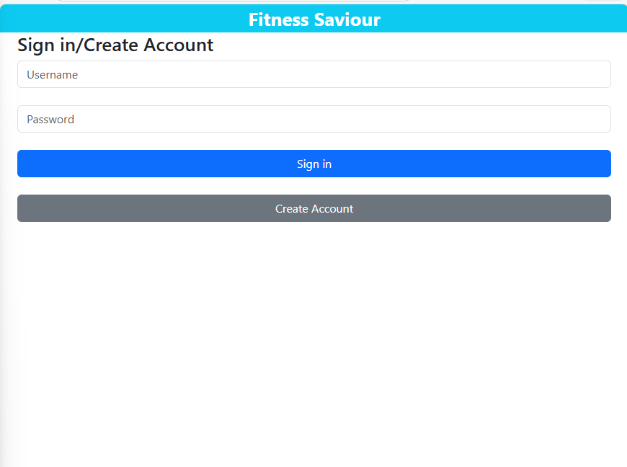

I need the sign in button to take the user back to the home page, and the create account button to take the user to a new page where they can create their account.

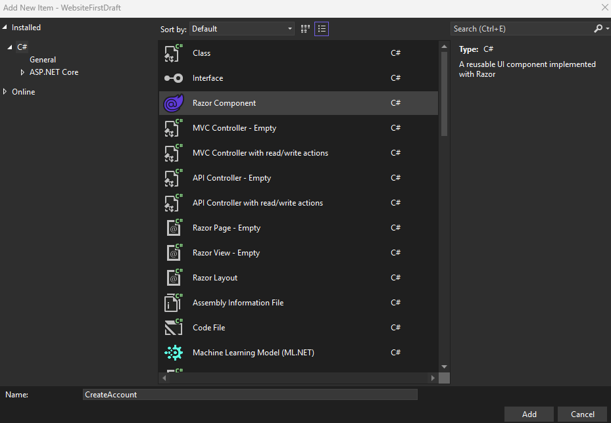

Adding create account page.

Had to inject the navigation manager onto the account details page for this next part to work.

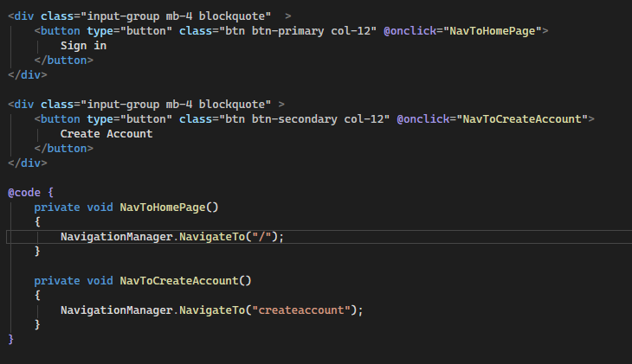

Added methods that add interactivity to the buttons. When the sign in button is clicked, it successfully navigates back to the homepage. The create account button navigates to the create account page.

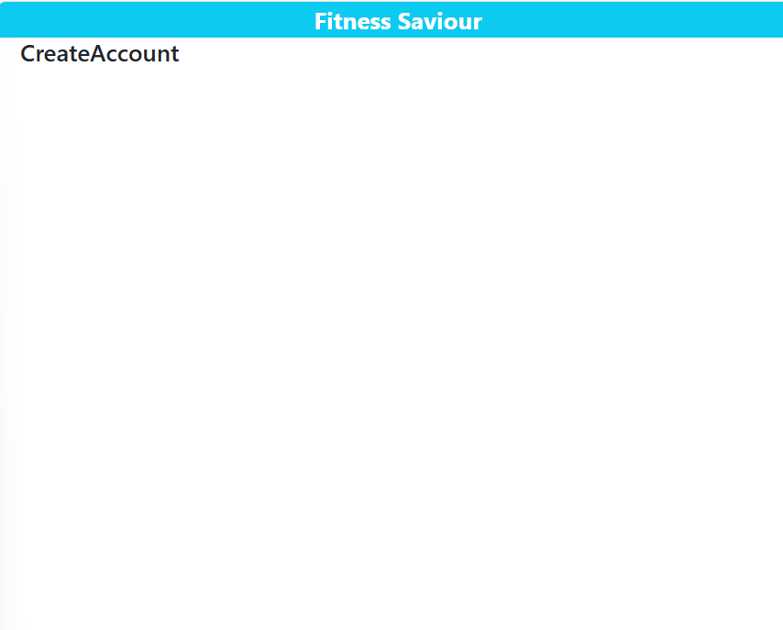

This is the create account page. Choosing to reuse the code for the username and password inputs as no need to make it any different.

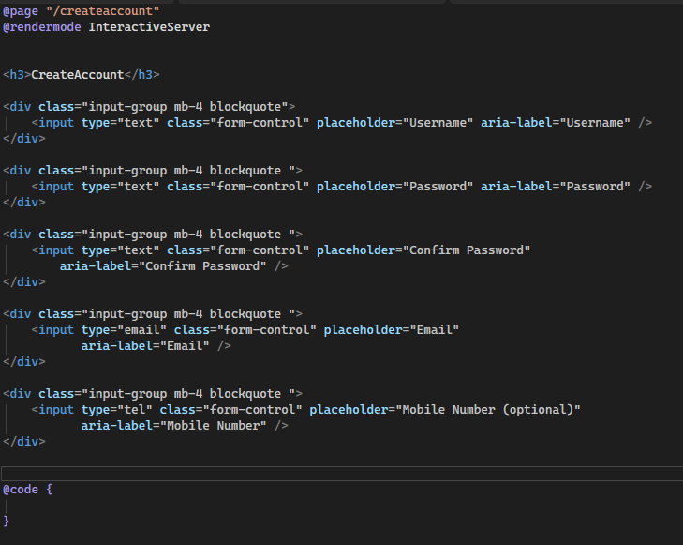

Confirm password button following same principles as the password button. Created an input of type email for the email (built in validation) and the same for the mobile number.

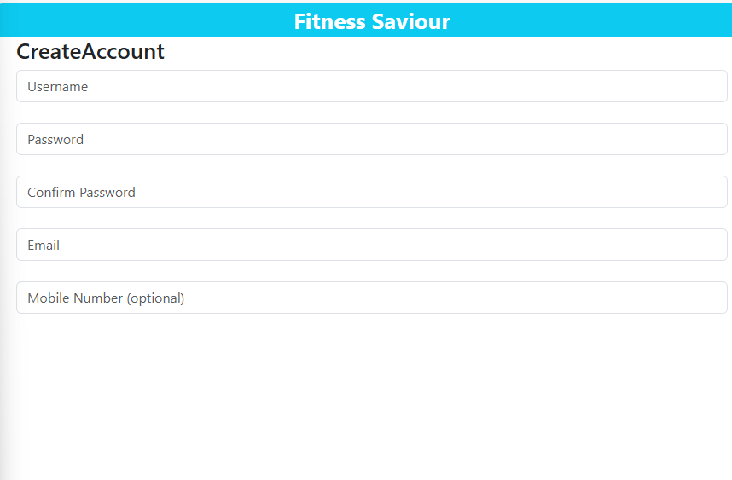

How the changes look so far.

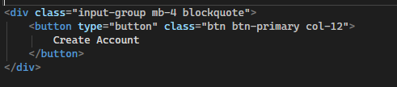

Modified the create account button from the account details page by making it primary.

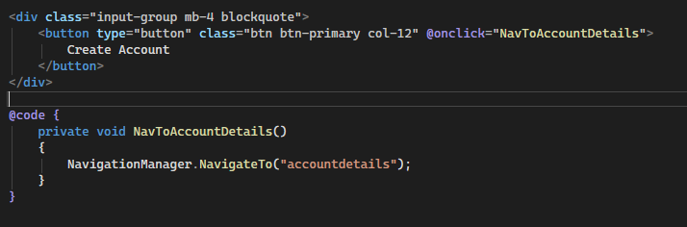

Added functionality, clicking button will direct user to sign in page.

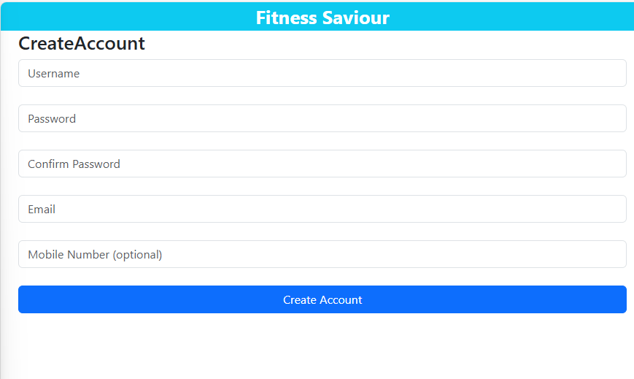

For now, finished page.

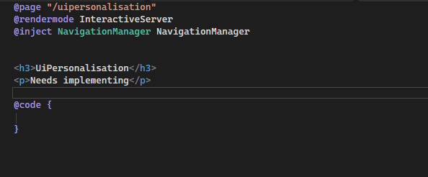

Created personalisation page. Due to heavy dependency on backend, not sure how to implement this right now.

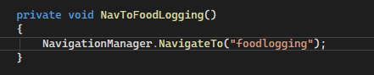

Added method into the homepage code that will allow for navigation to the foodlogging page, which I created.



Clicking banana image will navigate user to the food logging page. Successful.

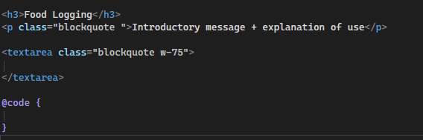

Code for foodlogging page so far.

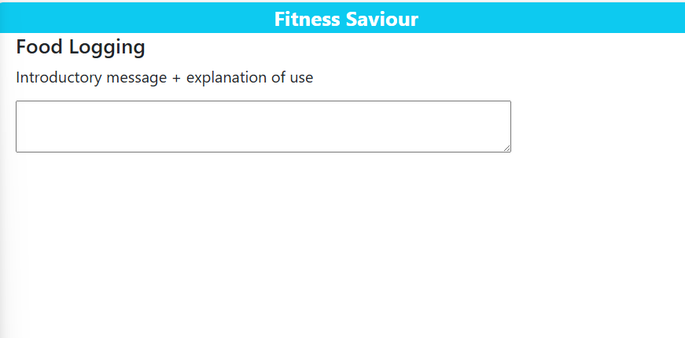

Added Placeholder for search bar, centred text.

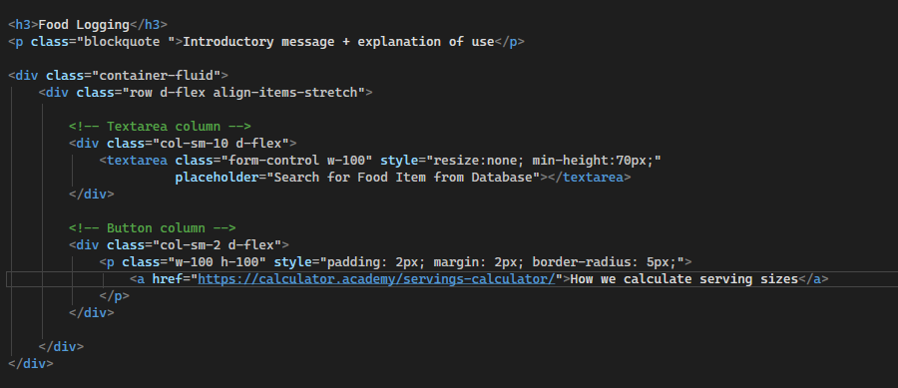

Added hyperlink to serving size calculator, aligned items on same row.

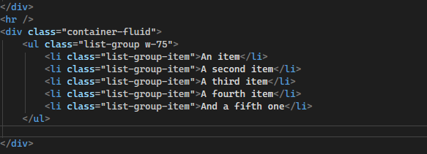

Created a list from bootstrap for the food logging list. 75% width as plan is to add content to the right of the list.

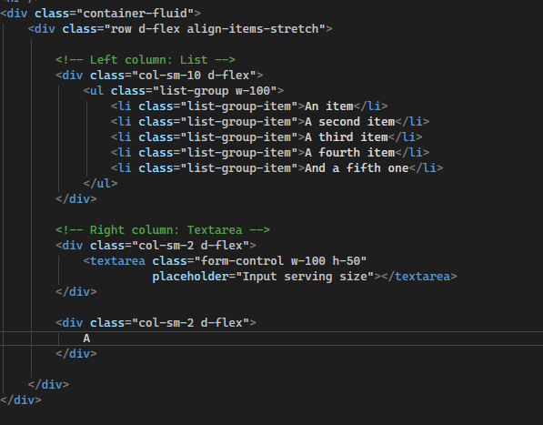

Adding the input serving size box and the graded system icon.

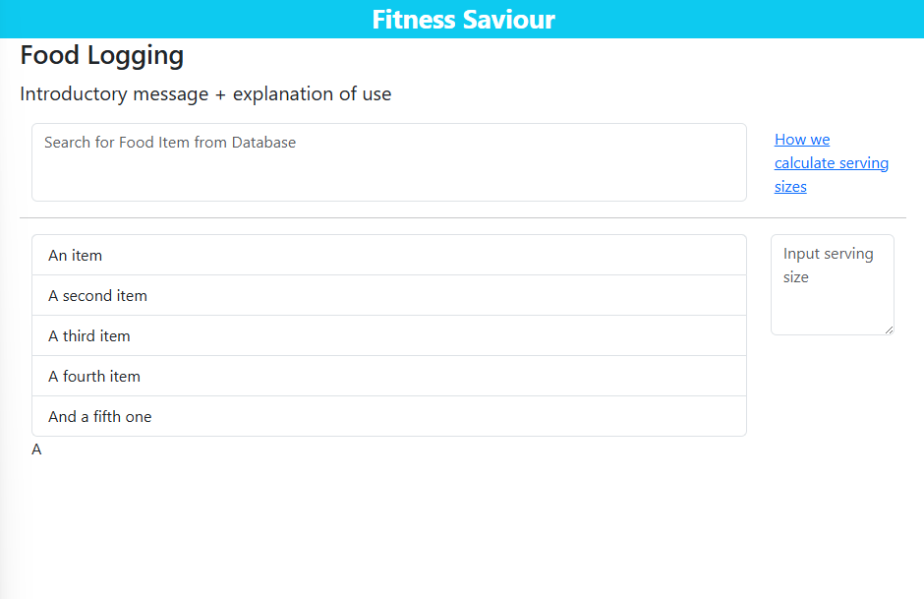

Issue: “A” isn’t aligned with the list/below the input.

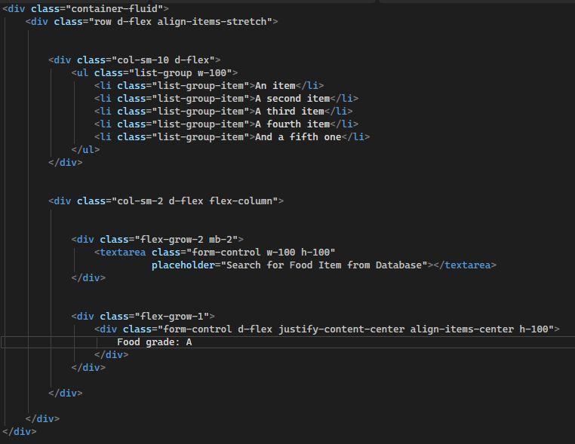

Solved the issue.

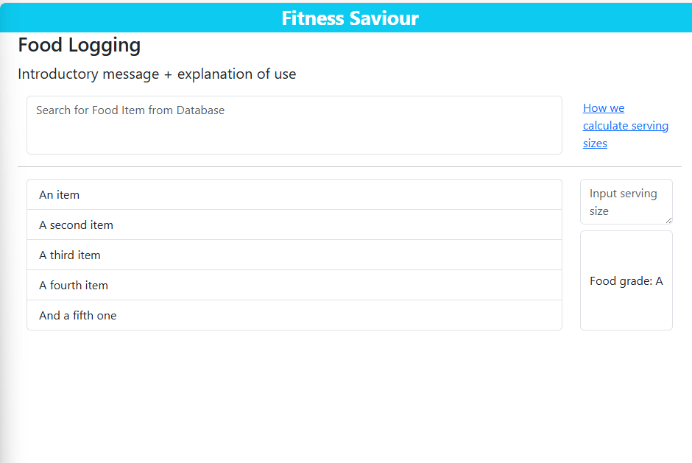

Looks better now. I need to make the pie chart for the macro composition. Cannot rely on bootstrap libraries. Created a css file called foodlogging.css.

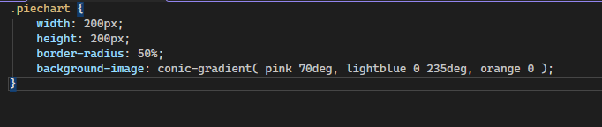

Created a piechart class that will serve as a template.

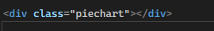

Gave a div the class.

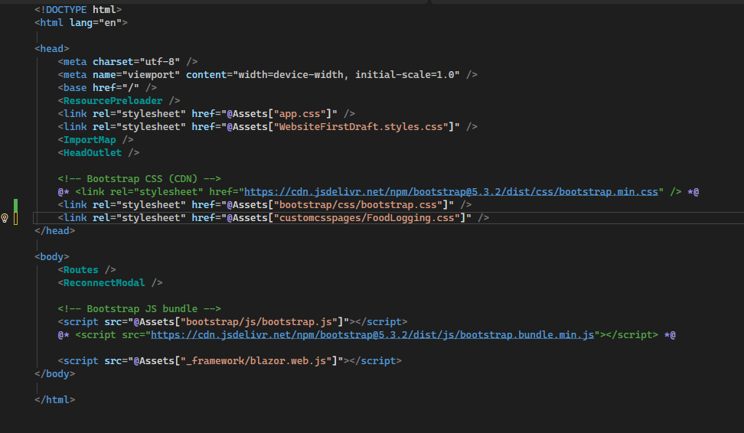

Added my css page as an asset on the app.razor page.

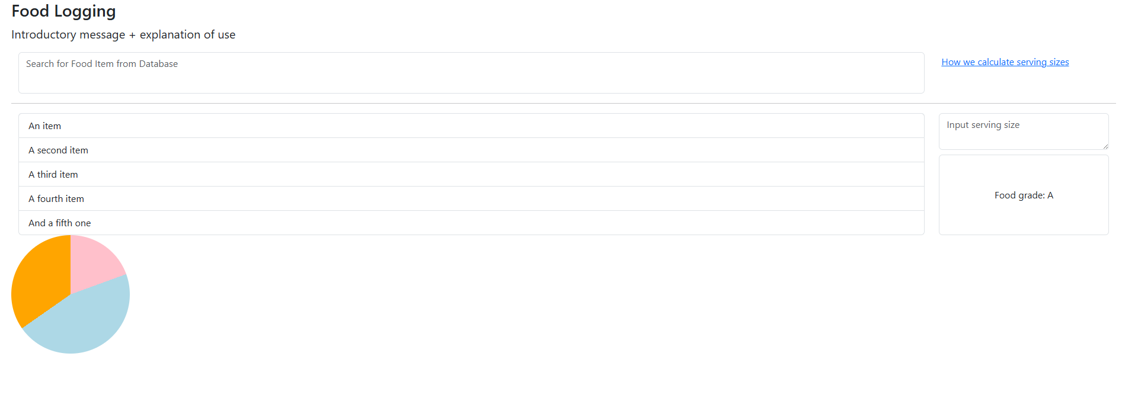

Piechart requires formatting.

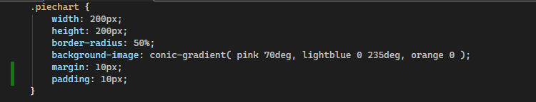

Added margin and padding. Looks slightly better.

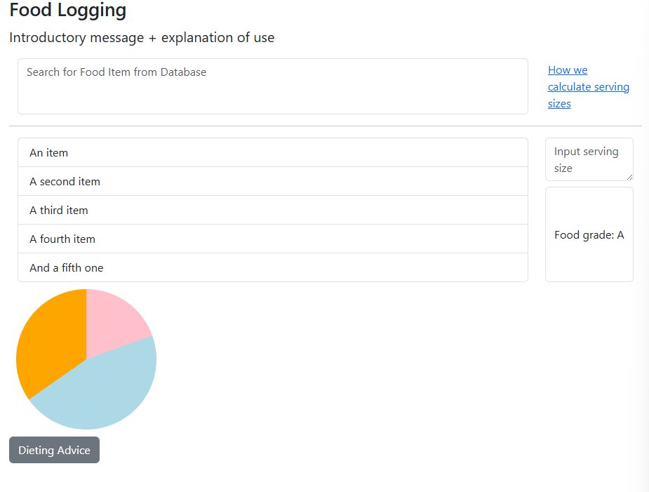

Added a button for the dieting advice. Secondary class to indicate its importance. Issue is I want the pie chart, the button and a text area for manual entry all on the same row, so I will revisit the concepts I used for the elements above.



Code for button.

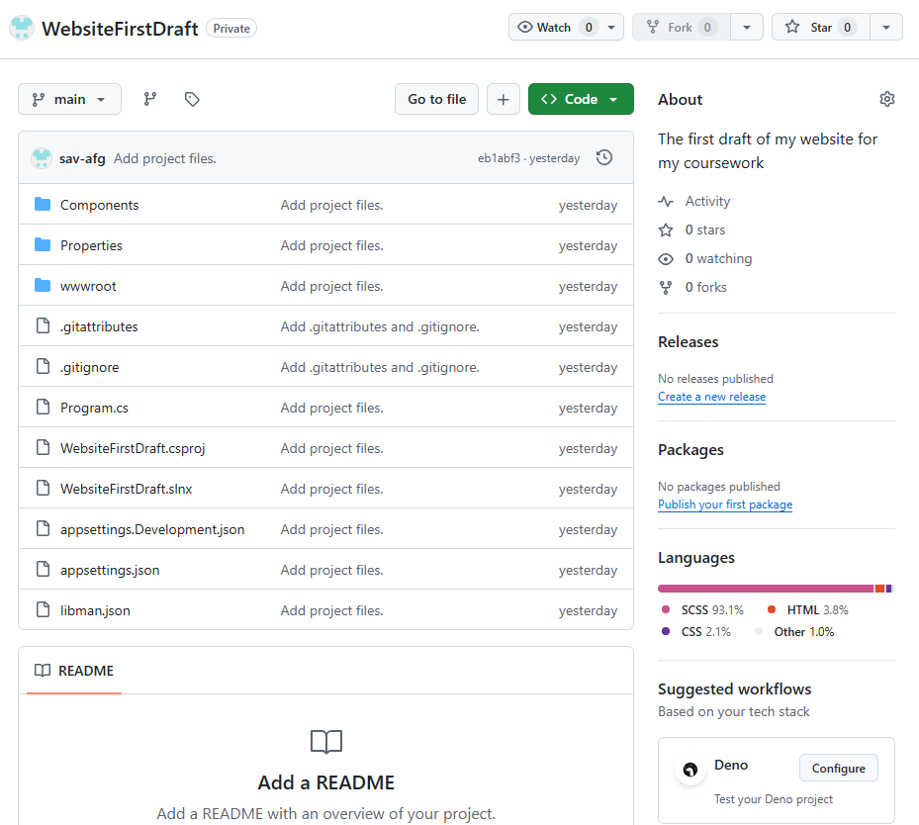

Implemented version control and linked the visual studio files onto a repository on github.

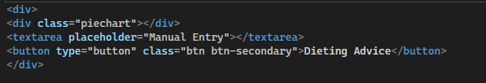

Wrapped all 3 elements into a div, and added the text area with placeholder “manual entry”. Manual entry will consist of input fields of name of food, serving size and number of calories.

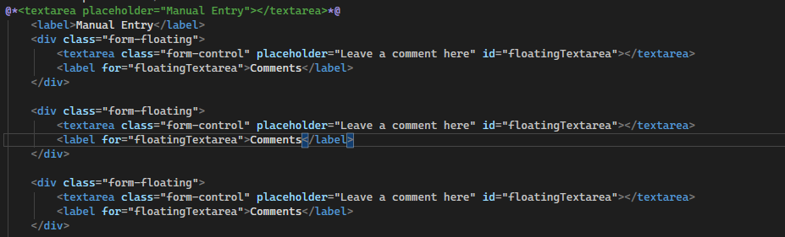

Here I used a template from the bootstrap library to see what adding 3 floating text areas would look like.

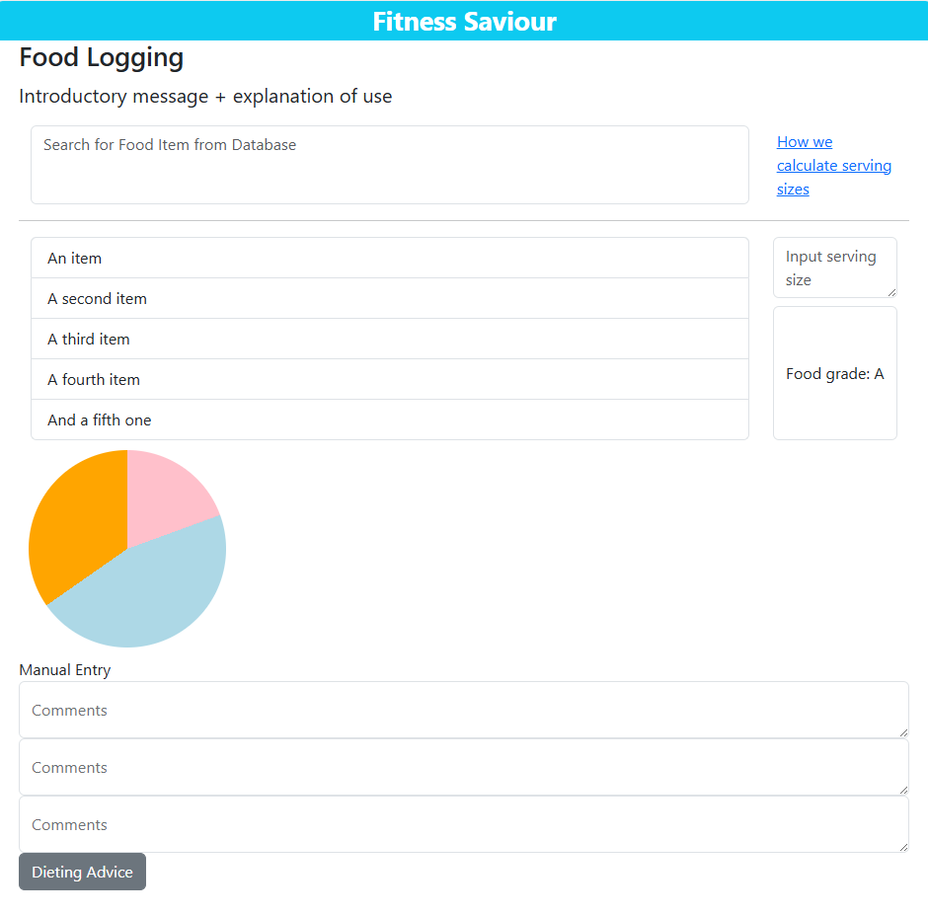

Felt too cramped, margins might help.

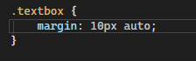

Created textbox class in foodlogging.css page and assigned the class to the div elements.

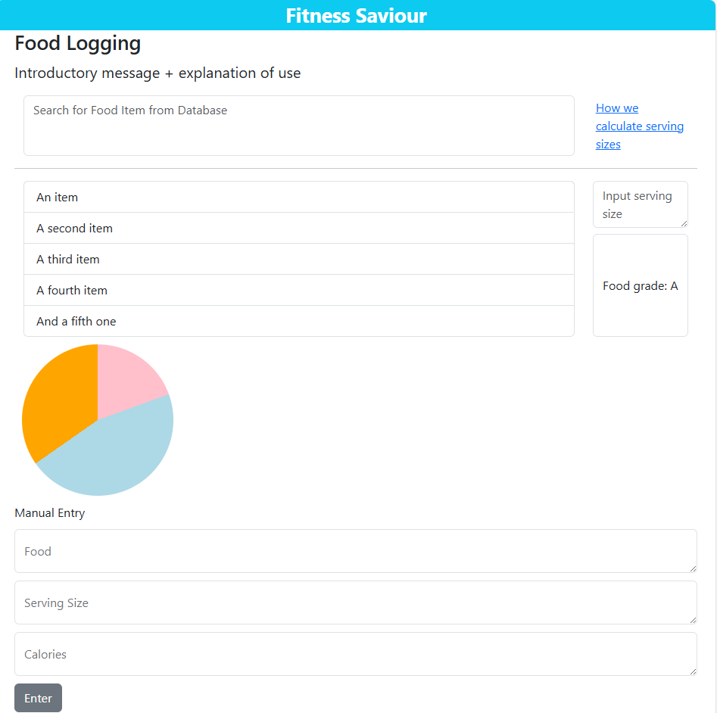

Less cramped now.

I need an enter button to the right of the pie chart so that the user can enter food items that they have selected from the list. I also removed the div element that wrapped the bottom half of the pages elements as it was void.



Added a button to enter food items from the list. Given the primary class to provide hierarchal contrast to the enter button for manual entry.

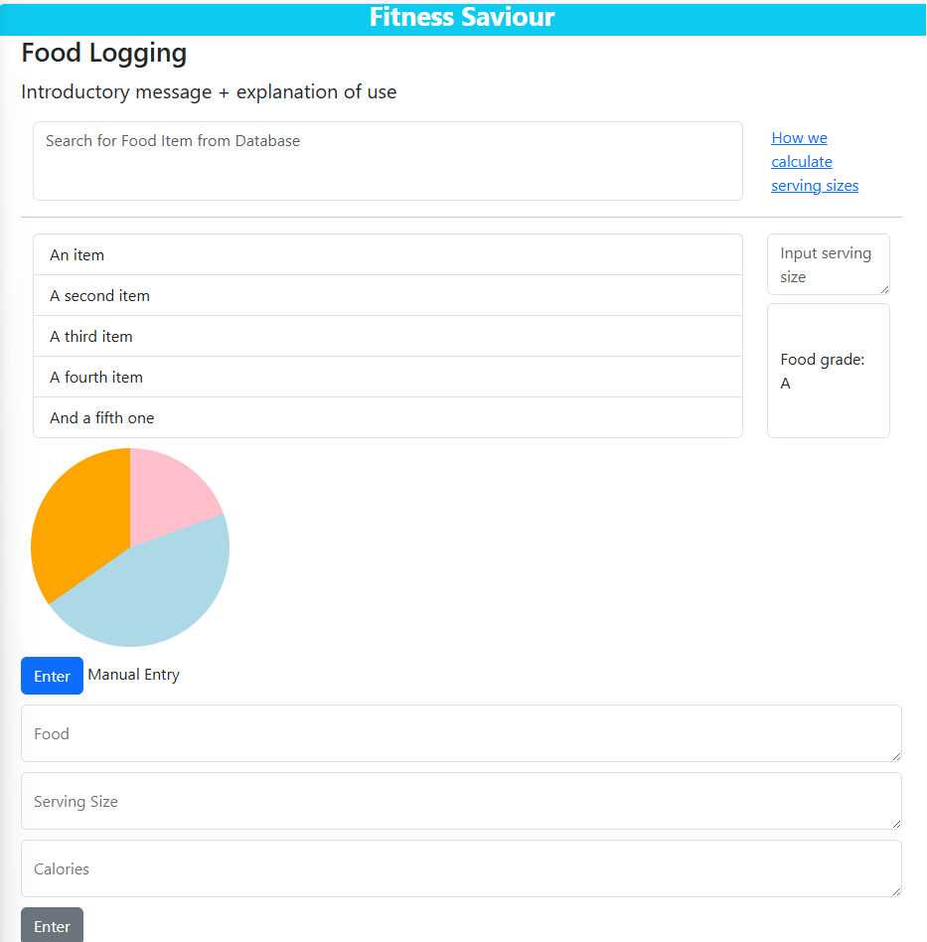

Needs to be on the right side of the pie chart, not under it.

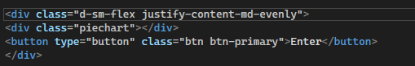

Wrapped both elements in a div with flex-box properties, from the bootstrap library. The justify content evenly class spreads the elements out in a row with equal spacing between the edge of the page and themselves, However the button expanded in height to match the height of the pie chart, making it look far too stretched as u can see in the screenshot below.

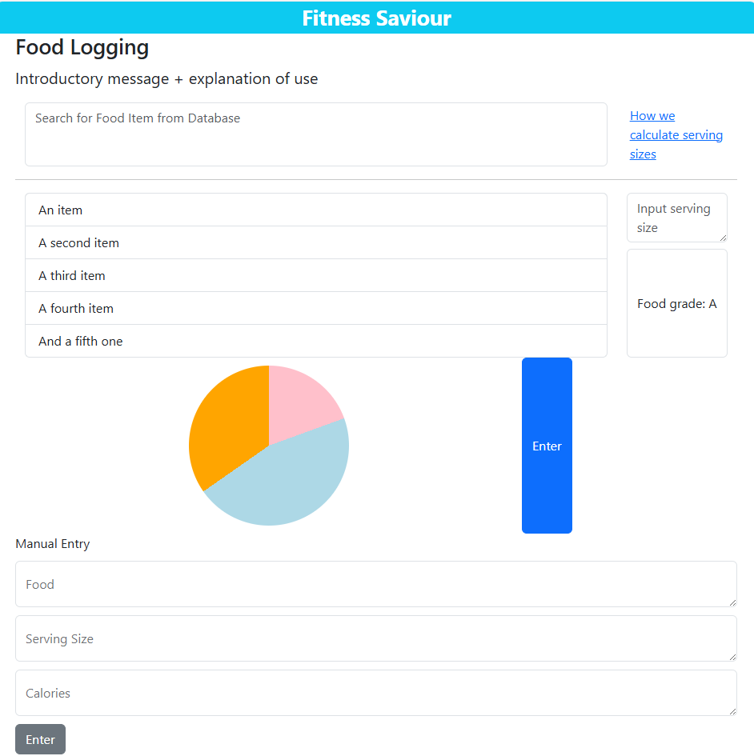

Need to reduce height of button.

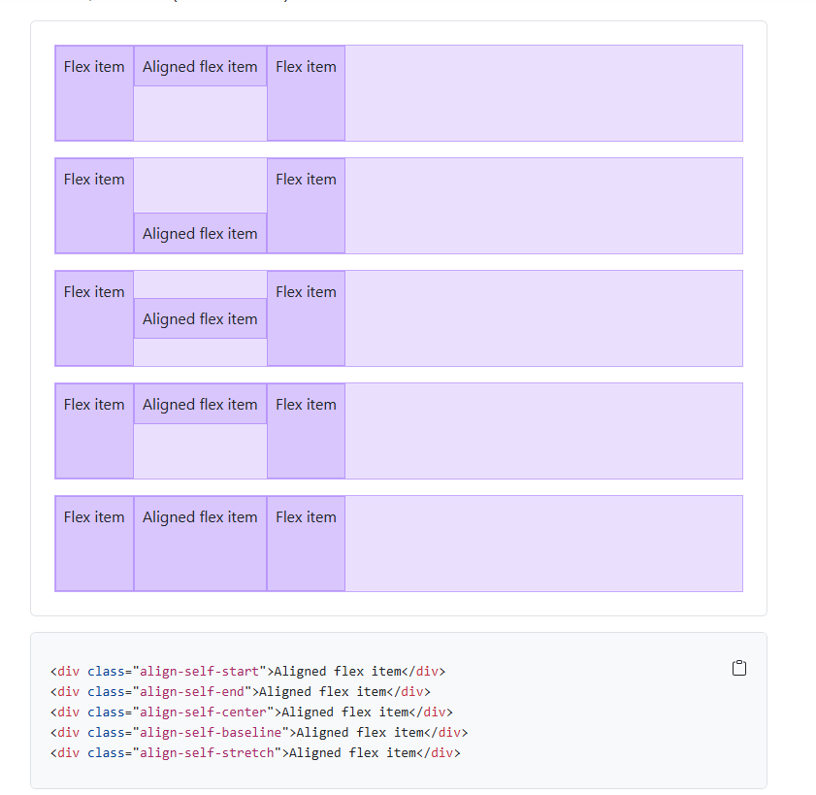

Found relevant page on bootstrap. The second option seems reasonable.



Added the class to the button.

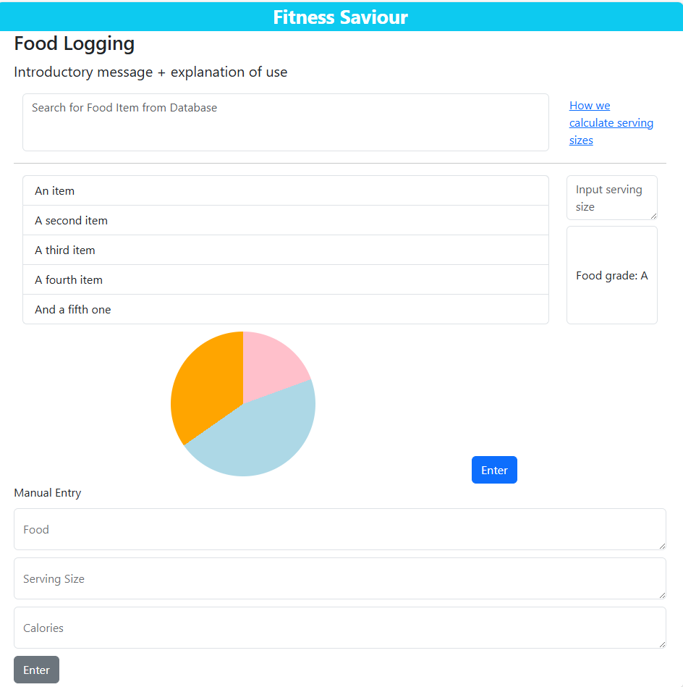

Looks much better now. Implementation of food logging page looks good enough for now. Last thing to do is add the dieting advice button. I want this on the same row as the enter button but on the opposite end. For this I need to set up both elements as a flex box.

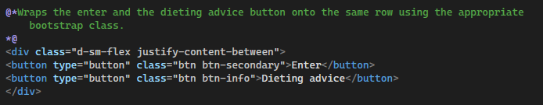

Added a comment onto the code explaining its use. Will be useful when I look back on it. I gave the dieting advice button the bootstrap info class as it matched its intended usage.

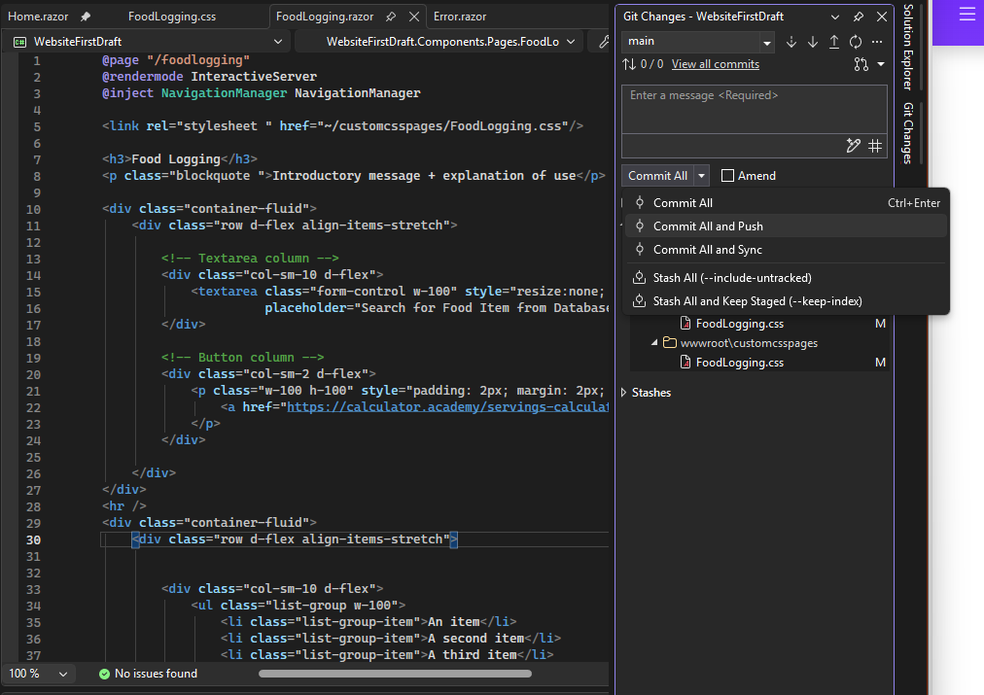

As I have finished a new page, good time to push and commit the changes onto github. I successfully did this.

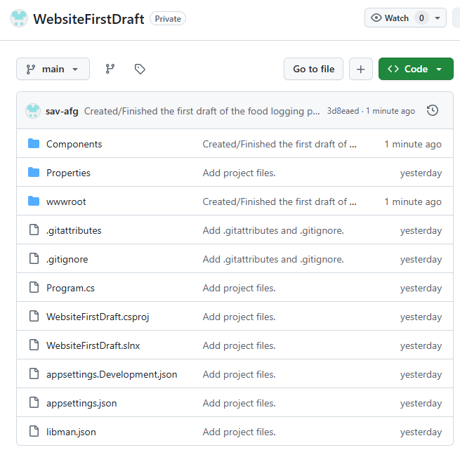

Now I will implement the exercise logging page. Due to its similarity to the food logging page, I will copy the food logging page and work backwards to make it the exercise logging page. I believe this approach will be more time efficient.

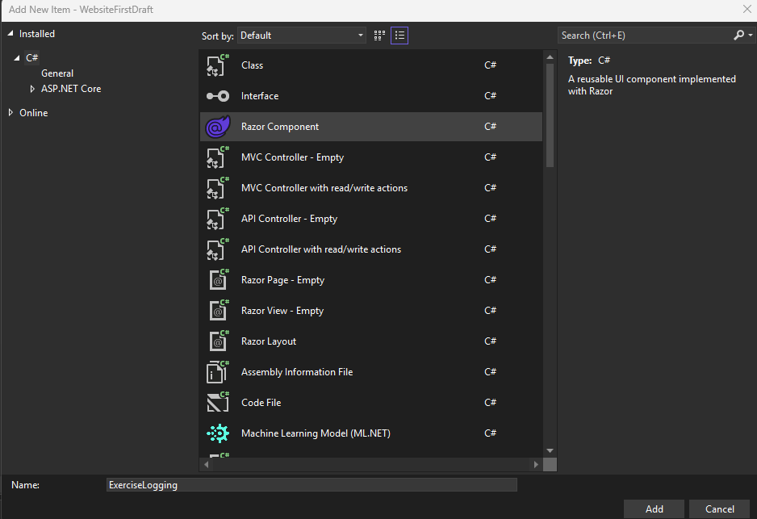

Added exercise logging page. Inside the code space, I copied and pasted the code for the food logging page. In order to access the page and modify it in real time, I need a way to navigate to it, which I will implement in the home page.

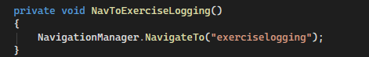

Implemented the function in the home page.



Added the “onclick” function to the exercise logging image on the homepage. It successfully works.

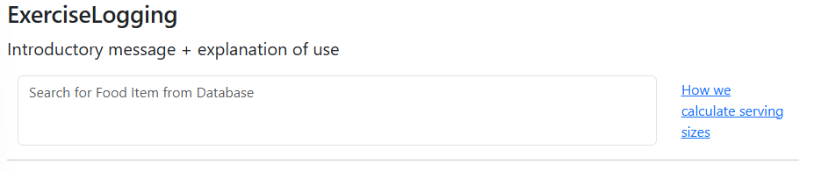

For the top part of the page, the link is redundant now as the exercise logging page does not require one. The placeholder for the input box must also be updated.

Before:

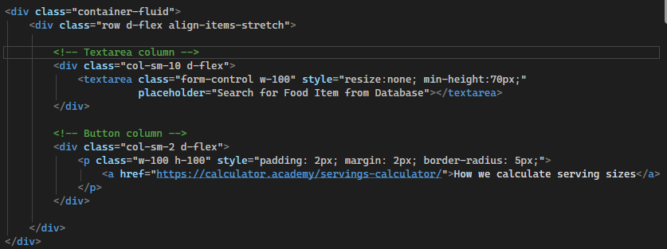

After:

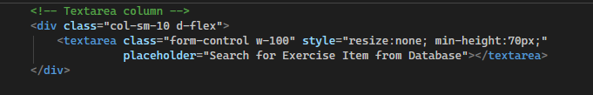

No need for the flex box attributes, just needed a simple text box.

*Removed the word “item” from placeholder for grammatical sense. *

Before:

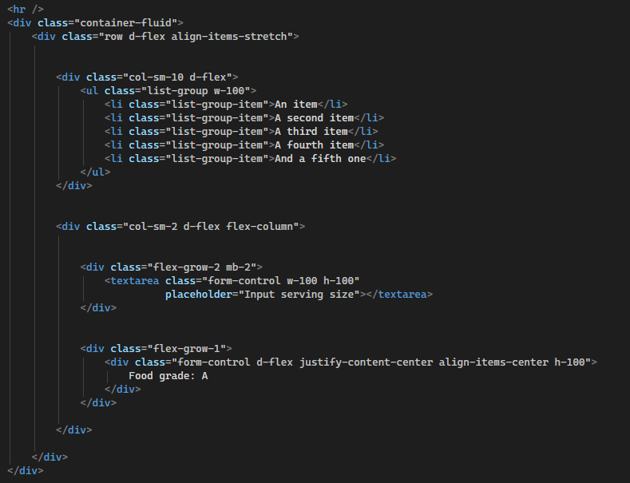

After:

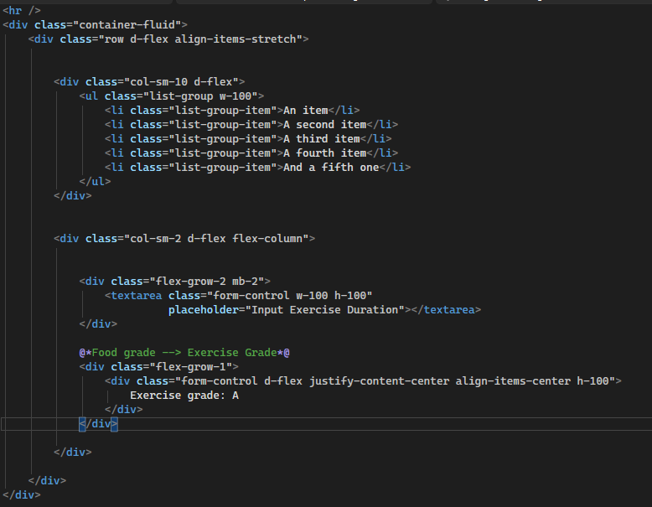

Changed the placeholder to “input exercise duration” and changed the grading from food to exercise.

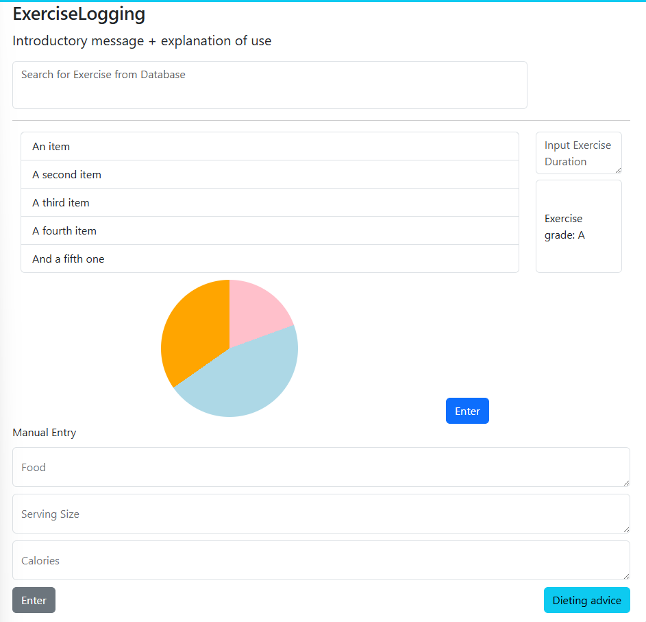

Top half of the page successfully modified.

I removed the pie chart as it was no longer needed. However this ruined the layout of the page.

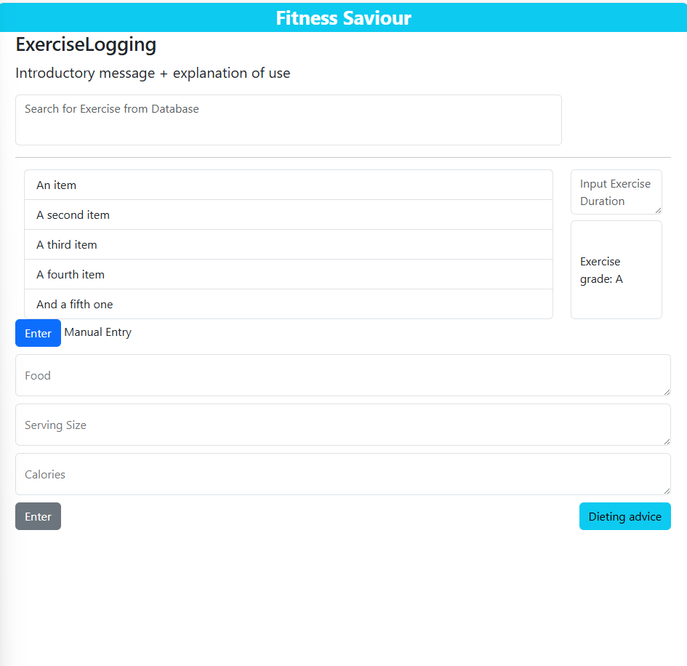

I would like to add the enter button to the flex box of the list so that it sits under the exercise grade.

Before:

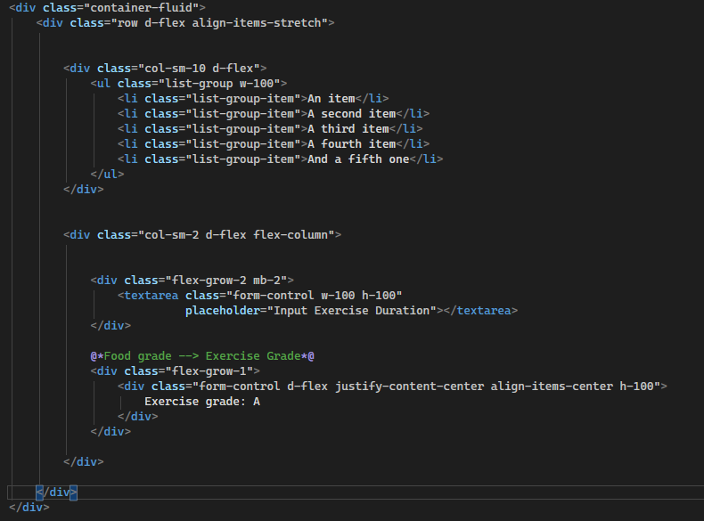

After:

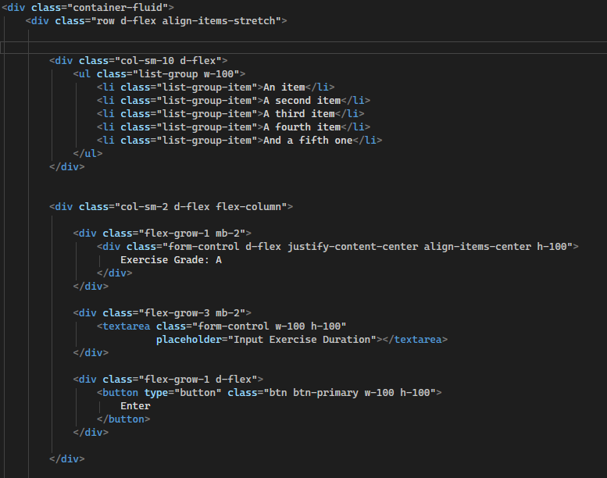

Flex-grow-3 class on bootstrap allowed for a 1:3 ratio of items stacked vertically. I put the grade on top this time with the input box above the button as this makes more sense.

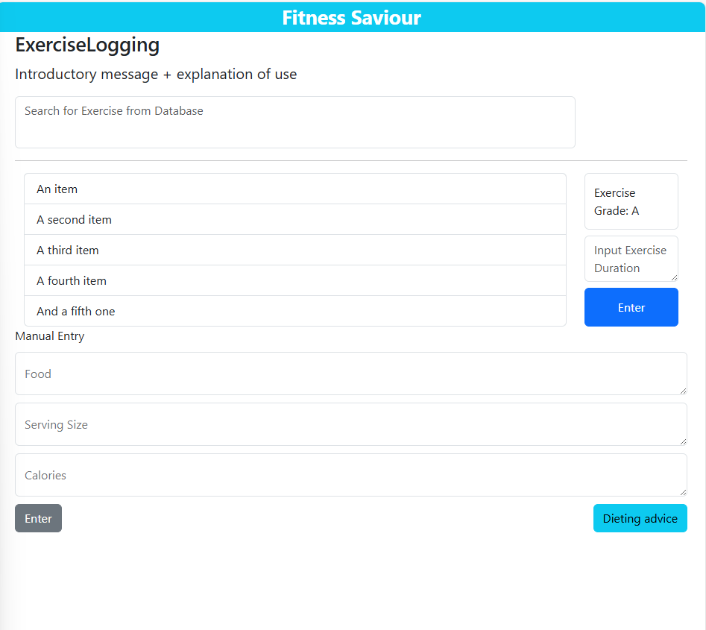

Happy with top half now.

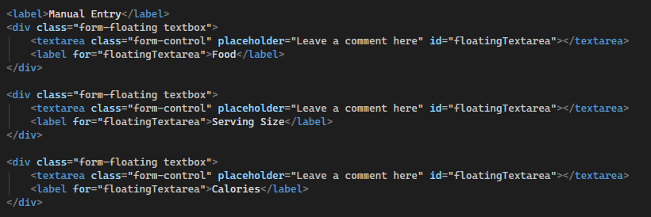

This is the pre-existing code from the food logging page. Not much change has to be made here, just the text changed to the relevant details.

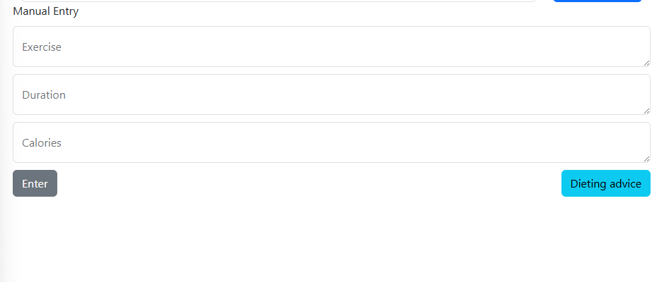

How it looks after changes have been made. Last thing to do is change the text of the button on the bottom right.

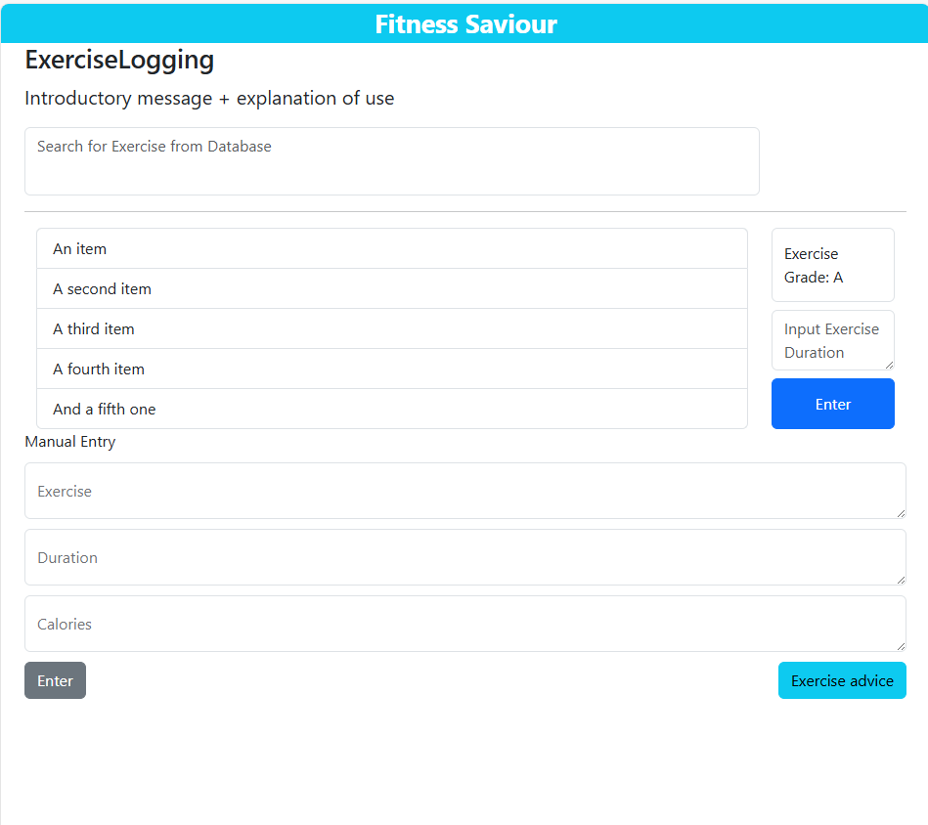

Realised I needed a button that takes the user to the hypertrophy page from the exercise logging page. I decided the best place to add this button would be on the top right, on the same row as the search bar.

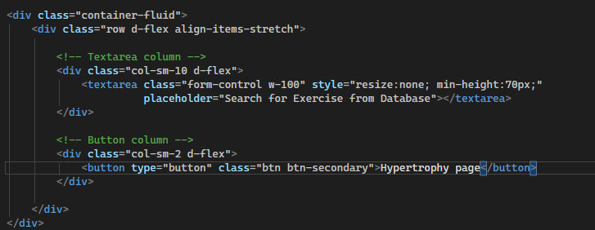

I added a flex box design to the elements with the same implementation as on the home page, with the difference being a button on the right rather than a hyperlink.

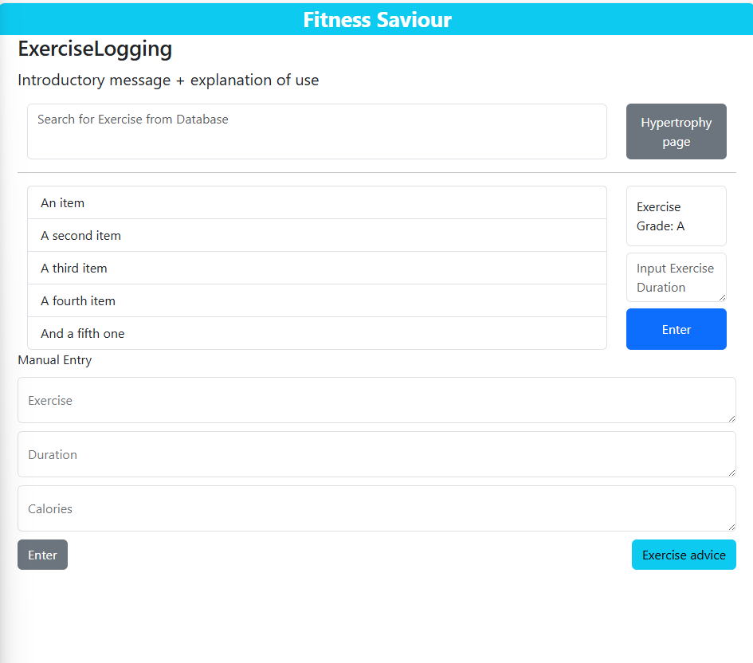

Final look of the page’s first draft. Pushed new version onto github.

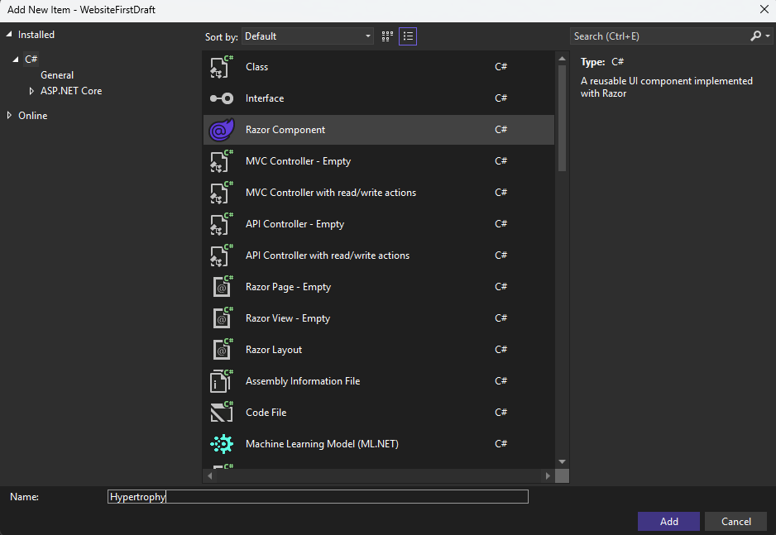

Created hypertrophy page. Need the “hypertrophy page” button on the exercise logging page to navigate to this page.

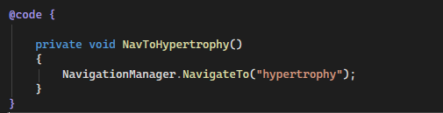

Added the method onto the exercise logging page.



Called the method when the button is clicked. Tested and it works.

Once again, the hypertrophy page will have a similar functionality to the pre-existing pages of food logging and exercise logging as they all involve the logging of something. For that reason I will again use the code of an existing page and work backwards to achieve the intended result.

Before:

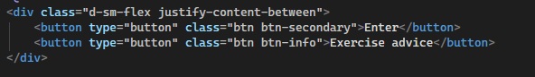

After:

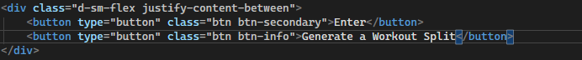

First off I changed the button on the bottom right to generate a workout split as this is relevant to the hypertrophy page.

I then changed the text for both enter buttons to “Log”.

Before:

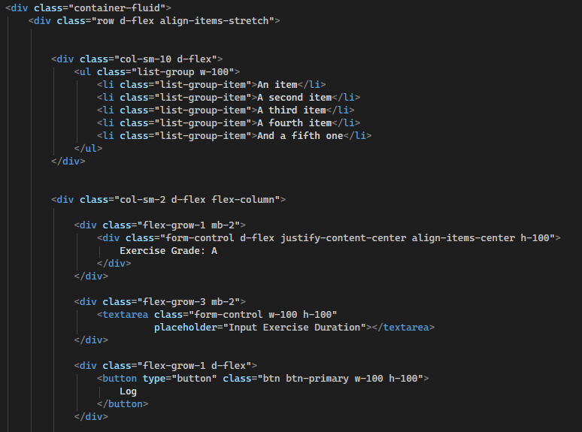

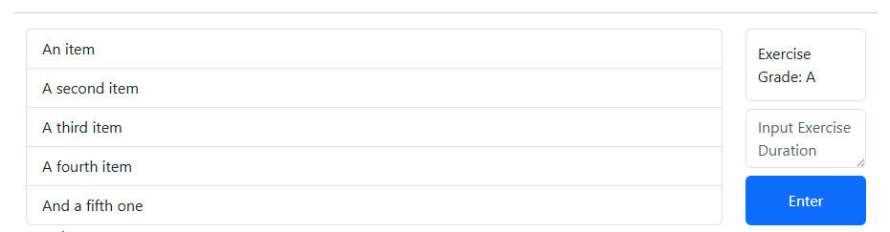

After:

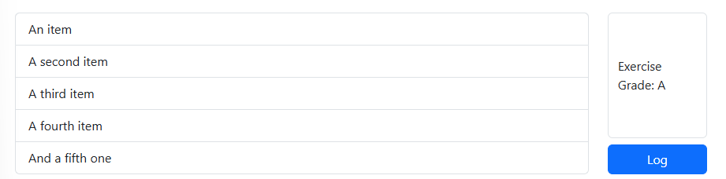

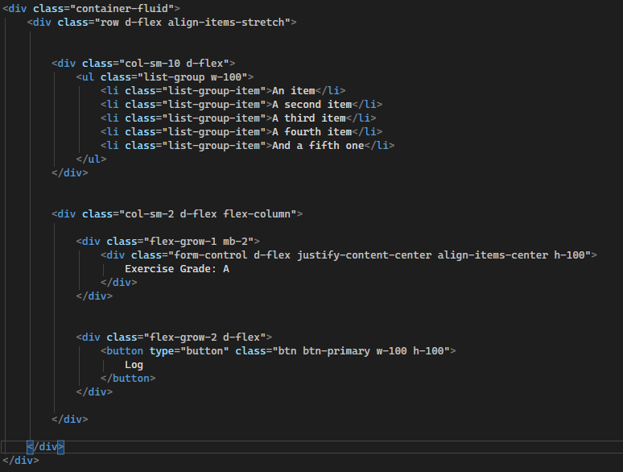

I managed to alter the flex box layout to a 1:2 ratio rather than a 1:3 ratio as I no longer needed the input exercise duration field. I chose the right bootstrap class to ensure that the exercise grade icon covered 2/3 of the vertical height of the container, to ensure the height of the log button was consistent with the other buttons on the page.

I now need to edit the manual entry fields.

Before:

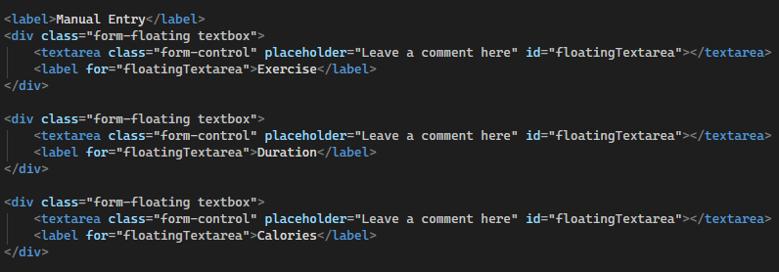

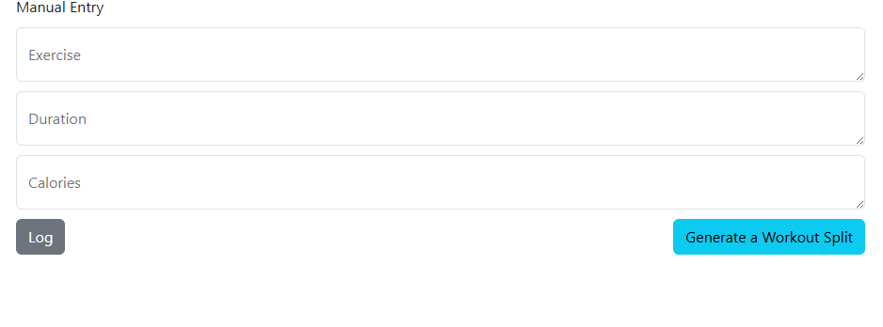

After:

I need one of the fields to be a drop down lost called “type” with options of what type of exercise the user wishes to input.

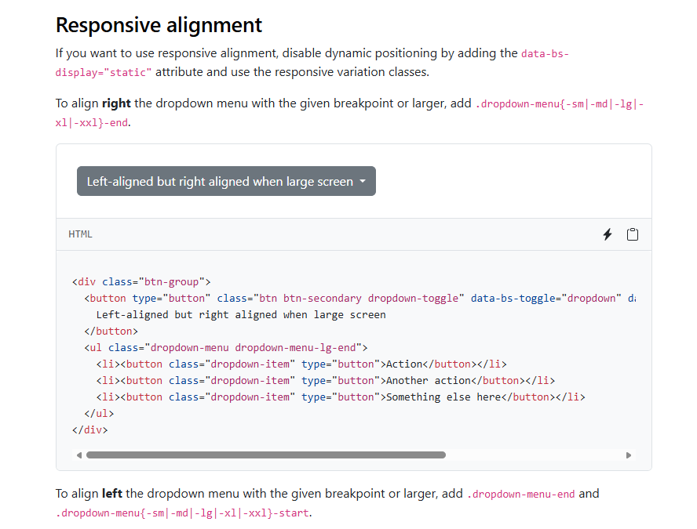

Useful bootstrap page containing what I need

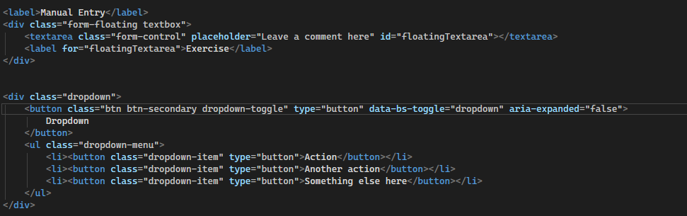

I removed the duration textbox and added a sample drop down menu.

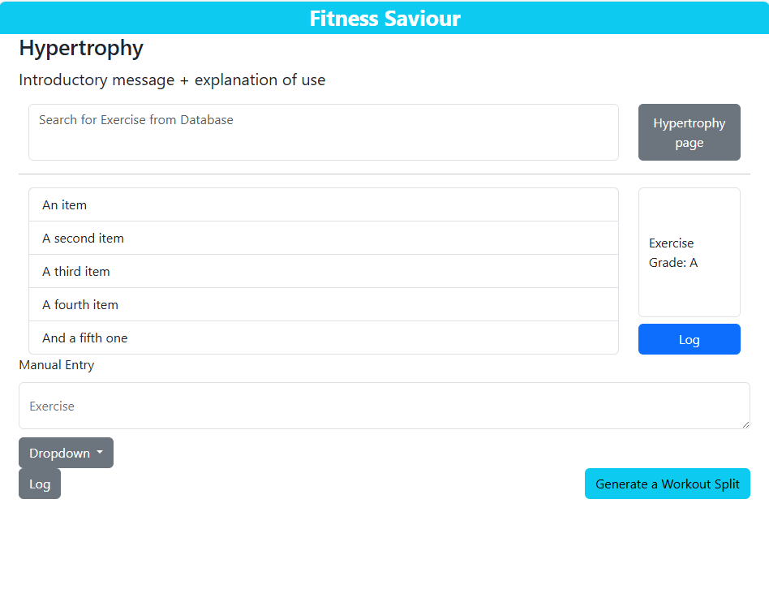

Issue: Clicking on the drop down didn’t show me the elements.

After commenting out the 2 buttons under the dropdown-list, I found that I could now see the elements.

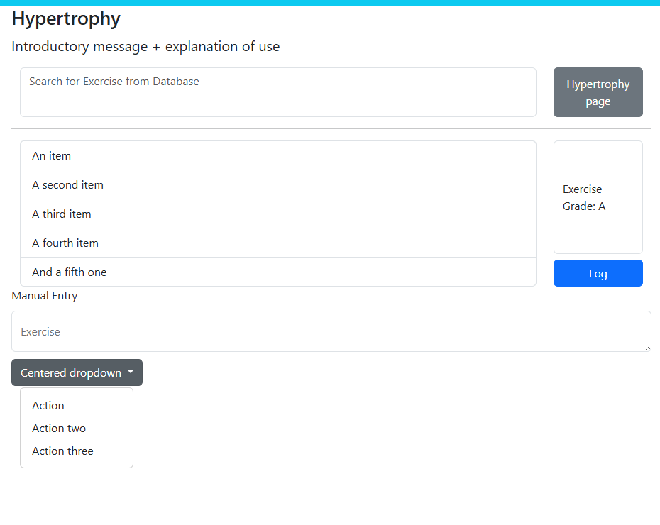

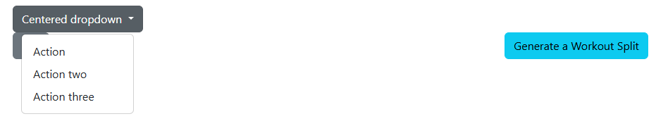

After I added the buttons back, I noticed the drop down covers one of my buttons. To solve this I intend to align all 3 buttons into a flex box. I will do this by adding the code for the drop down menu into the div that has the class “justify-content” where the log and generate buttons are.

Before:

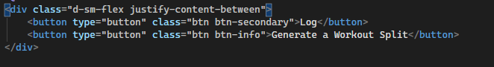

After:

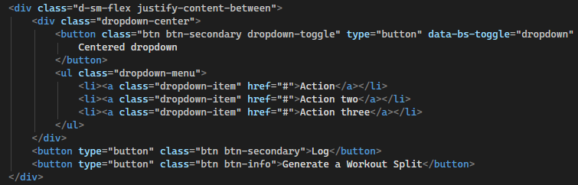

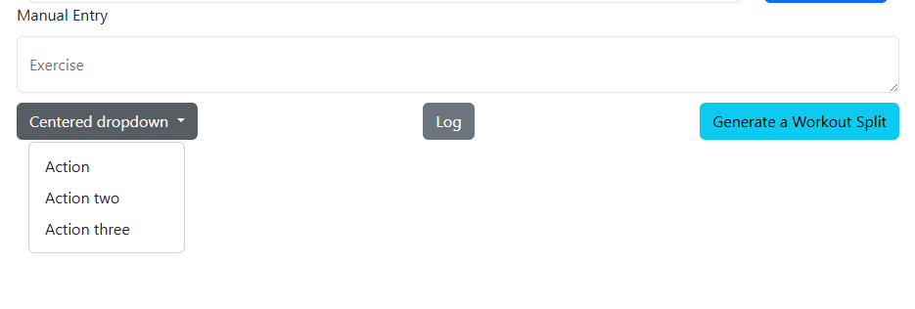

Layout looks a lot cleaner now.



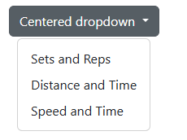

Added more contextual items to the drop down menu.

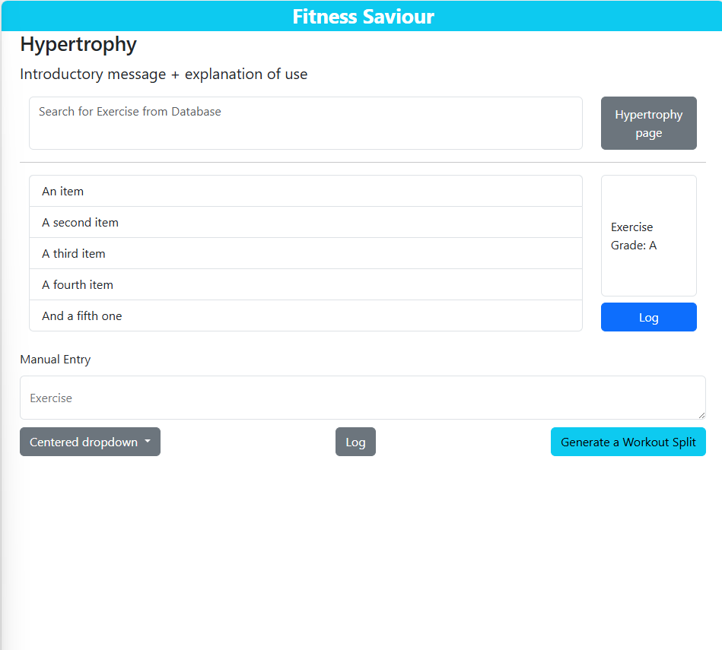

First draft of the hypertrophy page. Will push onto github.

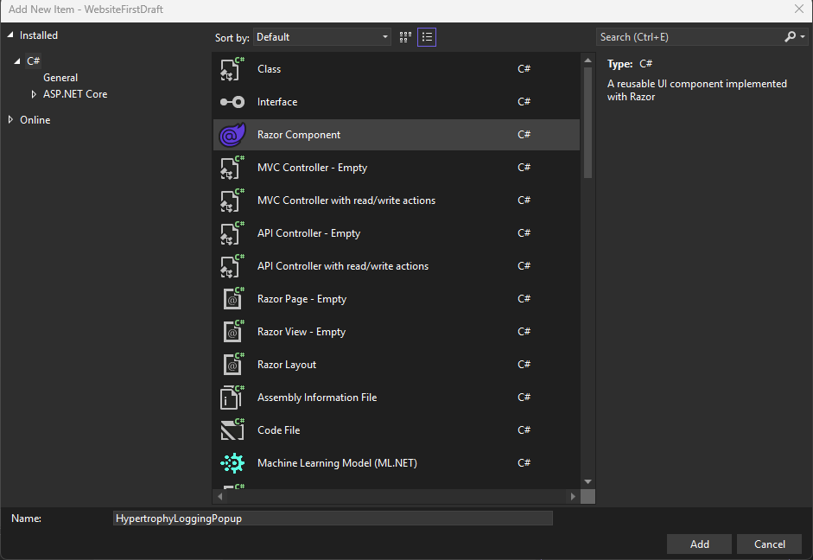

Created the hypertrophy logging pop up that I want to pop up when I click on the log button on the hypertrophy page.

Important things to note:

* I cant use the navigation manager here because it changes pages. I want a pop up
* I want a “modal dialog” which will use a modal that is component based and will have its visibility toggled from the parent page
* For this I will create a page like ive been doing previously, but it will have a lot more backend c# code integrated from the start
* I will create a Boolean variable named IsVisible which will state whether the pop up should be visible or not, because if it shouldn’t be it should not be there.
* I will then call this page from the hypertrophy page using the pop up modal element in html.

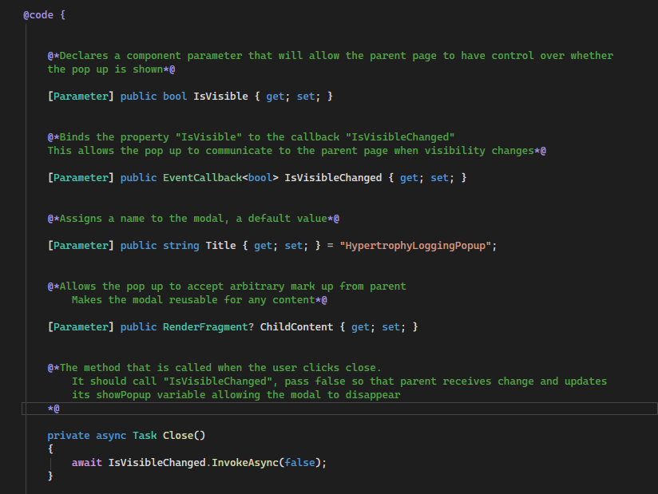

Here I have created methods and explained their functions in comments. Essentially these are needed to control the communication between the hypertrophy page and the pop up.

The code about to be shown is also inside the hypertrophy pop up page. I will explain each line with the comment on the line.

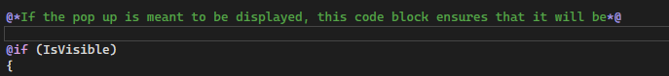

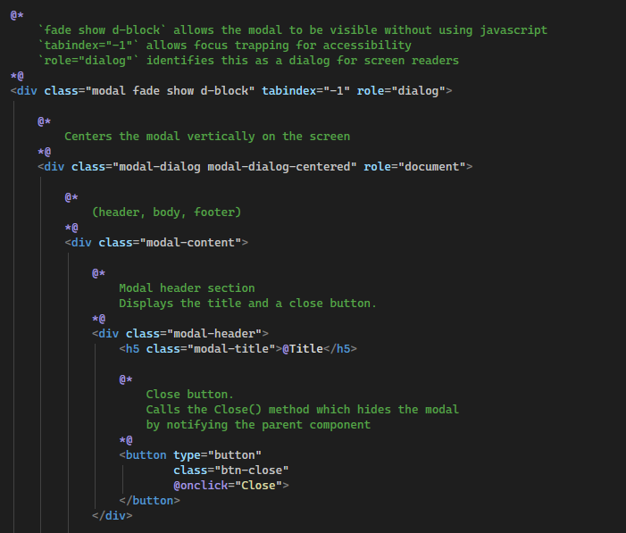

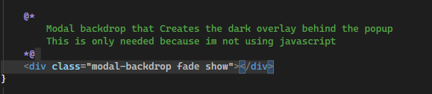

Now on the hypertrophy page:

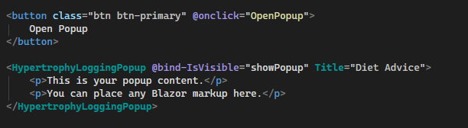

I added a button that, when clicked, will open the pop up by calling the OpenPopup method which I will explain below. The second section was tricky, I couldn’t find a html element that would display the pop up so I had to use the razor component of the pop up page and use that as the element. I will edit this with the right information later.

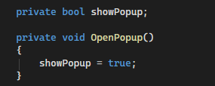

The Boolean variable showPopup will be set to true when the open pop up method is called. This allows the modal component to render.

Before clicking button:

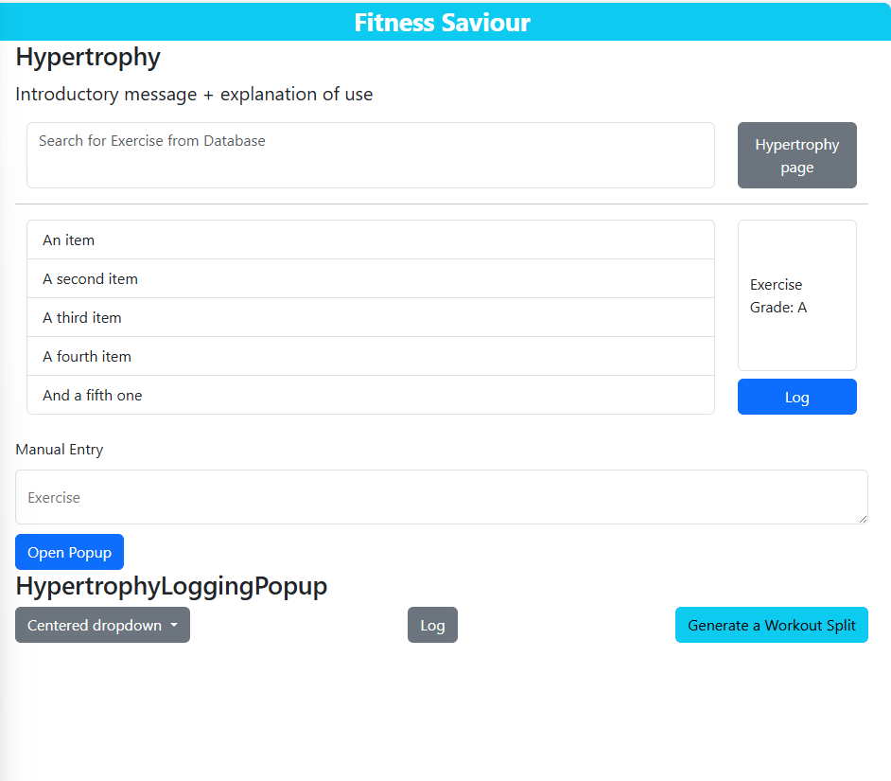

After:

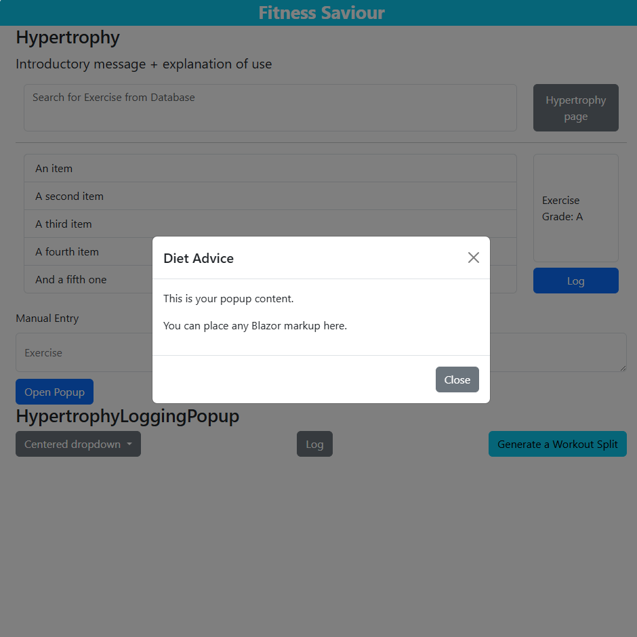

Background dims nicely. Pop up size is too small. I need to remove the pop up button and add this functionality into the existing log buttons.

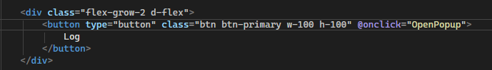

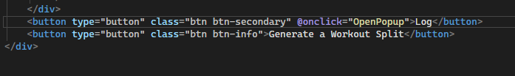

Adding the onclick command to both buttons. Removed the open popup button. Removed the heading on the hypertrophy pop up page as it was out of place. Now log buttons have intended functionality, and heading has been removed.

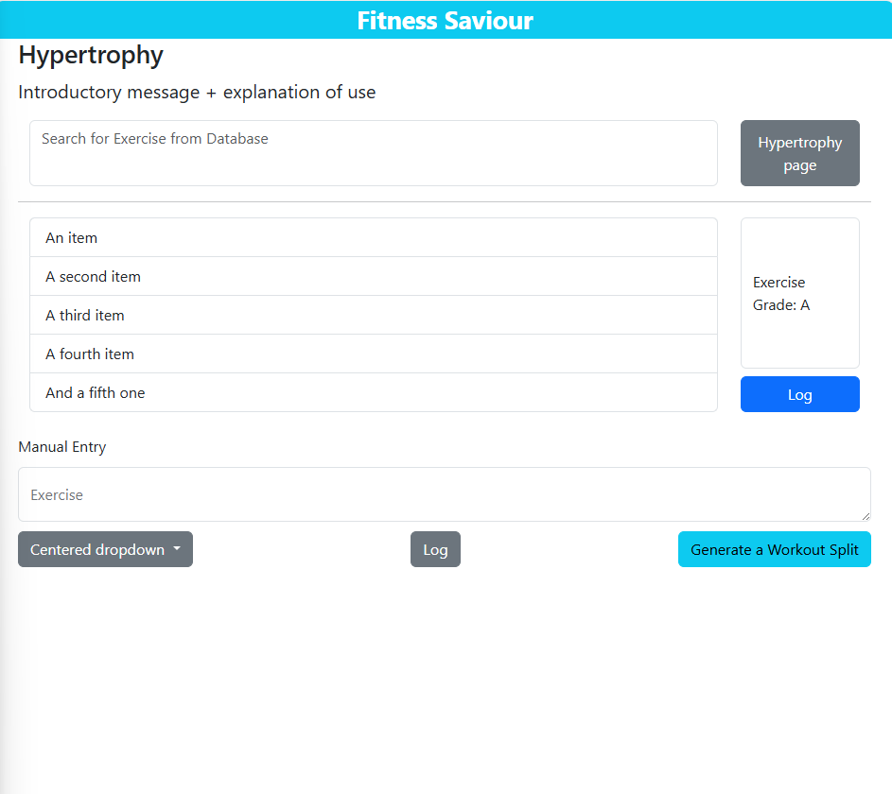

Heading removed.

Now I will work on making the pop up look the way it needs to.

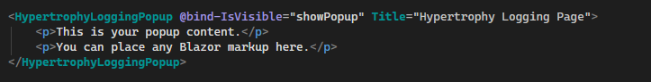

Changed the title. I will be making edits to the pop up here rather than the pop up page as this will allow for reusability of the pop up component, and any changes I make here will be part of the child content variable I created.

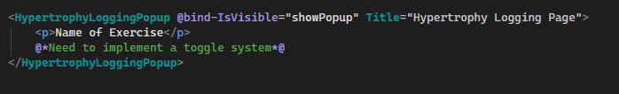

For the toggle system, I found 2 different versions of implementation on the bootstrap library that looked very similar, so I implemented both.

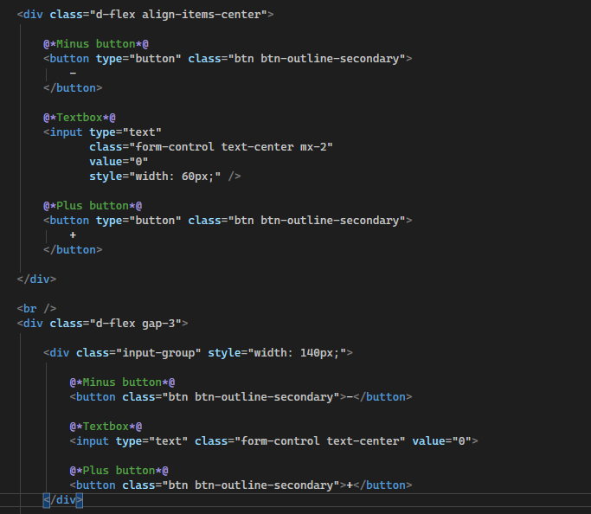

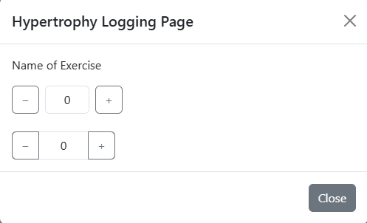

Second one looks better as there isn’t space between the toggles and the central accumulator. For this reason I removed the code for the first toggle.

Now I want a description of the toggle on the left side and the toggle on the right hand side, and have a combination of these that go down the page.

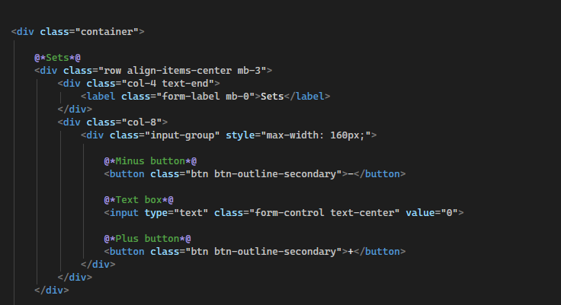

Inside a div of the container class, I set up a flex box with a label element that gives detail on what the toggle is for. I repeated this for 4 more toggles.

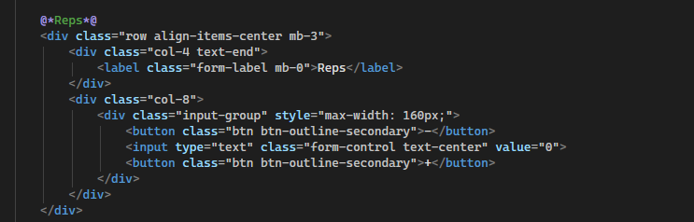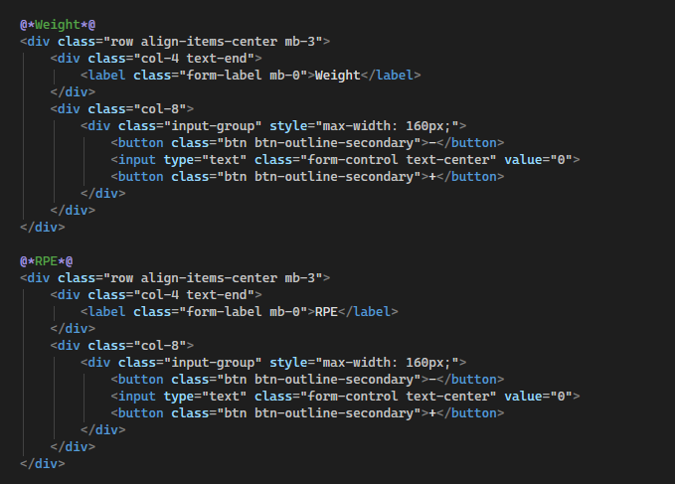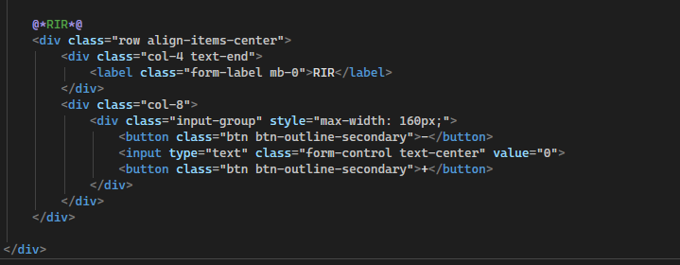

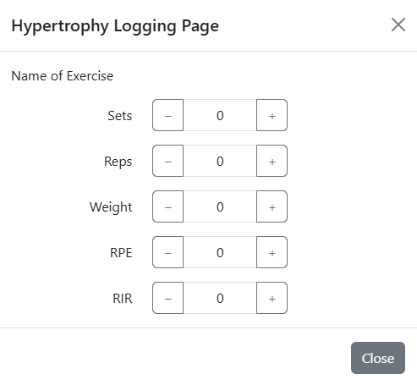

This is what the pop up now looked like. The issue is, the toggles aren’t incrementing the value that is inside the textbox.

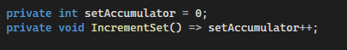

Here I have used an expression body method that increments a variable called setAccumulator, that stores the number of sets the user has completed.

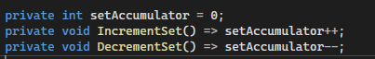

Added another method that decrements the set.

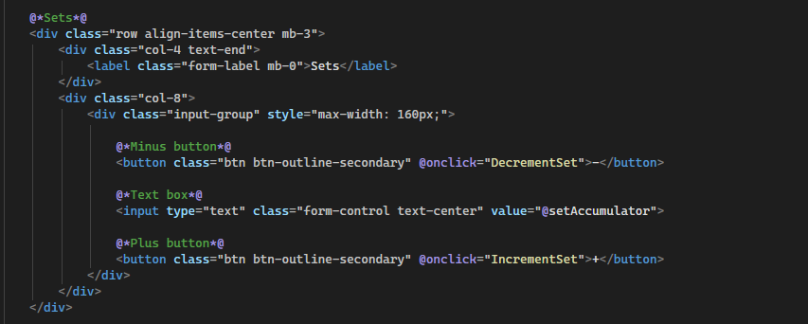

Now I modified the code for the sets toggle. When the user clicks the plus button, the increment set method is called and increases the value inside the text box by 1. Clicking the minus button will do the opposite.

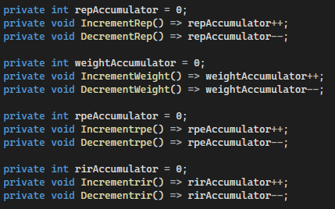

Repeated this same logic for 4 other variables corresponding to the other toggles. I then added the button logic to each one like I did with the sets.

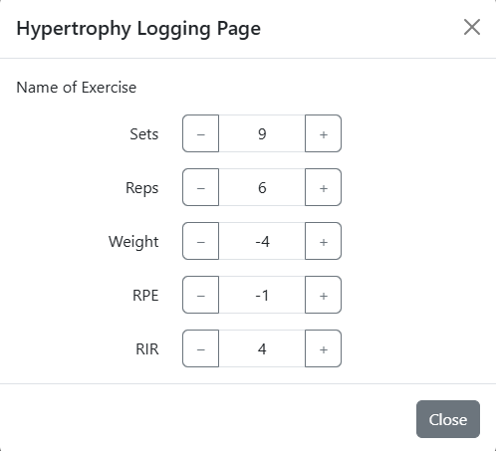

Issue is that negative numbers can be displayed.



I made the setAccumulator variable an unsigned int instead of an int to see if that would solve the issue.

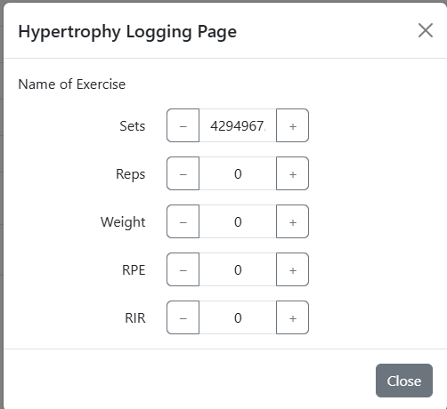

Clicking the minus made it loop to its maximum value. I need to implement some validation rules at some point.

The last thing I want to do for now is add 2 more buttons, one to log the exercise and the other to direct the user to the graphs page.

I want these aligned with the close button so will implement a flexbox. The issue is, the close button is not part of the hypertrophy page, but rather the generic layout of the modal dialog that I created. I will have to instead align the 2 items in a row with the close button under.

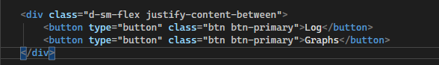

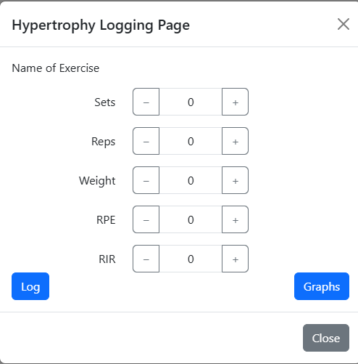

How it looks after the changes.

Attempt to sort out problems with negative number values:

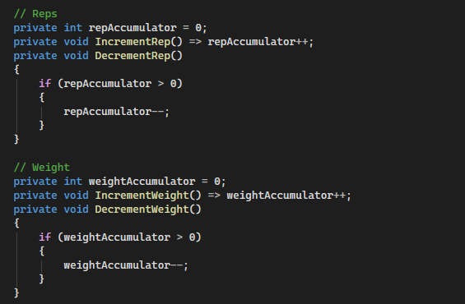

For the decrement methods, I passed in an if statement that means it will only decrement if the variable is greater than 0, preventing negative numbers.

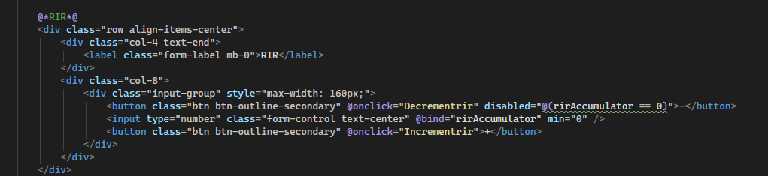

I added a disabled property that doesn’t allow the user to click the minus toggle if the variable is equal to 0. This will show them that it is not possible.

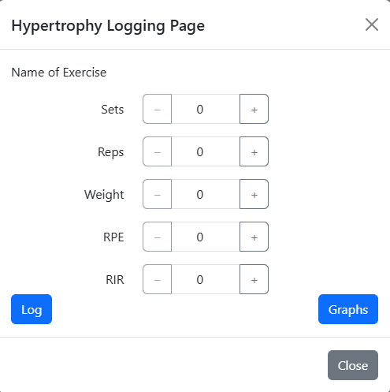

Now the toggle button is faded when the number is 0 indicating the button has been disabled.

Now I need to change the variables to what they should be. I changed every variable to a byte except weight, which I changed to a float. For RPE and RIR they can only take values between 1 and 10, so I will add some new validation rules here.

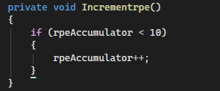

Changed the method for incrementation on both the rpe and rir methods, Now they will only increment if the variable is below 10.



Added the disabled element to ensure the button will look disabled when the number is 10.

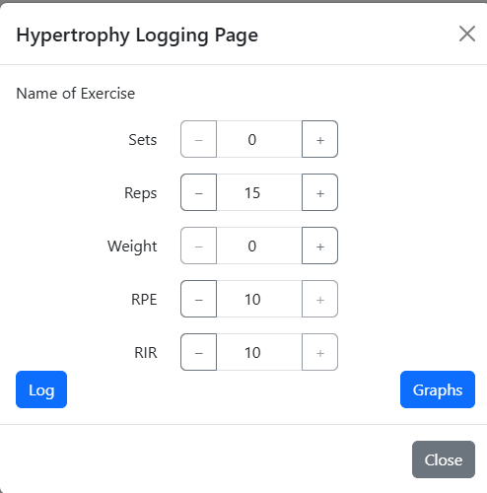

Now they both look disabled when it is at 10. Good enough for now, will push onto github.

Now I will start coding the UI personalisation page.

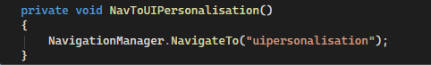

Added this method on the home page that allows navigation to the ui page.

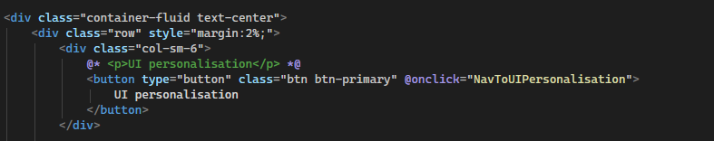

Invoke the method when the ui personalisation button is clicked.

Navigation works.

UI personalisation page:

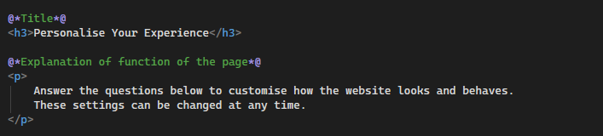

Start of the page

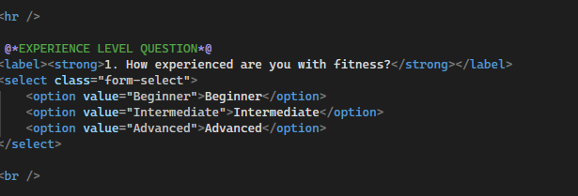

The first question asking the user about their experience level which they will select from a drop down menu. Strong element used to make text bold.

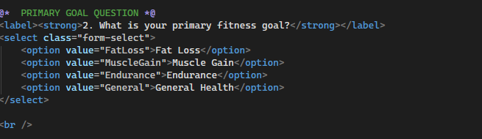

Same concept for next question. No external CSS styling for now as it appears okay.

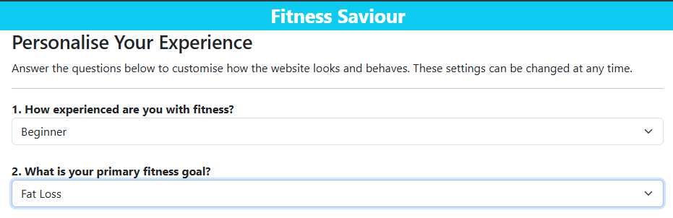

What it looks like so far.

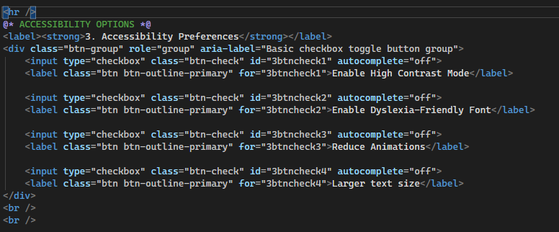

Added horizontal division to separate the next questions as they are styled with css classes from Bootstrap. Here the next 3 questions follow the same concept. A label contains the question and the user can select one or more of the checkboxes which will go blue when selected. The ID and for attributes contain a number at the start which corresponds to the question number, btncheck, and then a number corresponding to the order it appears on the screen.

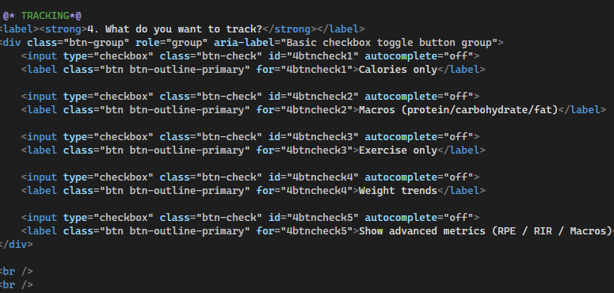

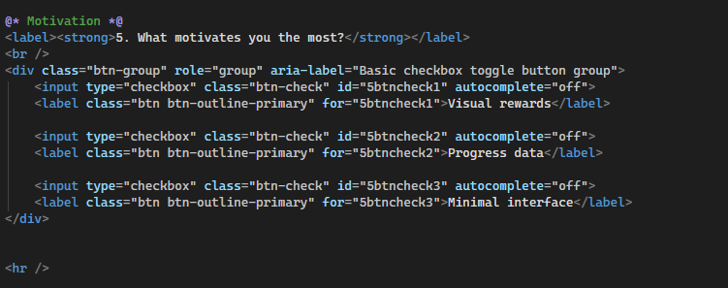

What the page looks like now:

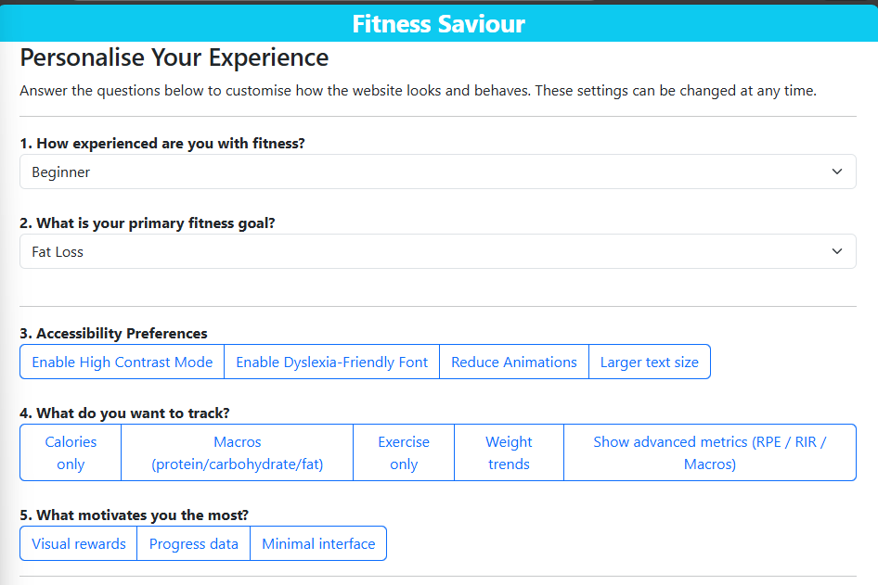

Now I will add a button to apply the settings

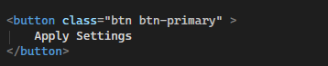

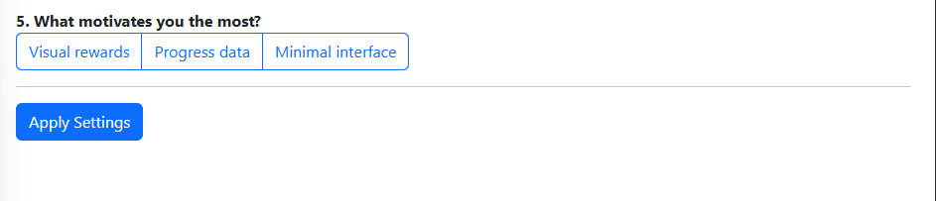

When the user clicks the button a message must be displayed indicating that the settings have been applied.

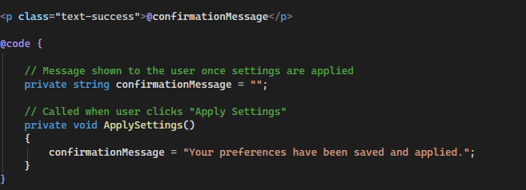

The code creates a string variable and attaches it to a paragraph that will be displayed under the button. When the method apply settings Is called, the confirmation message will be displayed on the screen.

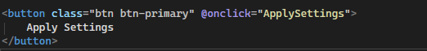

Call the method when the button is clicked.



Message is displayed but too close to button. Will add spacing.

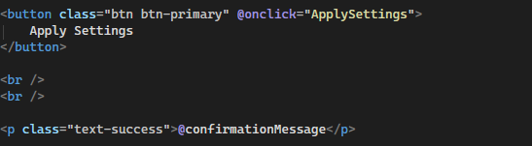



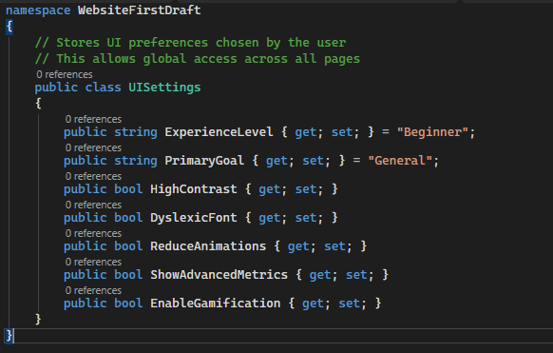

Here I have created a class and given it attributes to store user preferences in a single structure. This will make the system easier to update and maintain.

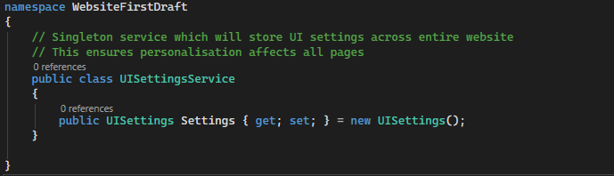



Added the service to the program.cs file. Using a singleton prevents duplicates and ensures consistency across all pages.

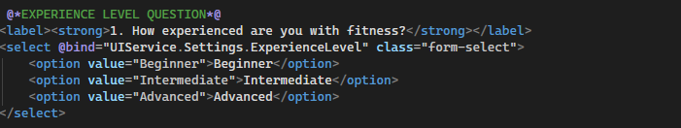

I now bind every attribute from the UI service class onto the associated form. Here I binded the experience level attribute to the correct question.

I will do the same for the other attributes.

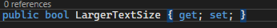

Forgot to add this attribute

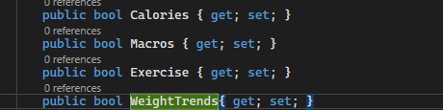

And these

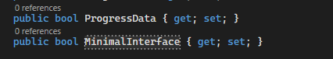

When I try to run the code, I get an exception:

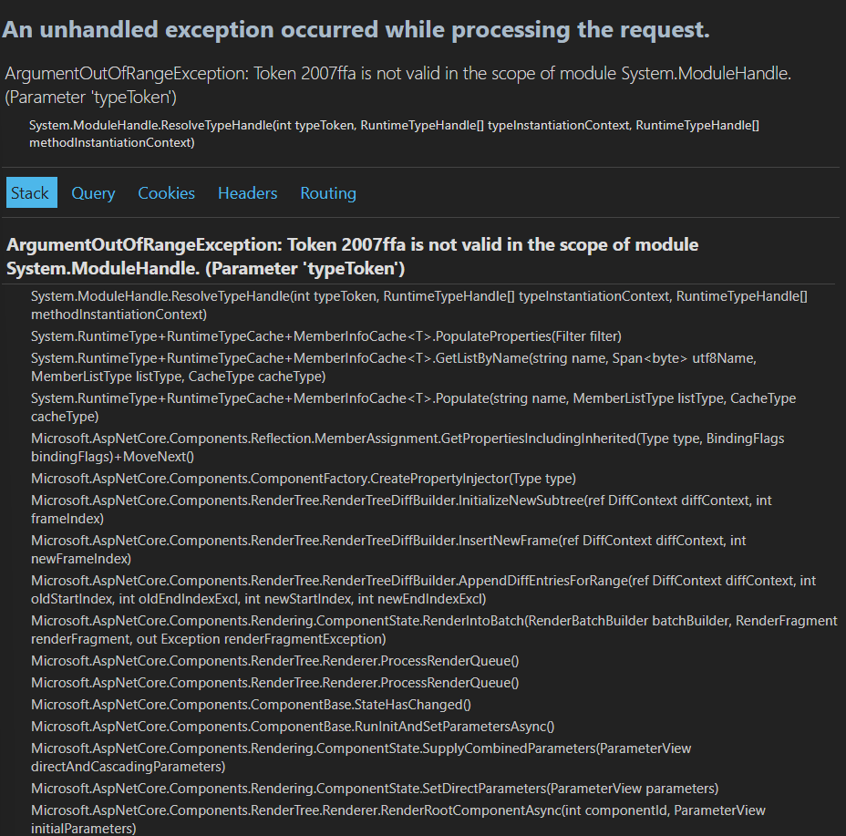

The issue here was my page name was “uipersonalisation” whereas the razor component was called “UiPersonalisation”. Blazor is case-sensitive. I changed the name on the top of my ui personalisaition page, rebuilt and ran and the page appears.

Advanced metrics on the hypertrophy page should only be displayed if the user has selected on the UI page that they want to see them.

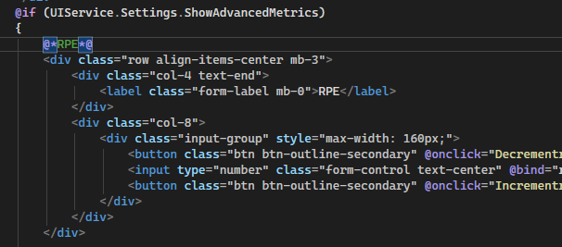

Here I have added an if statement around the code block that shows these metrics.

Before selecting Advanced metrics on ui page:

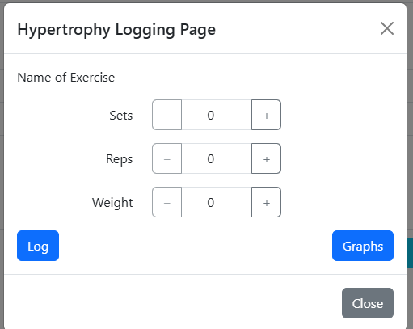

After:

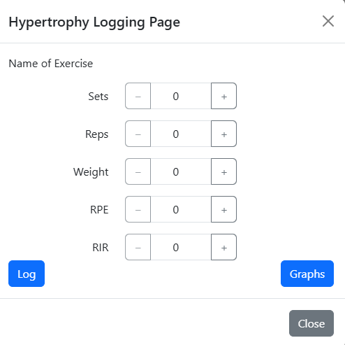

Success.

Having looked at the hypertrophy page I found this button that I forgot to name.



I named it.

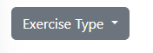

Now I need to assign every attribute from the ui settings class a job. Lets begin

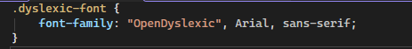

Created a custom.css file and created a class called dyslexic font. I have assigned it the font called opendyslexic with fallback options if the browser is not compatible with it.



I then added a class to the body of the website (located on the app.razor page) This will apply the new font if the user has selected it on the questionnaire.

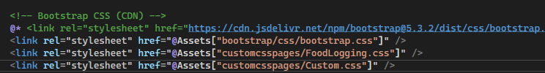

Lastly, I need to add this stylesheet on the app.razor page.

Before selecting dyslexia-friendly font:

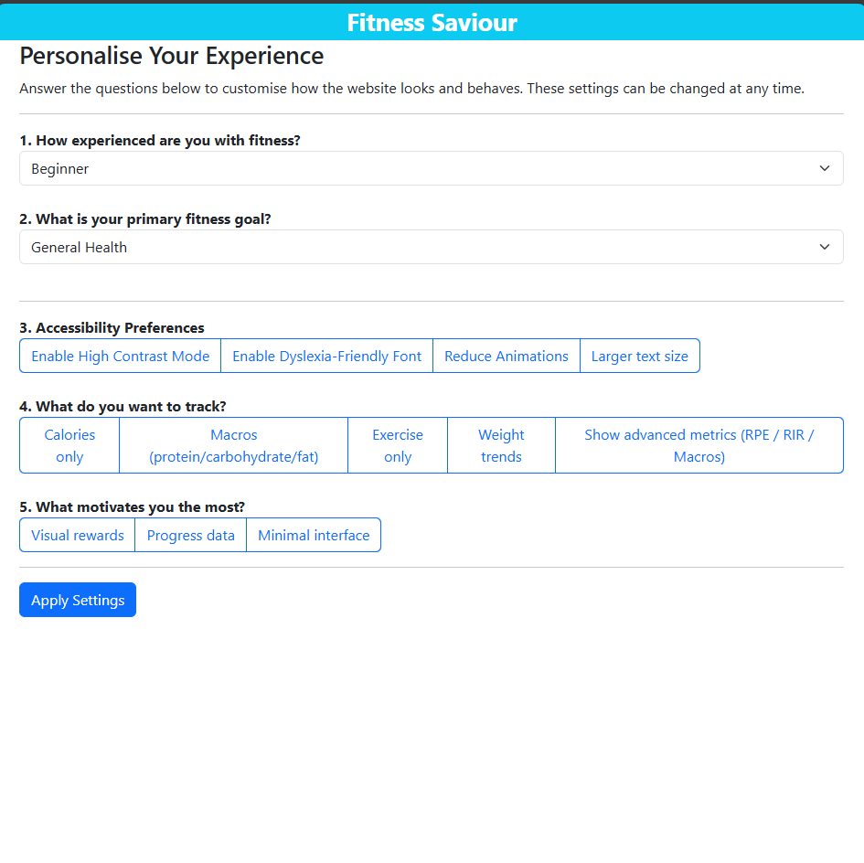

After: 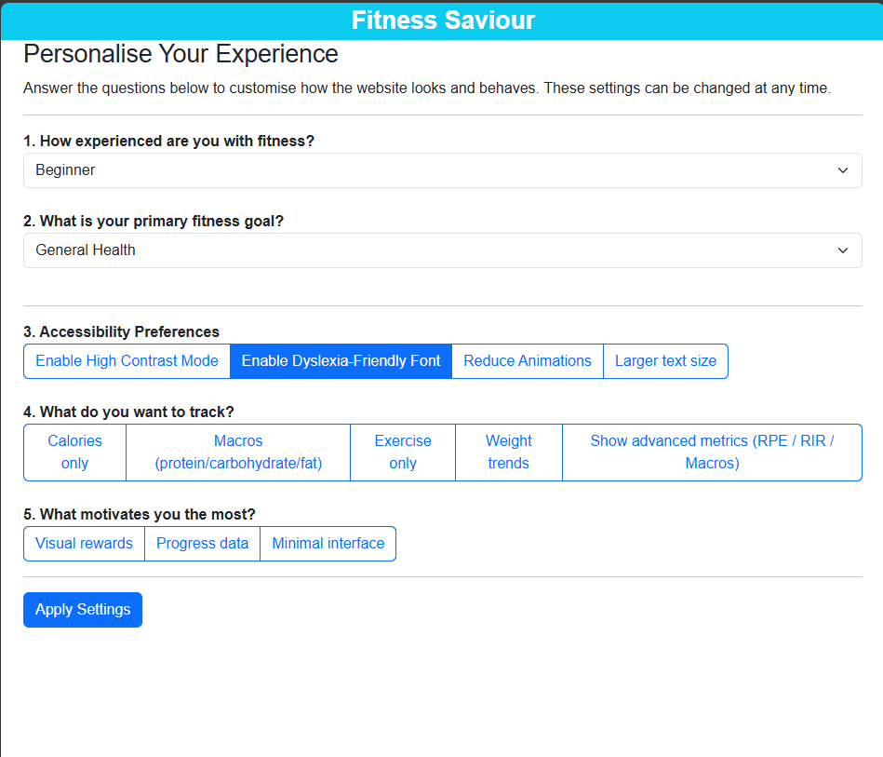

It worked.

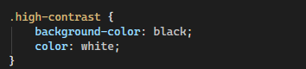

Added high contrast class to css page, with a black background and white color of text.

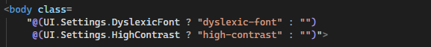

Added the same coding logic to the body: if the user selects the high contrast option on the questionnaire, the css will be applied on refresh.

Before:

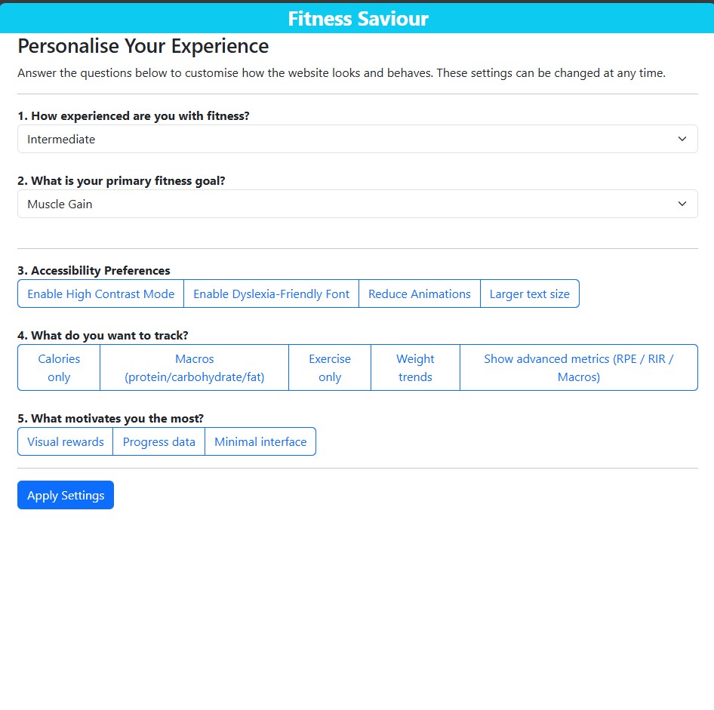

After:

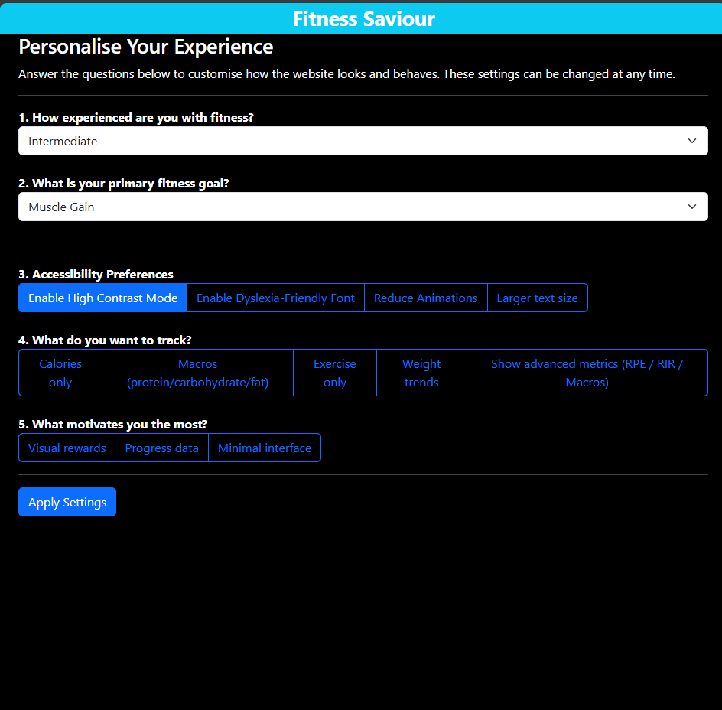

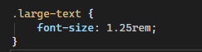

Added large text class, 1.25x larger than normal font

Added this to the body the same way I did to the others.

Before:

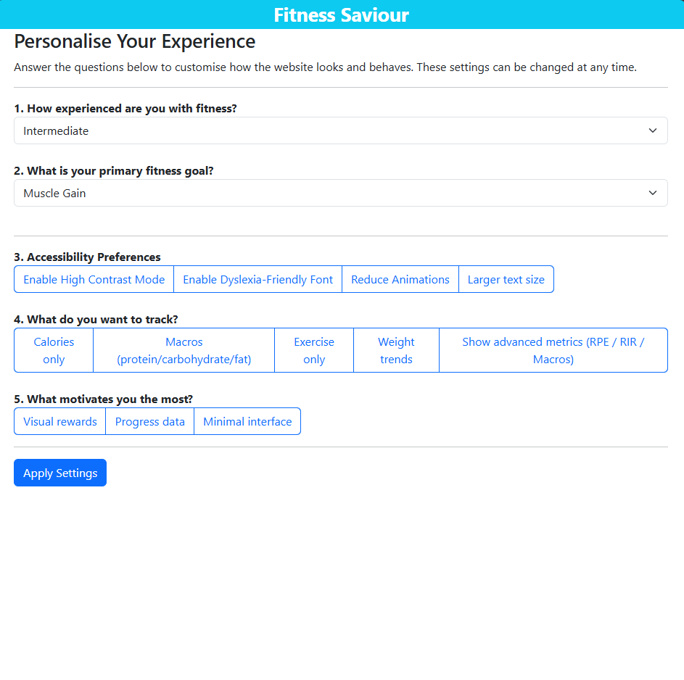

After:

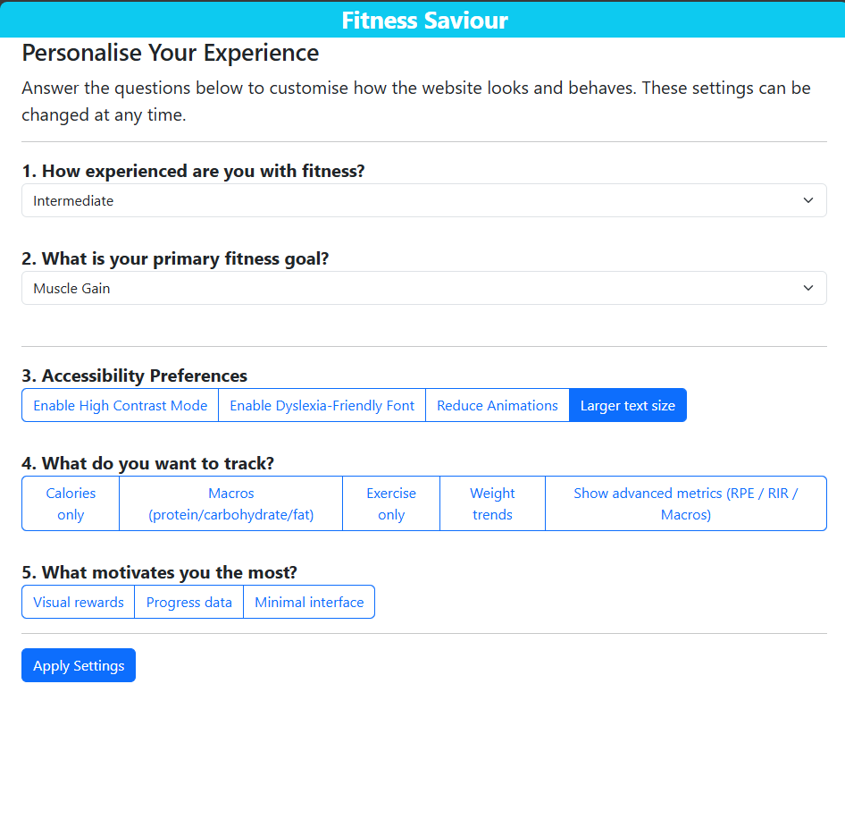

Now I will modify the homepage to actually switch between different motivational messages.

Currently it just has a template:

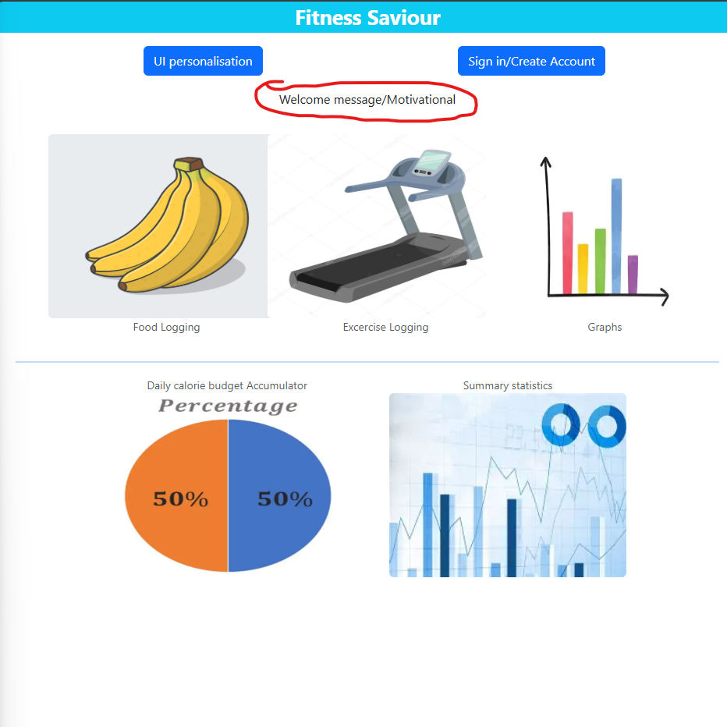

One way I can do this is by assigning the text inside a paragraph a variable and switch between different messages upon every refresh.

For this I will create 4 arrays to represent each of the primary fitness goals a user can select. Depending on which fitness goal they pick, they will be presented with random strings from that array. By default, the homepage will display strings from the general health array.

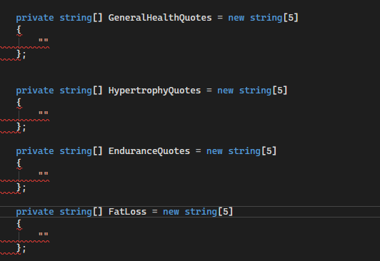

In the homepage code section I will initialise these arrays and populate them.

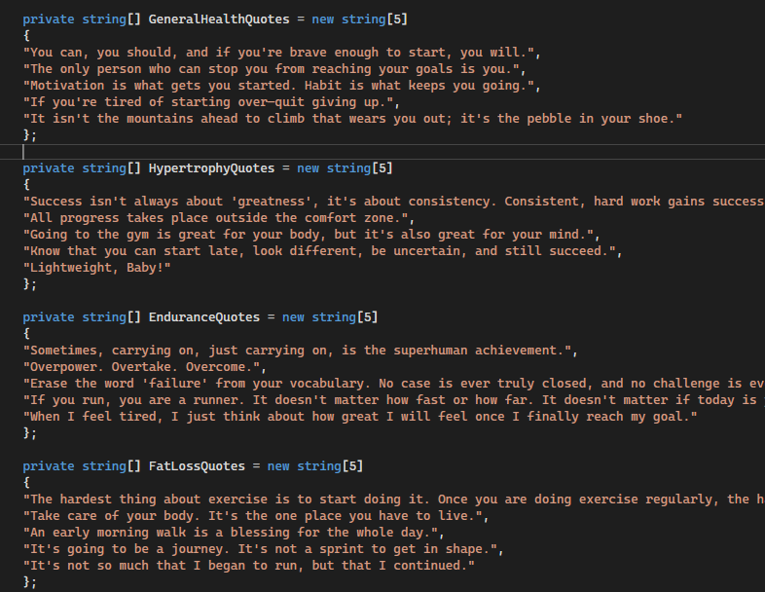

Now I need a random one of these to be called upon every refresh, and bind the ui.settings.primarygoal attribute.

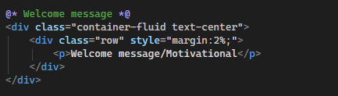

This is the code I am modifying,

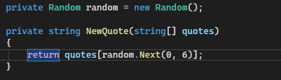

Here I have created a method that will take in one of the arrays as a parameter and return a random quote from within it using a random number as the index.

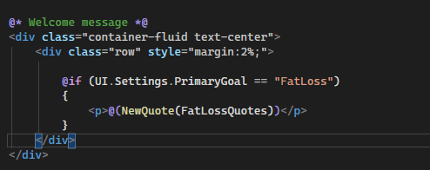

Now if the user has selected fat loss as their primary option, the paragraph will load a random quote from the fat loss array.

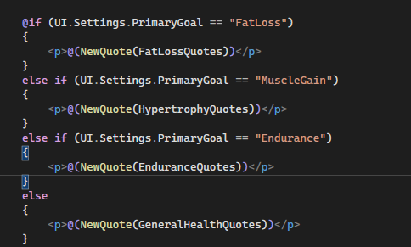

This covers all the possible outcomes.

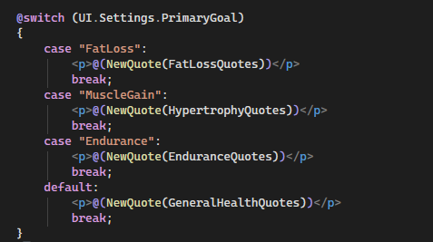

Better practice to use a switch statement.

When opening the website:

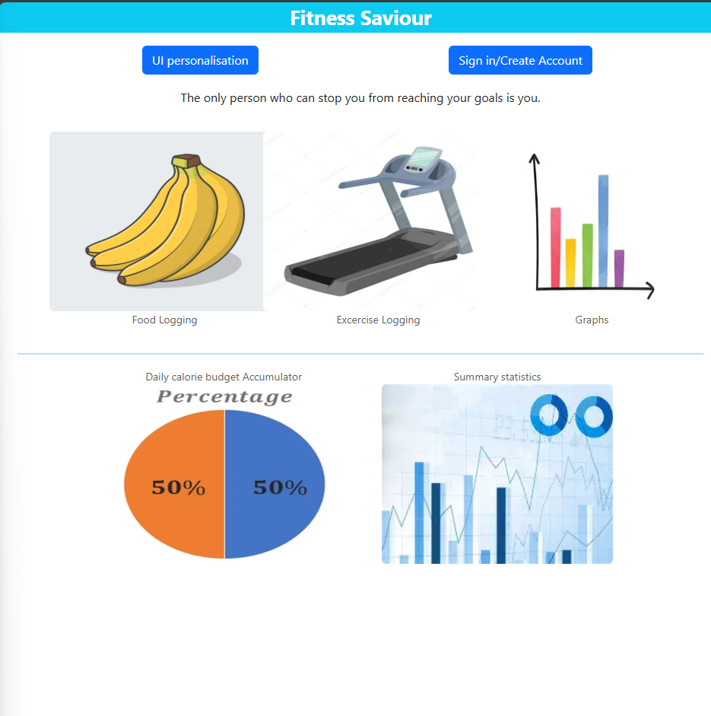

This is a quote from general health so this is a success.

When selecting fat loss:



When selecting muscle gain:



When selecting endurance:



All cases work.

Issue:

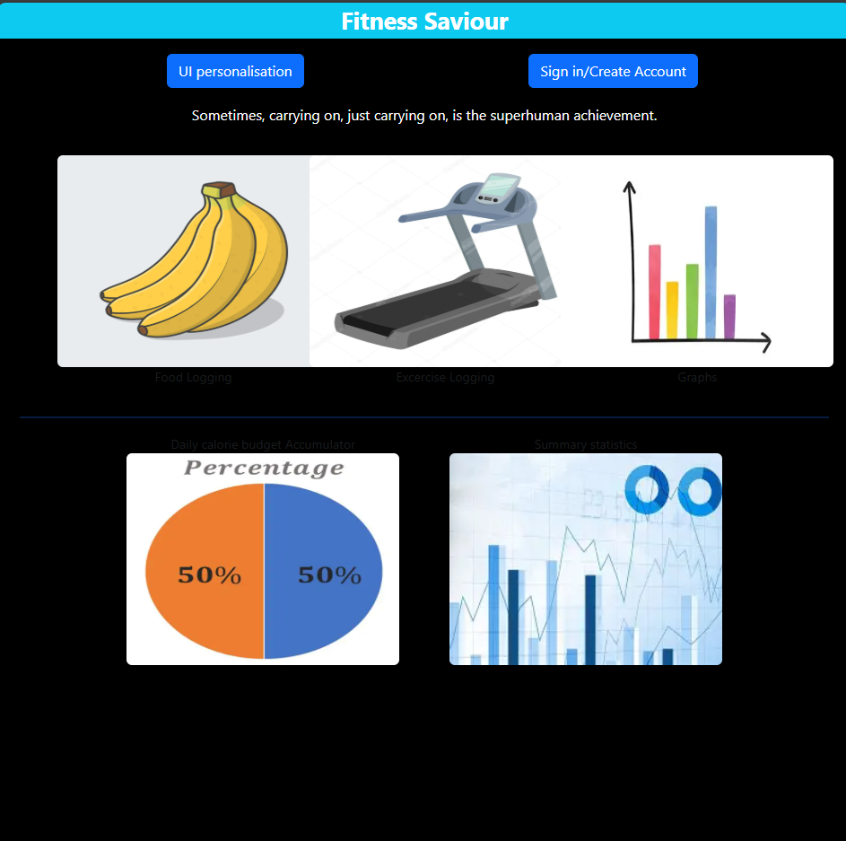

On high contrast mode text on the figcaption images are no longer visible.

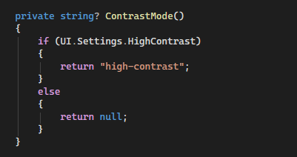

I created a method in the code on the home page. If the user has selected high contrast on the questionnaire, the method will return high-contrast, which is the name of the css class that applies the high contrast styling.



I then call this method on the figcaption element for food logging to see if it works.

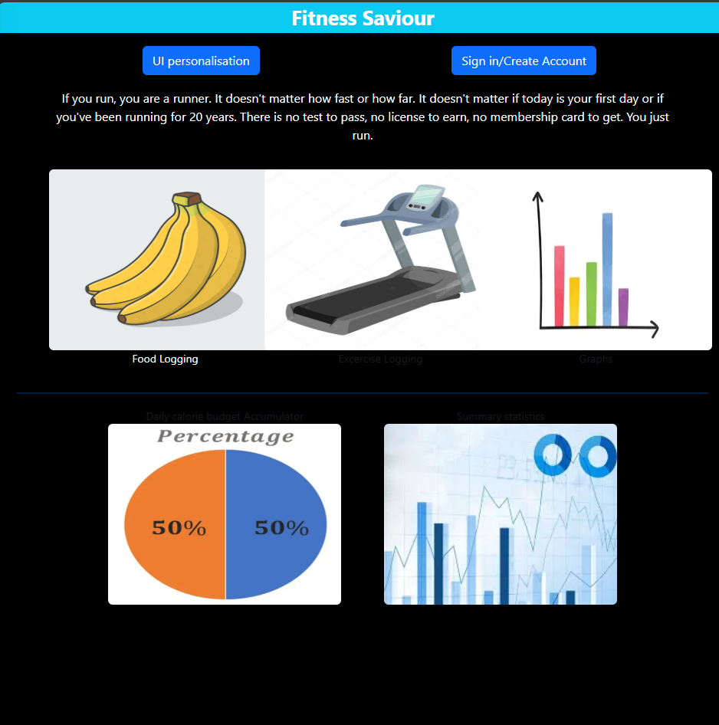

It works. I will apply the change to other images now.

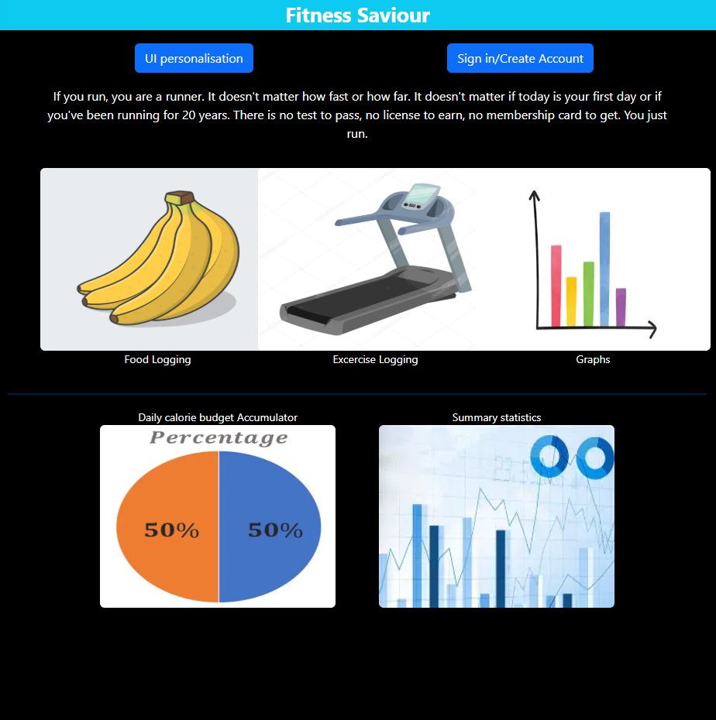

The apply settings button means u still have to refresh before the changes are applied so I need to make it so that clicking the button also refreshes the page. I have a method for this in my home page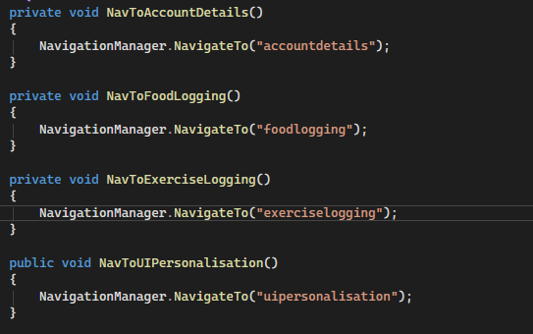

But it has limited scope.

So I will create my own method.

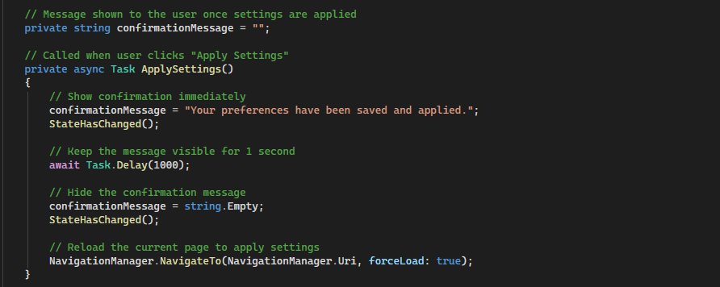

I have modified the method that is called when the apply settings button is clicked. Before it would just display a string on the screen. Now it calls a built in blazor method called StateHasChanged() which is used to re-render a component when its state has been changed (here the component is the confirmation message). An await method is called to keep the message visible to the user long enough to be read, and then the page is refreshed and the message removed (set to an empty string).

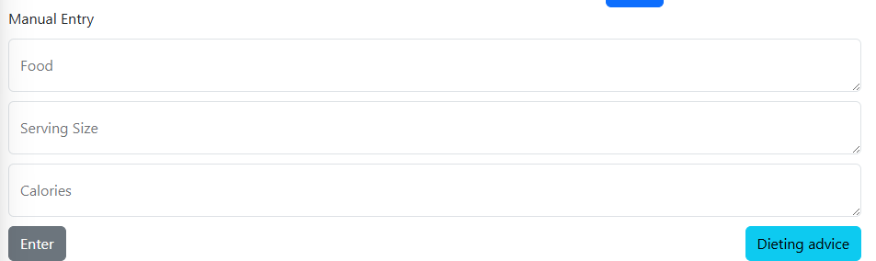

Now I will make the dieting advice page, which the user can access from the bottom right of the food logging page.

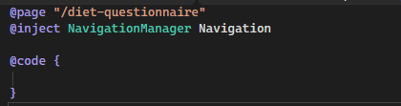

Created a new page called diet questionnaire.

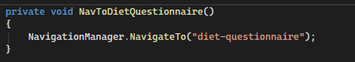

Method added onto food logging page that navigates to the diet questionnaire page.

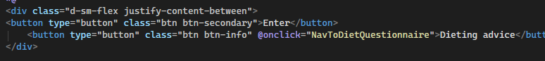

Call the method on the button.

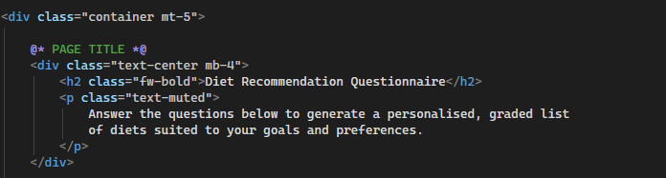

Here is the start of the diet questionnaire page. I have wrapped the entire page in a container of bootstrap class that will restrict the width of the content as I want to present the questions in a card format.



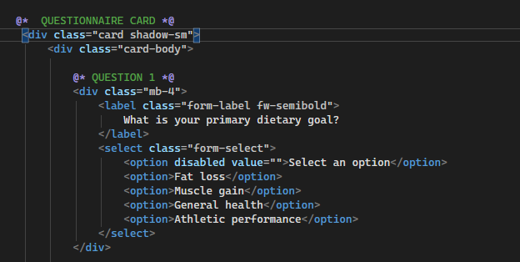

Next I created a questionnaire card that will hold all of the questions within it.

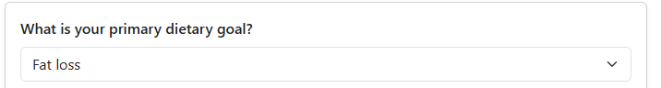

I then added the code for the rest of my questions

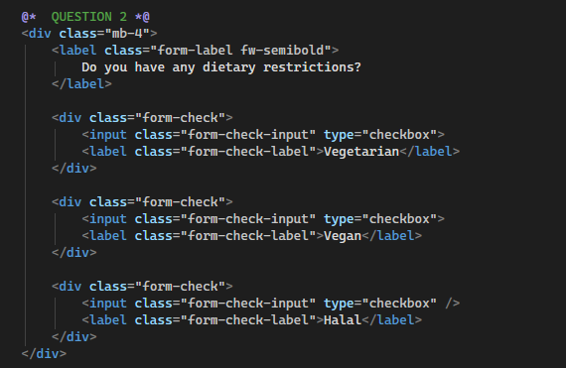

// Checkbox as you can be multiple one of these

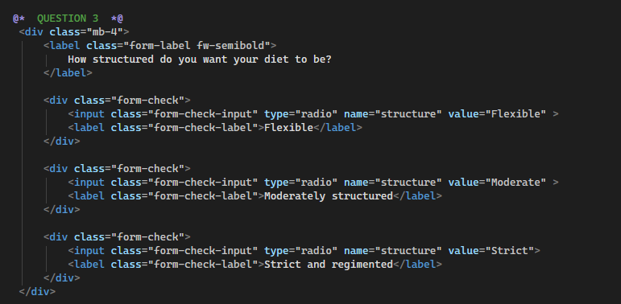

//Radio buttons as you can only be one of these.

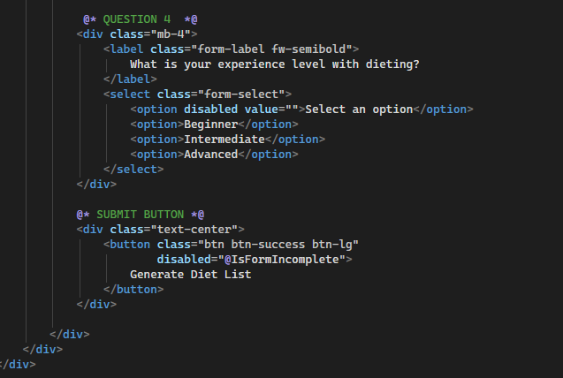

Button will appear disabled until the IsFormIncomplete is no longer true. I will explain this later.

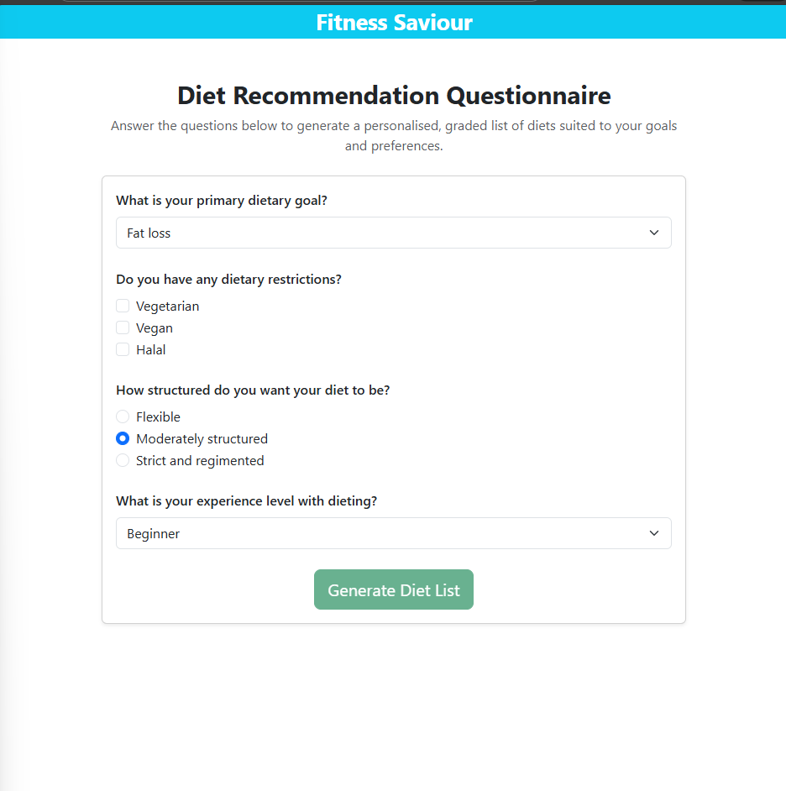

What the page looks like right now. I want the check and radio boxes to have a similar styling to the questions I had on the UI personalisation page so I will implement this.

Before:

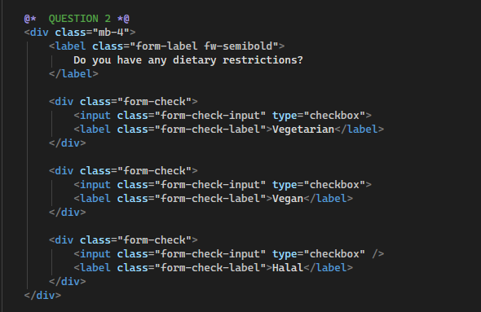

After:

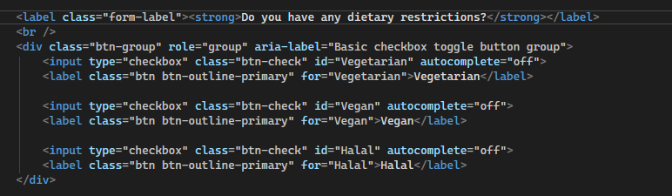

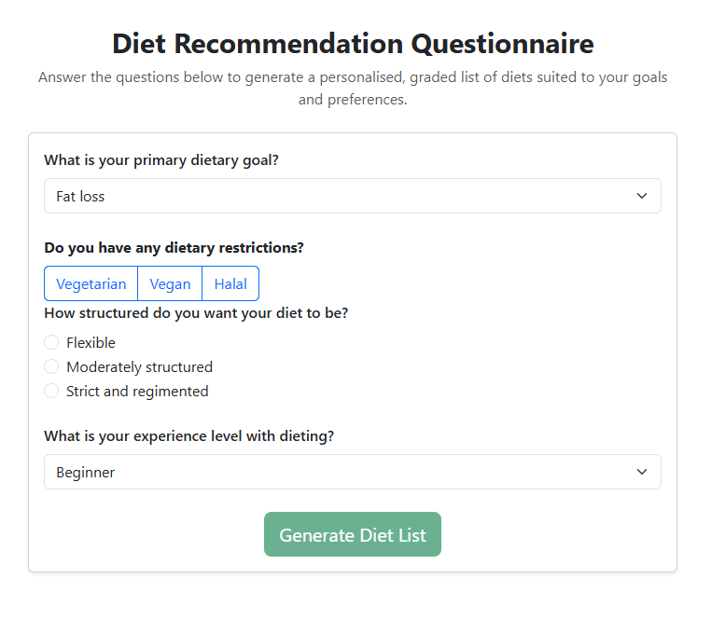

I then changed the code for the diet structure question.

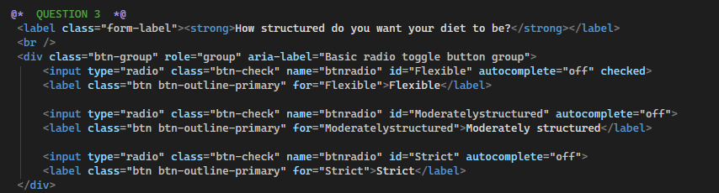

How the page looks now:

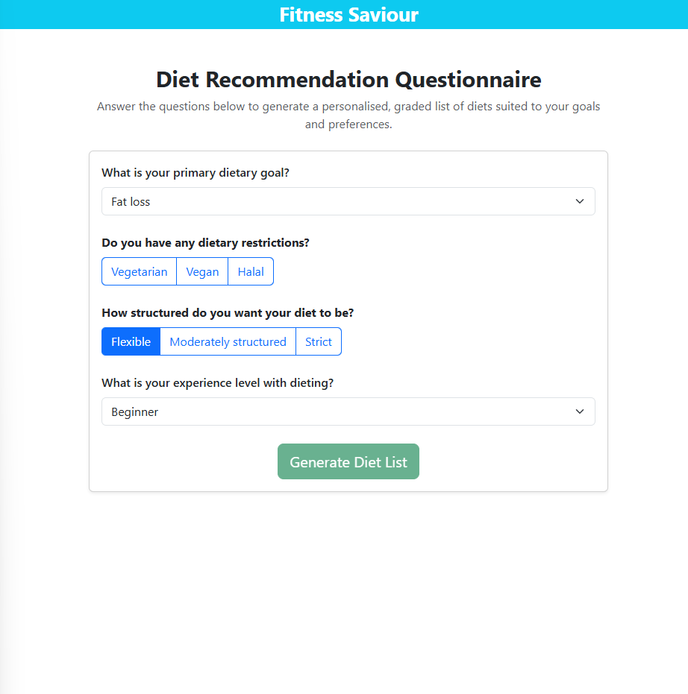

Font on the questions I modified is now bolder due to strong element,=. So I will add strong element to the other questions too.

After:

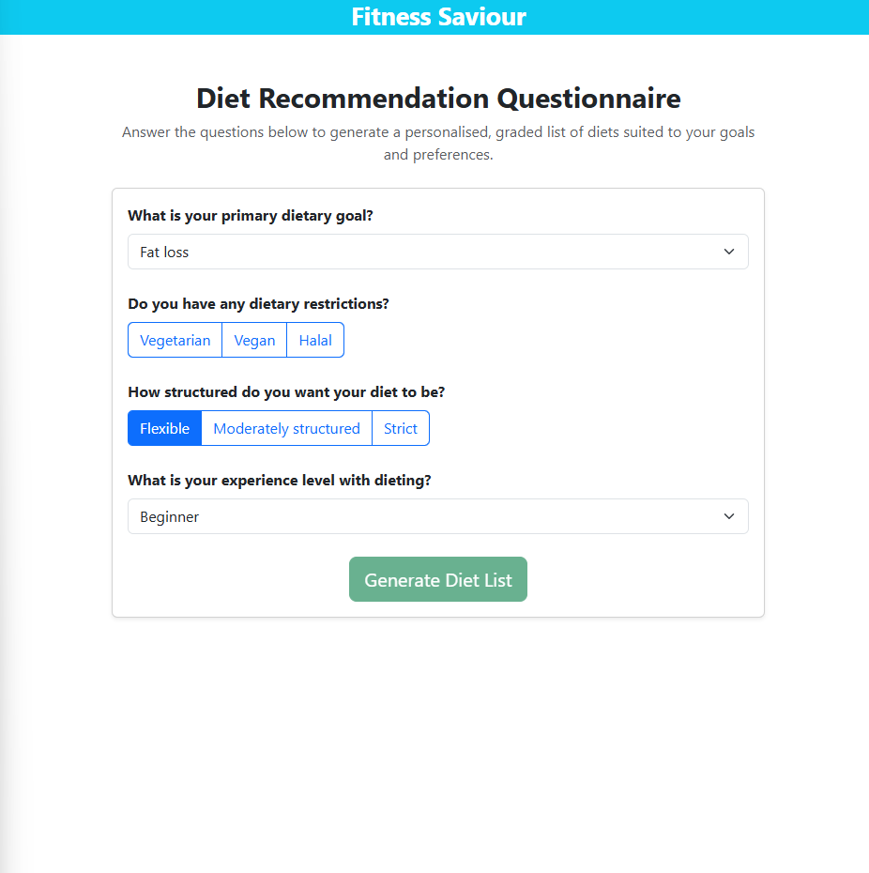

Now I will need to implement c# logic on this page.

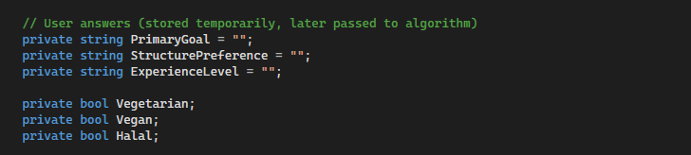

In the code section of the page I have created 3 string variables that will hold the values of the options the user selects. For the question on dietary restrictions, I have created 3 Boolean variables that will each state whether or not the user has selected a given option.

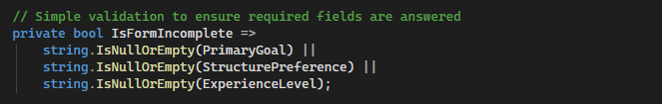

Here I have created an expression body method that will return a Boolean that will only be false when the form is complete. The way to check for this is whether the strings are empty on the 3 strings that hold the value of user input.

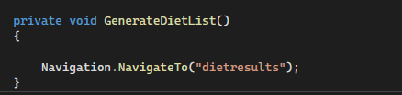

This method will be attached to the generate diet list button. For now it will simply provide navigation to the diet results page. The full implementation of this method will involve deeper logic.

I now need to bind the variables I have created with the values in the questions.

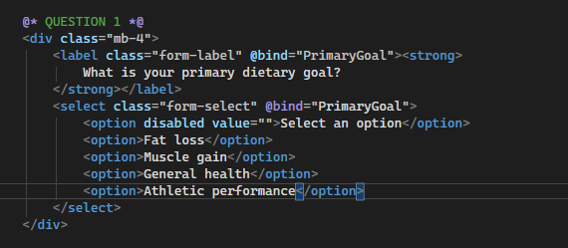

Bound the value of primary goal to question 1.

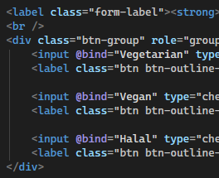

Bound the values in question 2 to their corresponding Boolean variables.

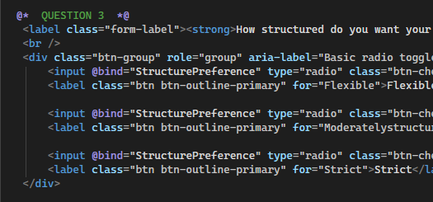

Bound the structure preference string to the question 3 radios.

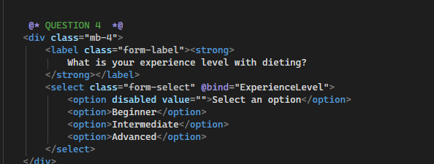

Bound experience level to the select.

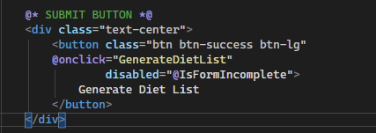

Generate diet list method will be called now when the button is clicked.

Issue:

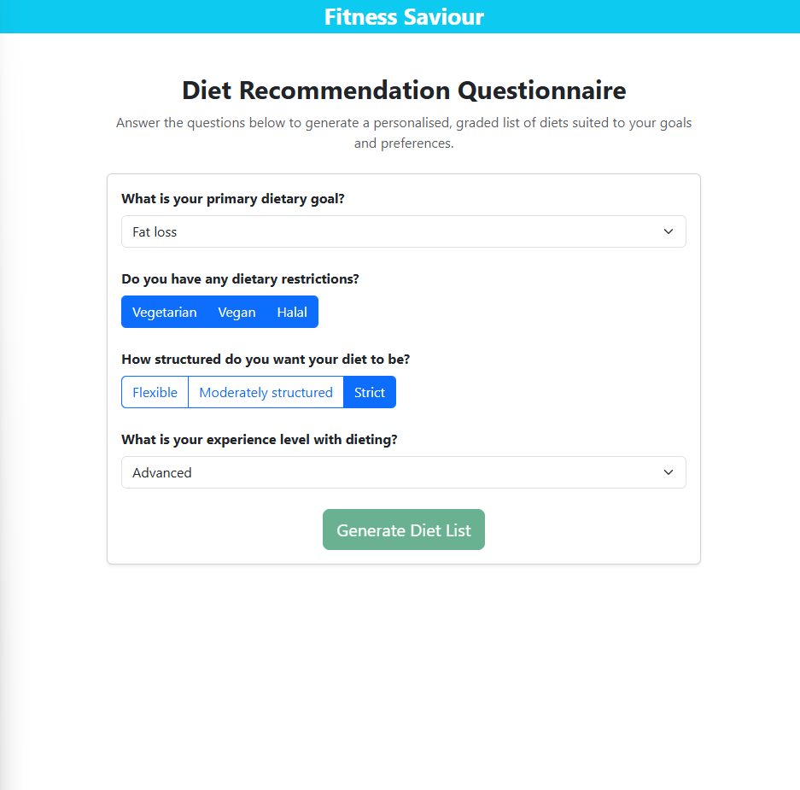

Even when the user has filled out the form, the button is still disabled.

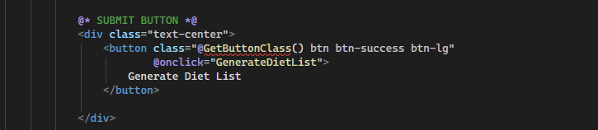

My plan is to set the class of the button as a variable itself, rather than use the disabled attribute which doesn’t seem to be working with my coding logic.

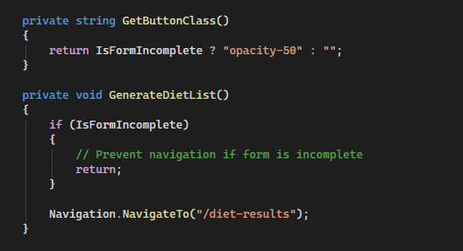

Now button will look dimmer when incomplete.

This still does not work.

So I removed the Getbuttonclass method and tried a different approach.

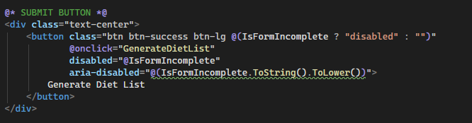

I set the class of the button to be the boolean variable, rather than the disabled attribute.

It still doesn’t work but I think I know the issue. When I hard code the string variables to contain something and refresh the page, the button becomes active. When I set a string as null and refresh the page, the button becomes disabled. The problem is I need the button to change state without a refresh.

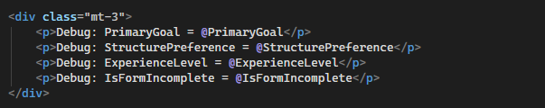

Added some code for debugging purposes, allowing me to see the values of the variables change in real time. This allowed me to pinpoint the error.

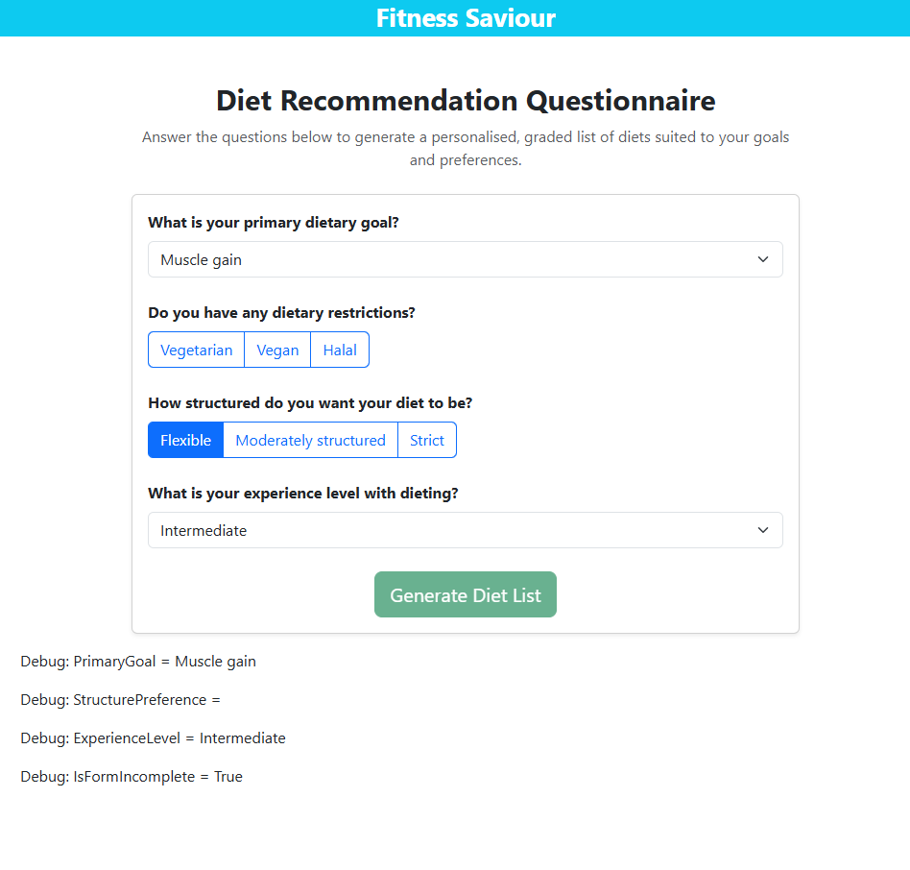

Selecting the primary goal and experience levels successfully updates the values of those variables. The issue is with the experience level , likely due to its implementation as a radio rather than a drop down.

Fixing the error:



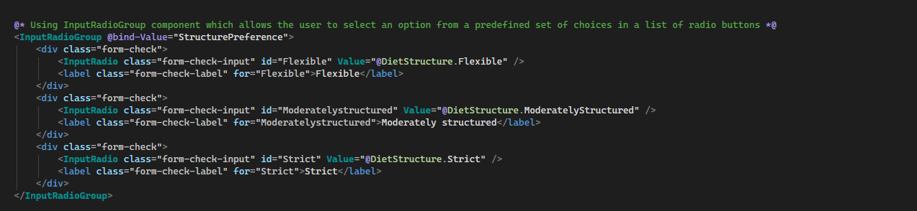

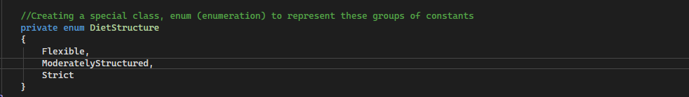

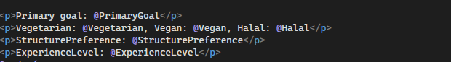

Debugging paragraphs so I can track the values of these variables in real time.

Before:

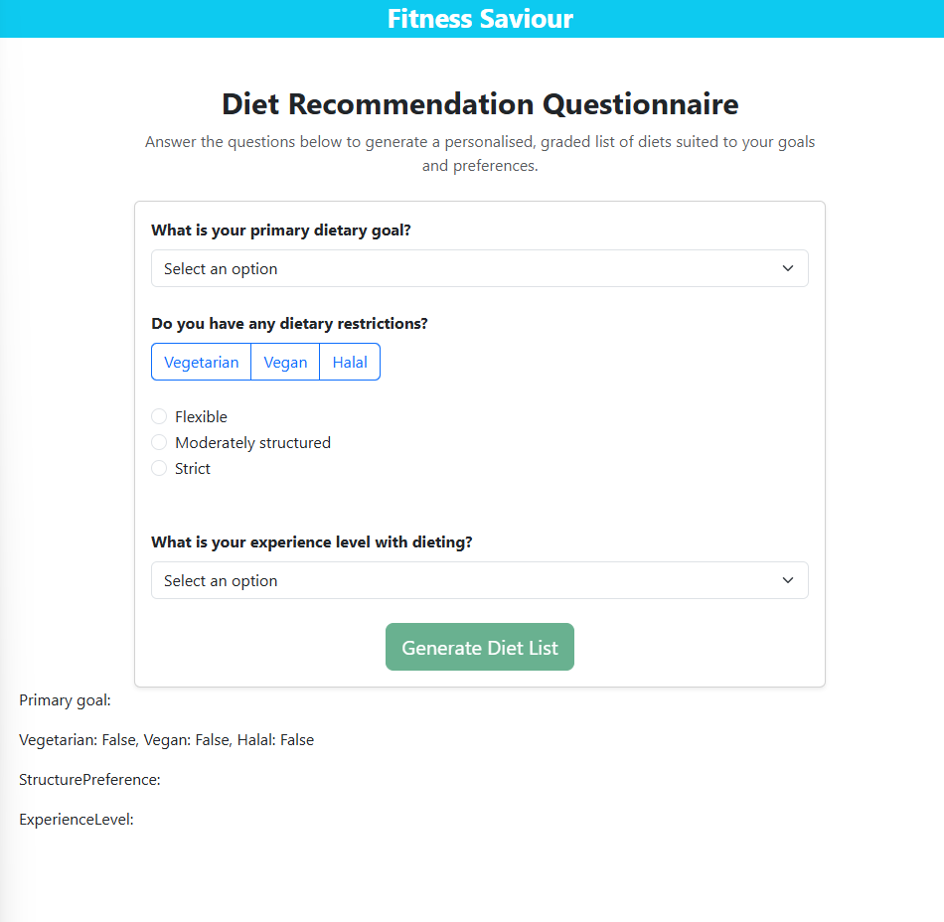

After:

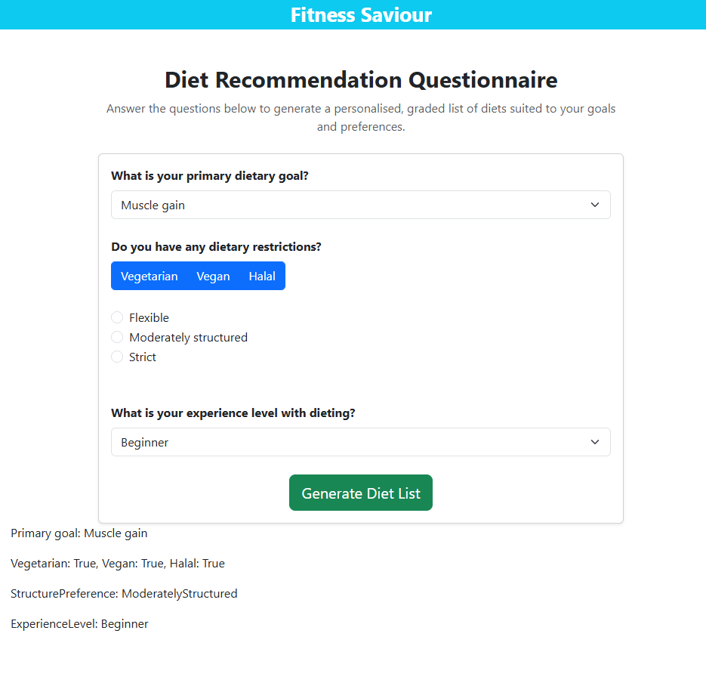

As you can see, all the variables have the ability to change values during user input meaning the binds are now successful, the button also no longer looks disabled.

Need to add label, done.

I need to add the question How many meals per day do you prefer? .



Stored here, default value is 0.

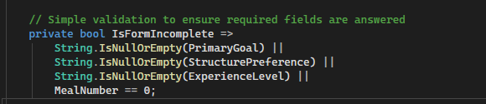

New condition

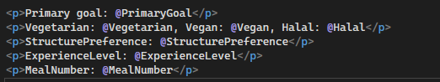

Added to debugging

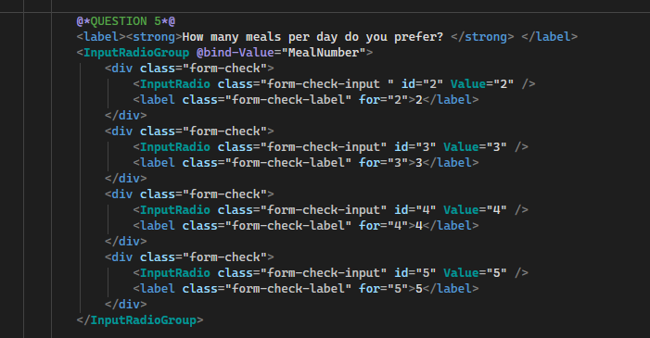

Added the question, bound all the correct values

Before:

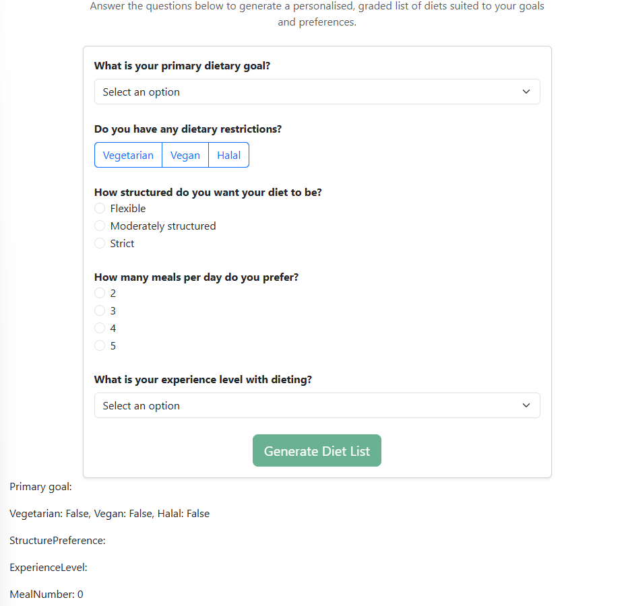

After:

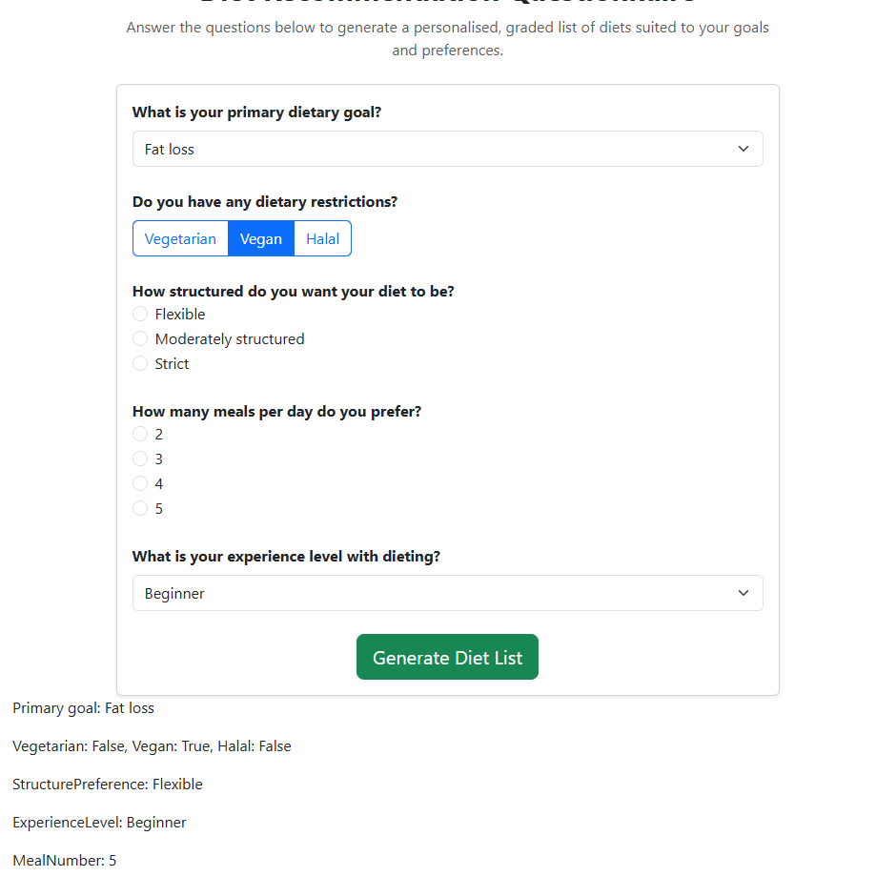

Success.

Issue with page: when i select a checkbox, it disappears after I click somewhere else on the screen. Solution:



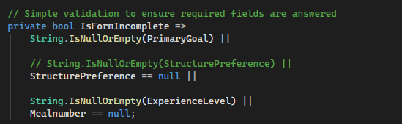

Now the check is whether its null or not.

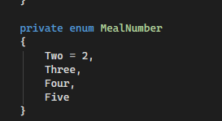

Created an enum for the mealnumber.

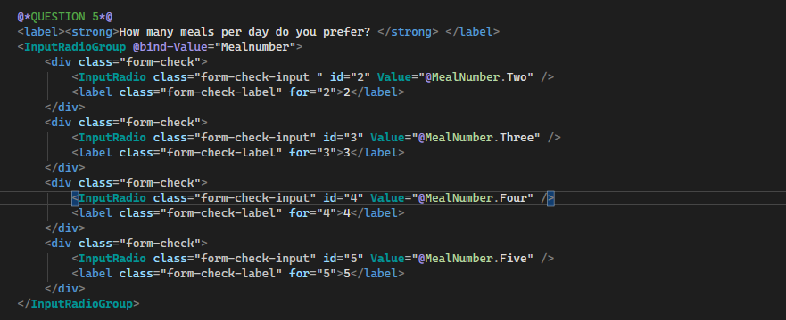

Updated the values.

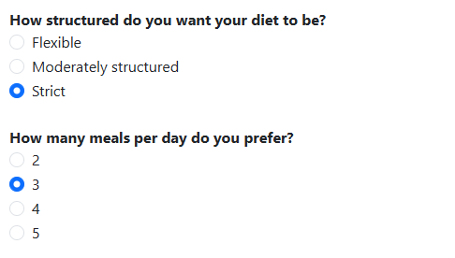

Issue resolved.

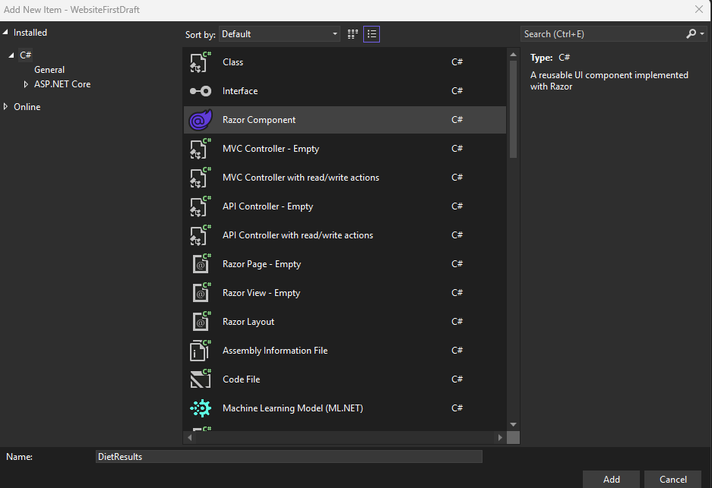

Created diet results page.

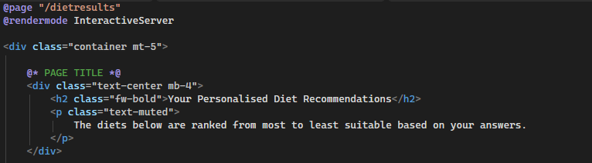

Wrapping the page in a container div with the same class as the div I used on the previous page in order to give it a consistent look.



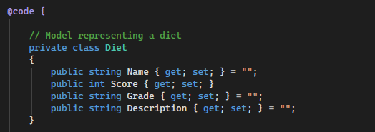

In my code section of the page, I have created a class called Diet containing attributes that would be expected of a diet. **:** Clear abstraction of real-world data.

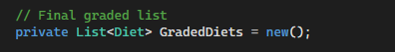

I then created a list of type Diet called GradedDiets.

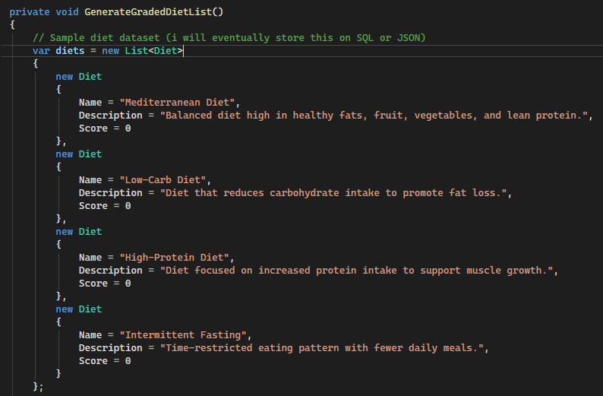

I then created a method that holds the values of the diet list. These will eventually be stored on a database rather than on the program file. Each diet is assigned the attributes of the class and a score initialised to a base of 0.

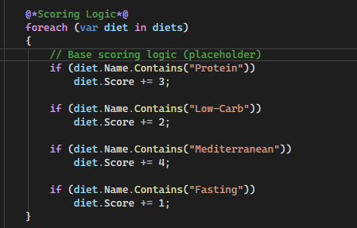

This code block will eventually contain my scoring logic, for now I have assigned it a static logic. It increments the scores of each diet if they meet a set condition.

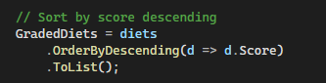

This is using LINQ to order the diets in descending order, so the best ones appear at the top.

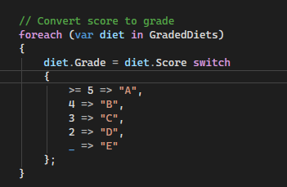

Self-explanatory.

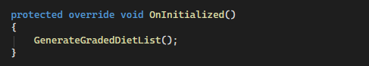

I have created method that will call the method that creates the diet list, this method is less encapsulated and can be accessed by sub-classes.

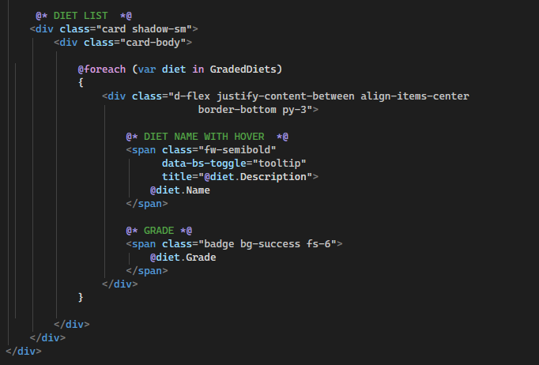

This is the rest of the code for the page. It uses a foreach loop to display every item in the diet list in descending order. Upon hovering over the name, a tooltip will appear. This usability feature ensures no screen clutter and will improve usability. It presents the Description attribute of the diet.

The last thing displayed is the grade which displays the letter associated with the Grade attribute of the diet.

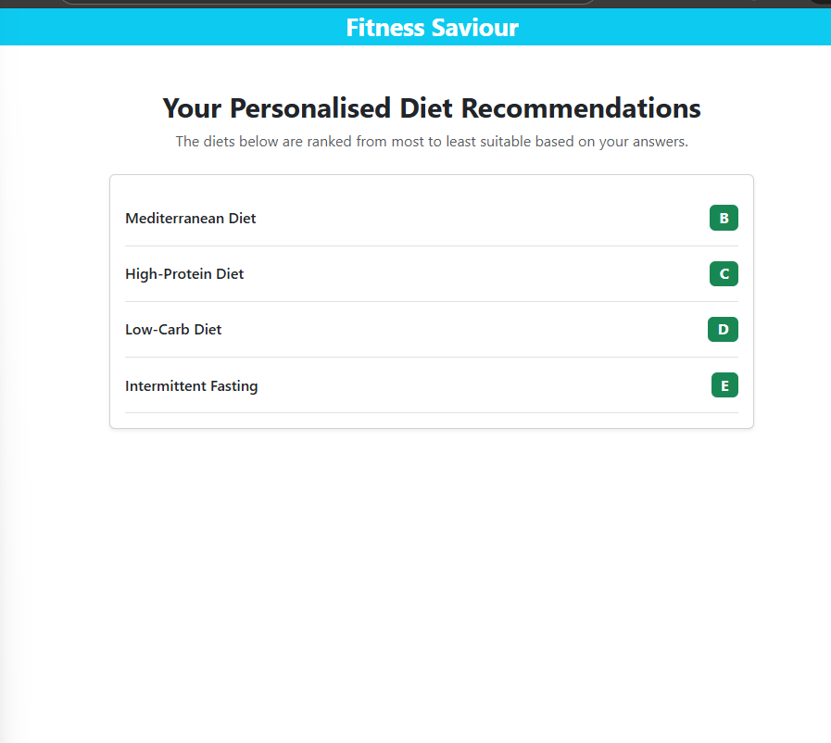

On hover:

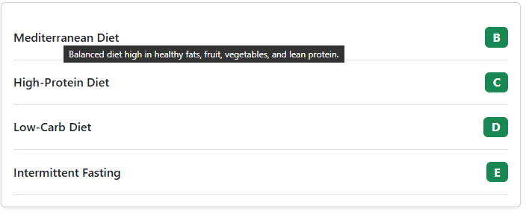

Looks nice, now need to add more diets with proper logic behind each one.

All of the variables that I created as part of the diet questionnaire form binding, they now need to be part of a class for this to work.

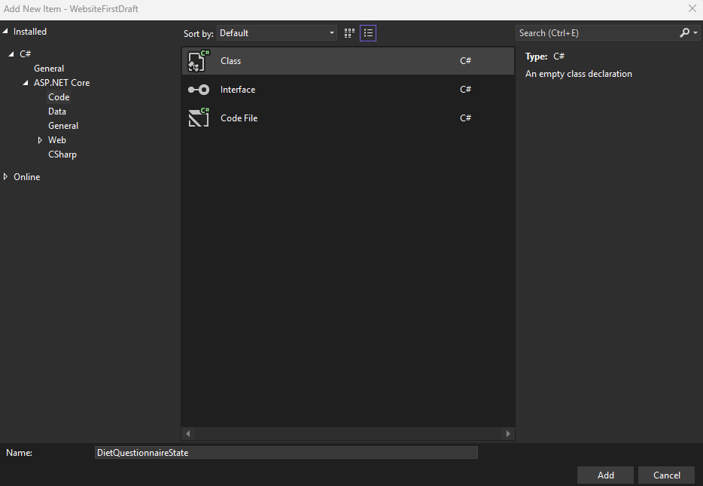

Created diet questionnaire state class.

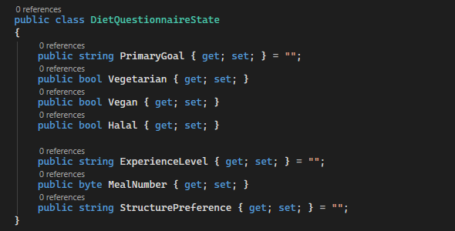

**Assigned it the attributes that correspond to the form.**

//



I registered this in my program.cs file.

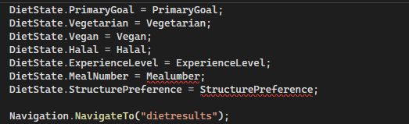

On the generatedietList method on the dietquestionnaire page, I attempted to modify it so that the results page contained real user data but it didn’t worl for meal number and structure preference due to them being enums rather than the types I specifieid in the class.

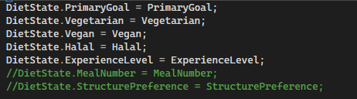

Commented them out for now.

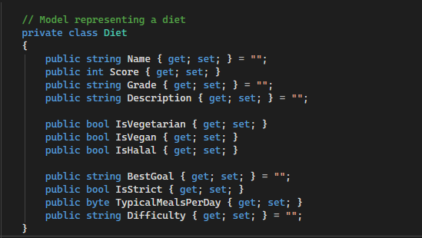

Added more attributes to the Diet class.

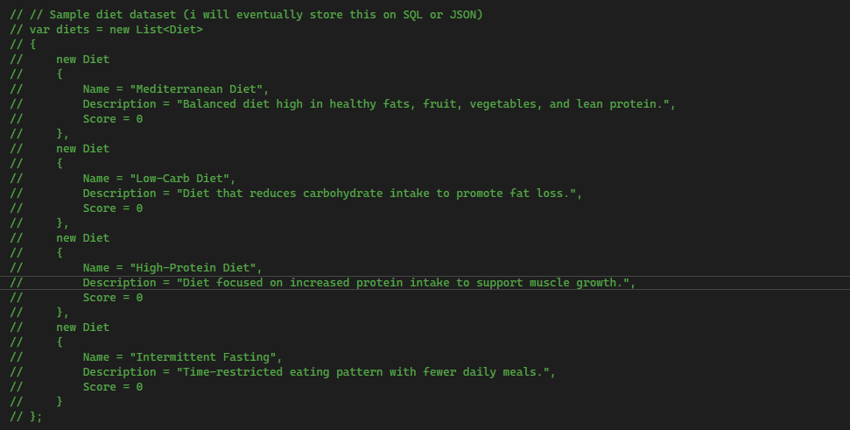

Commented out the sample diet set.

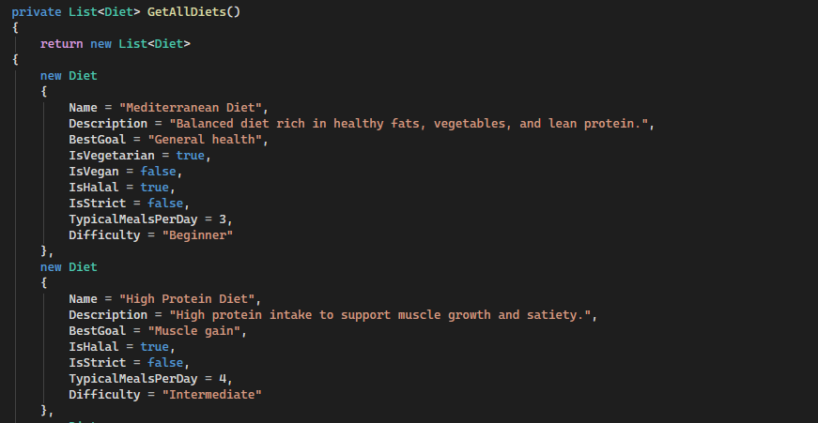

Created a method that returns alist containing 10 diets with all of the attributes.

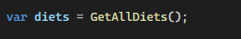

Inside the GenerateGradedDietList method I have created a new instance of the diet list.

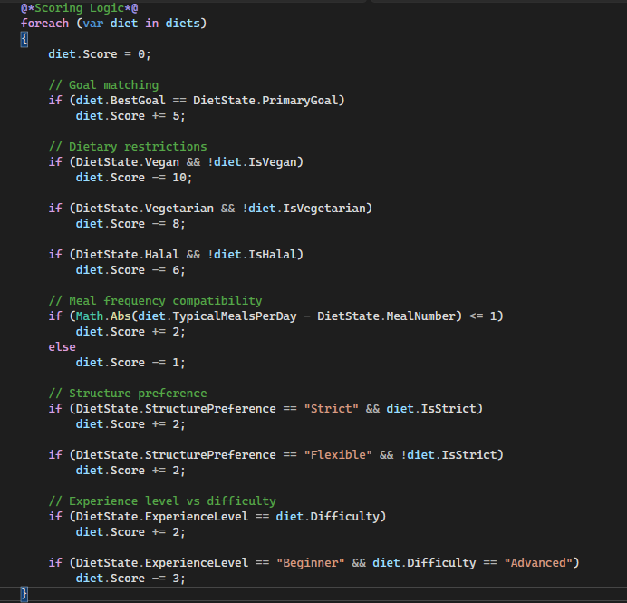

Updated foreach loop that contains proper algorithmic logic.

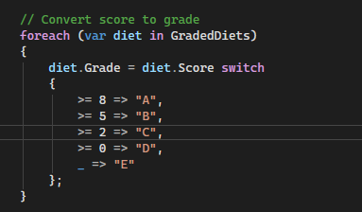

Updated the final foreach loop to support larger numbers.

It works.

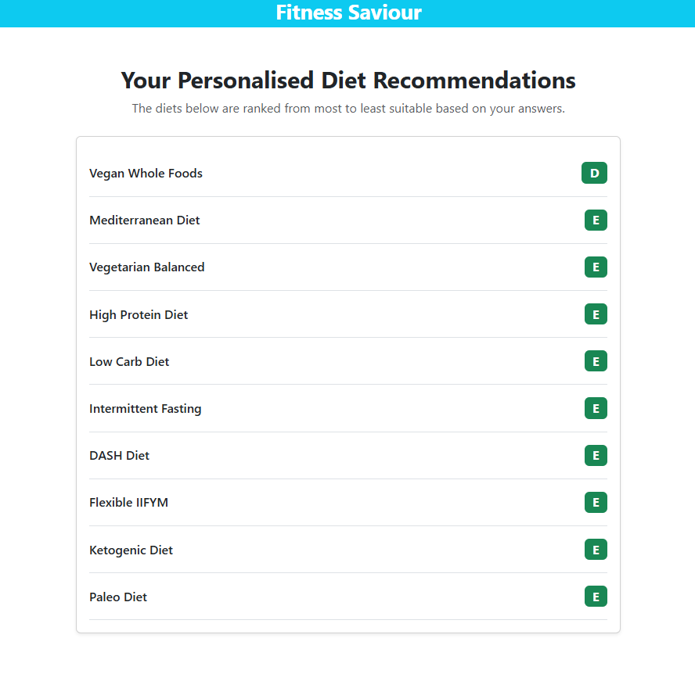

Produces different results based off what you enter.

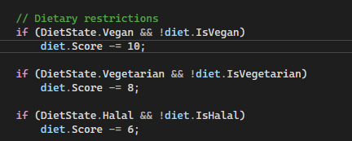

Going to set all of these to 4.

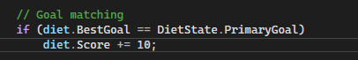

Changed this to 10.

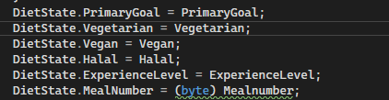

Casting MealNumber as a byte has resolved this issue.

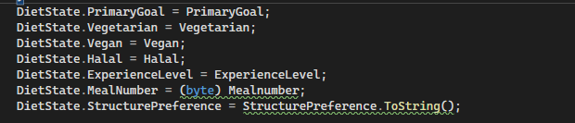

Using the ToString() method has resolved the issue with structure preference.

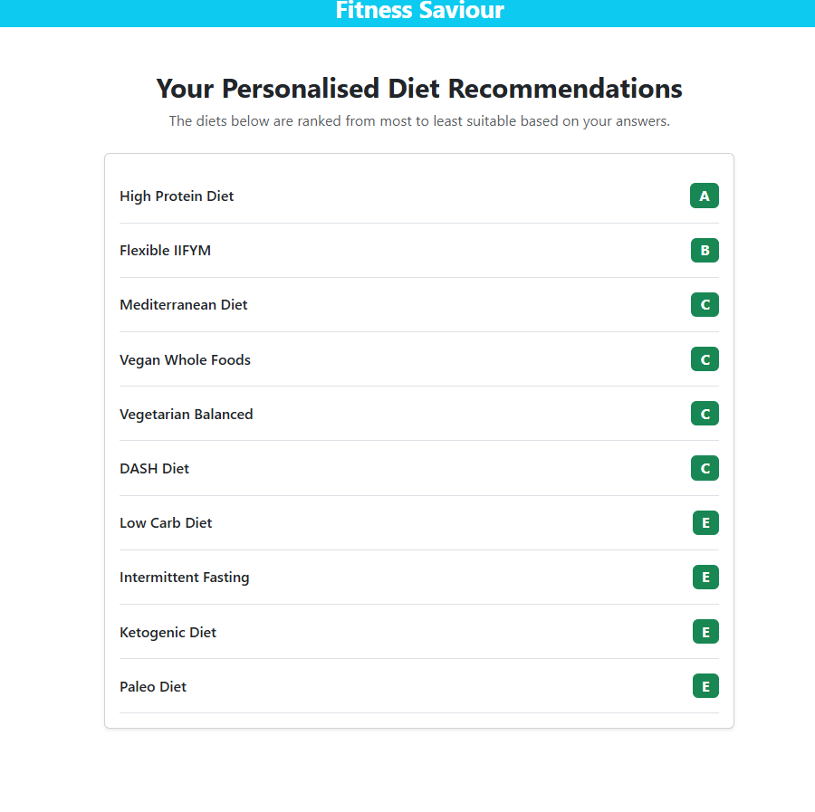

For users that the hover box isn’t enough for, I want to add a link to each of the diets that will direct the user to the necessary link for more information.

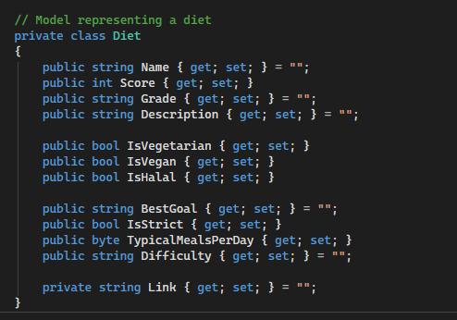

Adding a link attribute to the Diet class. (made it public)

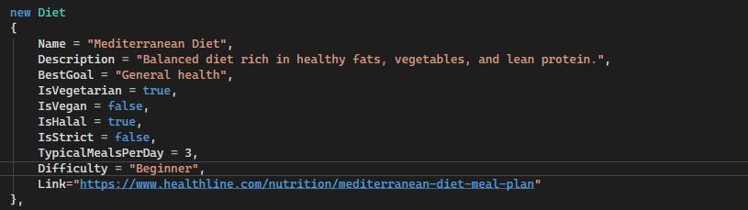

Added a link to each diet in the list.

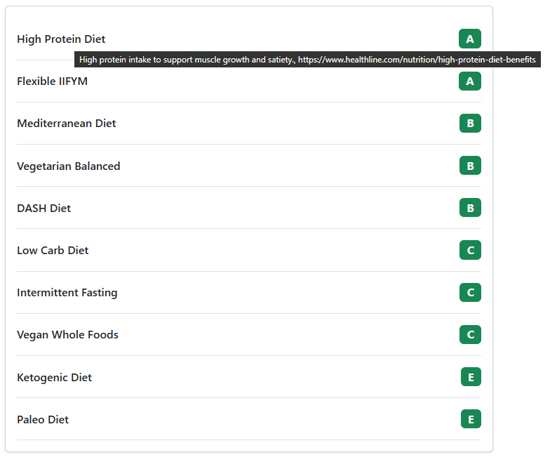

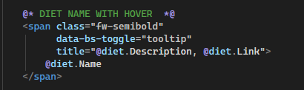

I first added the diet link to the hover component but realised there is no way for the user to copy the link as it fades before you can click on it.

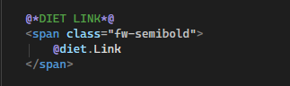

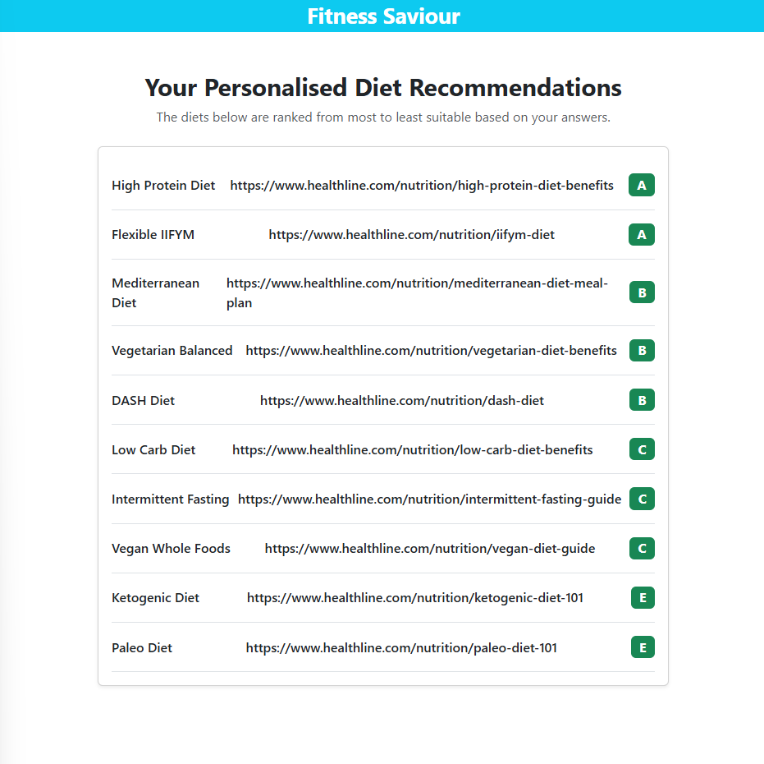

I achieved what I wanted but I realised this is a bad approach as it detracts from the weight of the actual diet name, id rather make it so that the links appear when the user wants them to. For this I will create a button on the bottom of the page called “Add Diet Links” and “Remove Diet Links”.

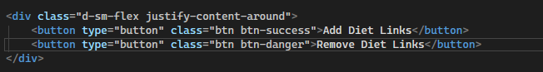

Created 2 buttons formatted appropriately. Adding has the success class making it green whereas Removing has the danger class making it red. This is for the general assumption that removing is red and adding is green.

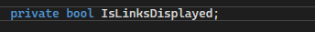

Created a Boolean value that will be true when the links are displayed and false when they aren’t.



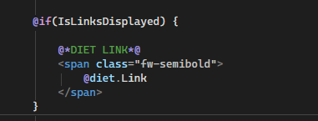

Wrapped the link in an if statement meaning the links will only be visible if the IsLinksDisplayed Boolean is true.

Perfect, works as planned.

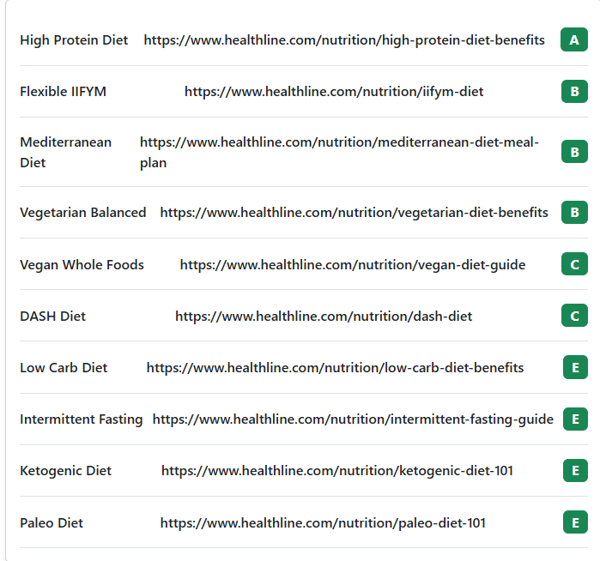

I want the links to actually look like links and also not be bold to not detract from the weight of the actual diet name.

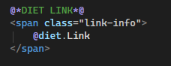

Removed the bold class and gave the link the bootstrap class that essentially makes it look like a link (blue).

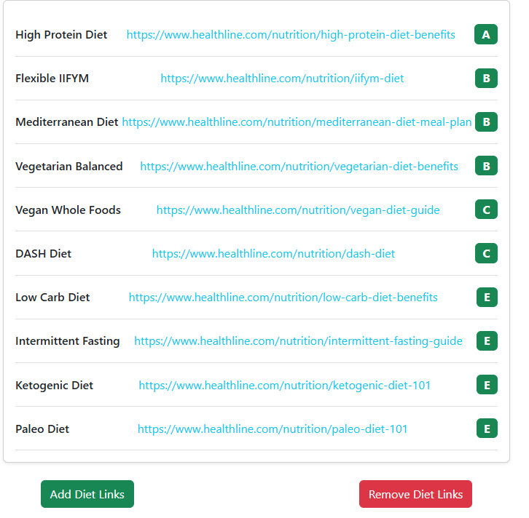

Issue now is clicking the links doesn’t do anything, I need to attach a hyperlink to them.

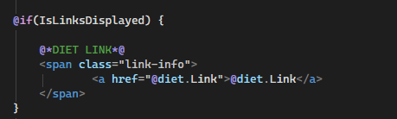

Wrapped the text in an anchor element with the href set as the diet link.

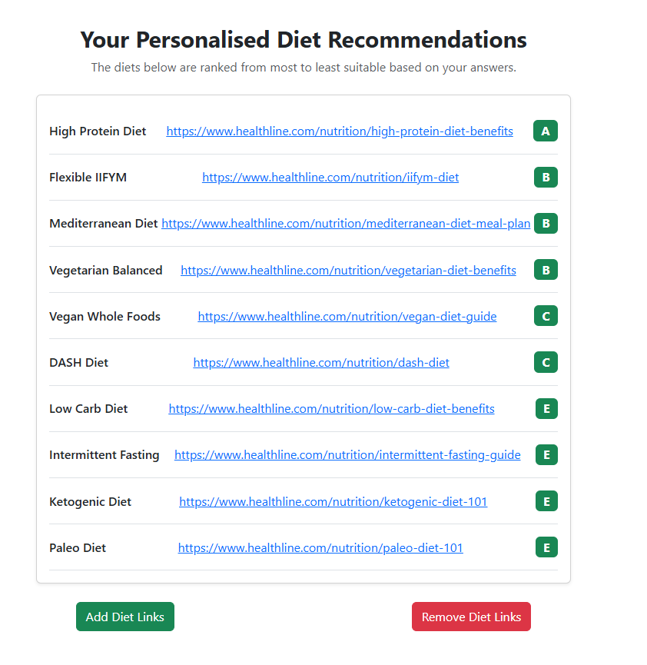

Looks perfect now., and works as desired.

Now all the grade buttons look green. This is not what I want, I want A and B to be green, C and D to be yellow and E to be red.

Class for red button: "badge bg-danger fs-6"

Green button: "badge bg-success fs-6"

L

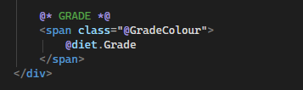

I have set the class of the grade icon as a string variable.



Green by default.

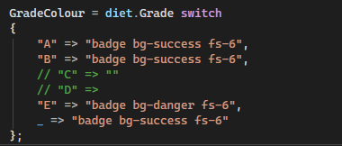

Will set up C and D later, but will check now to see if E graded diets look red.

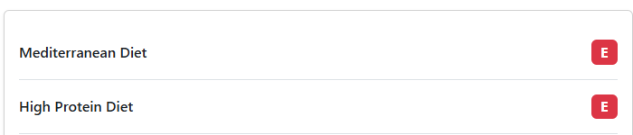

Success. 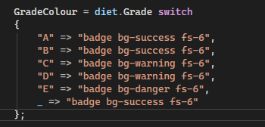

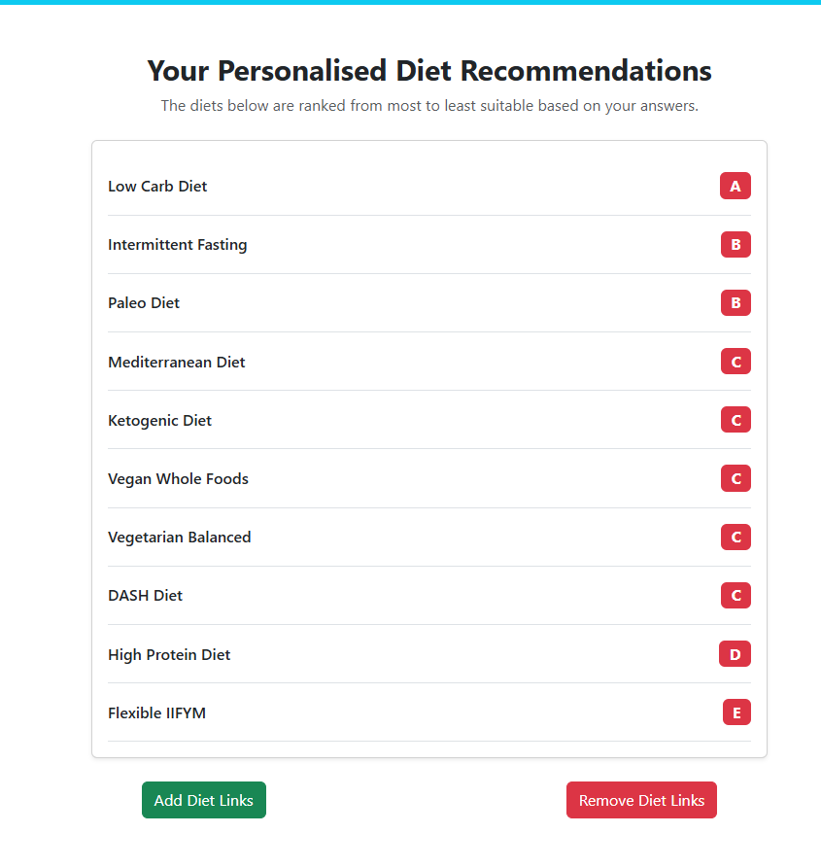

Issue: they all look red now. This is because each grade is initially grade E because the initial score of each diet is 0.

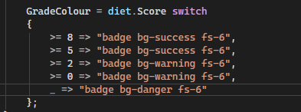

Switch statement based of diet scores now rather than diet grades.

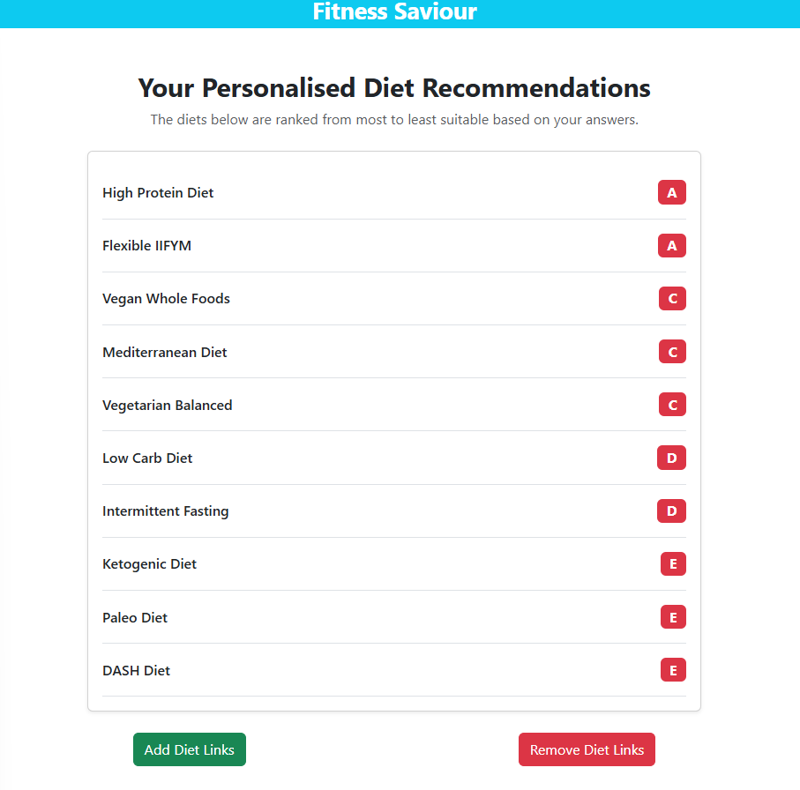

Still the same issue.

I think the issue is how im setting gradecolour as a single shared variable. When the loop finishes it will only contain the value from the last diet in the list which will always be E, hence it looking red.

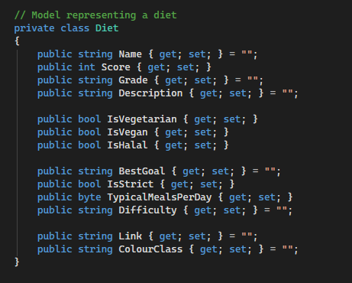

Added new attribute to the diet class.

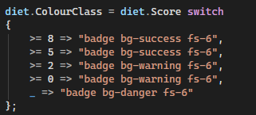

Score is assigned to colourclass rather than gradecolour variable.

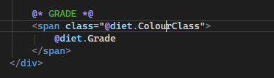

Updated this in the span element

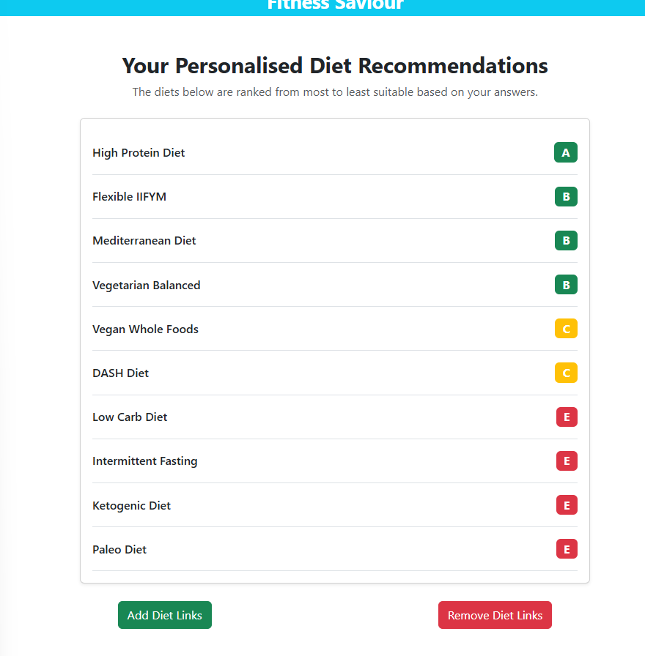

Now works perfectly.

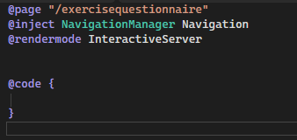

Created new page called exercise questionnaire.

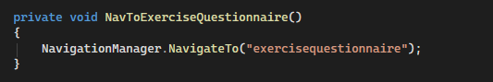

Created a method on the exercise logging page that navigates to the exercise questionnaire page.

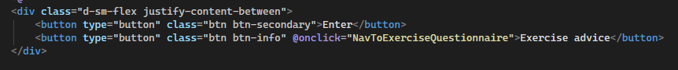

I call the method on the correct button

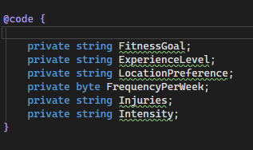

Set up the variables that will be based off user input.



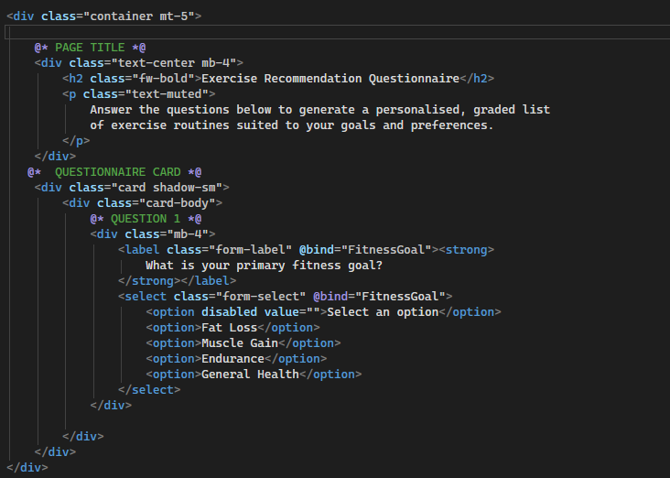

Added page title and first question.

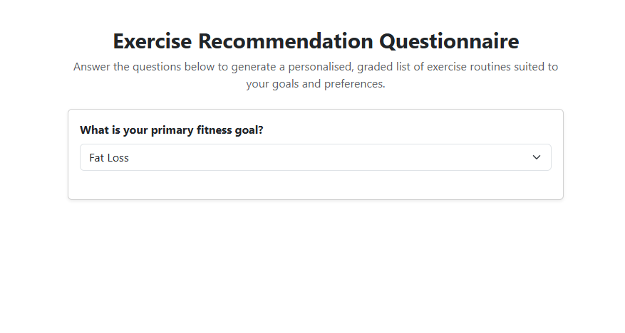

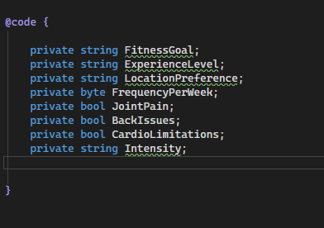

Set Boolean values for the injuries.

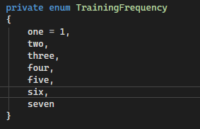

Created enum for training frequency.



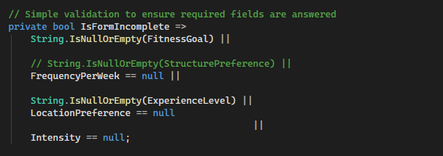

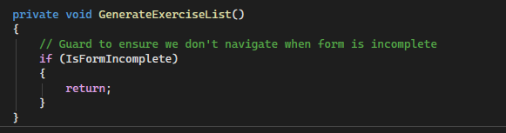

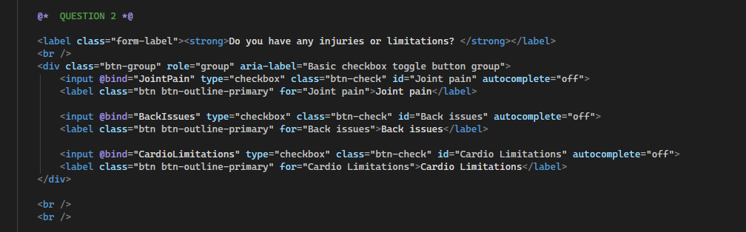

Second question using checkboxes with same styling as on the other questionnaire.

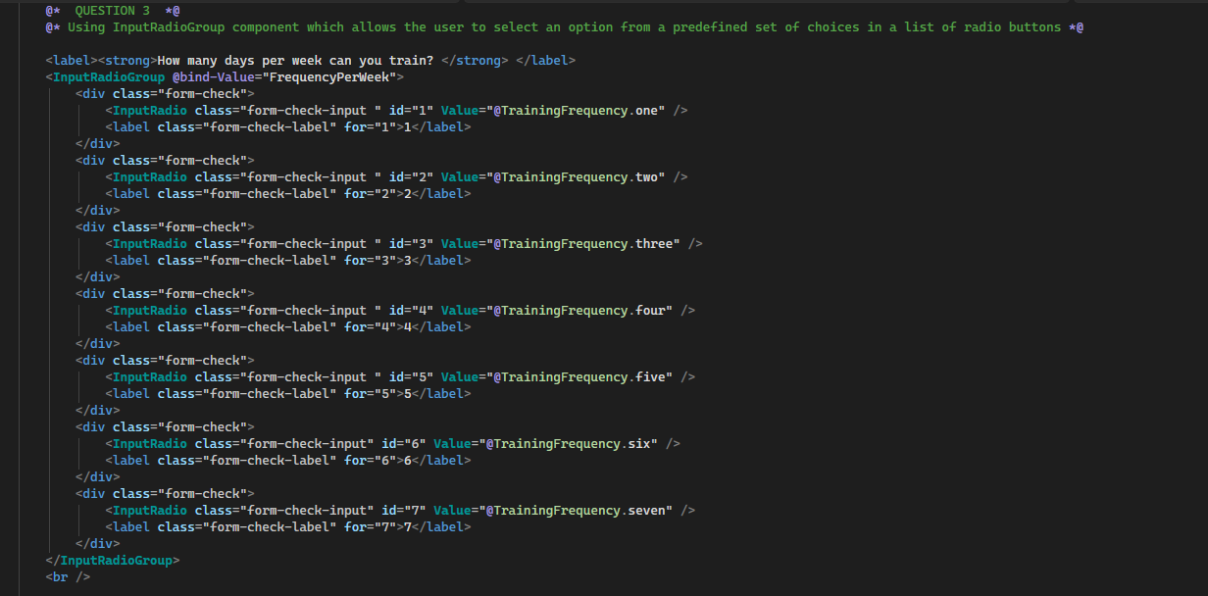

Question3.

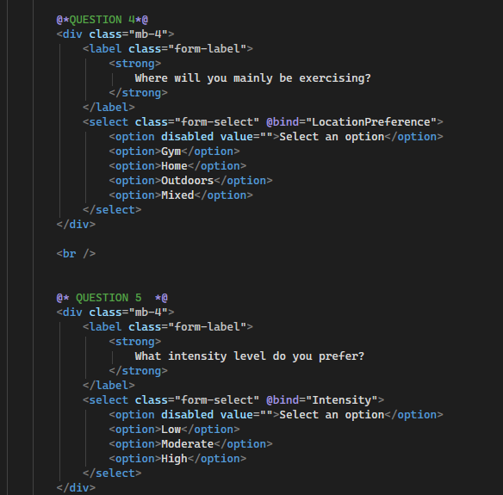

4 and 5.

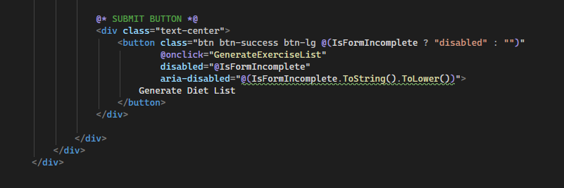

Submit button, reusable logic.

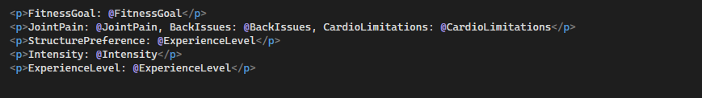

Debugging template.

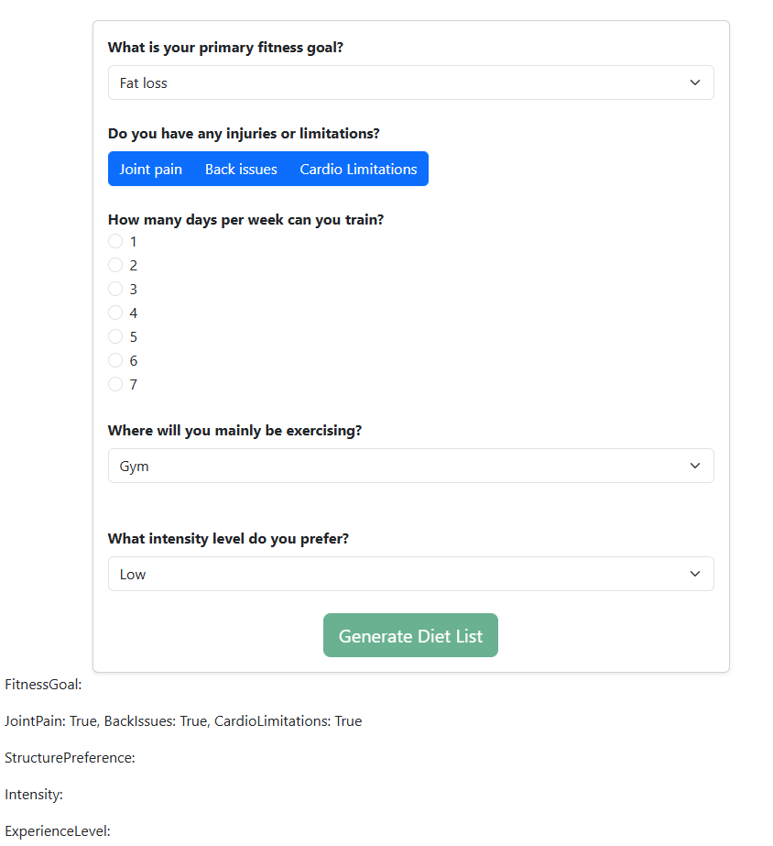

Checkboxes work.

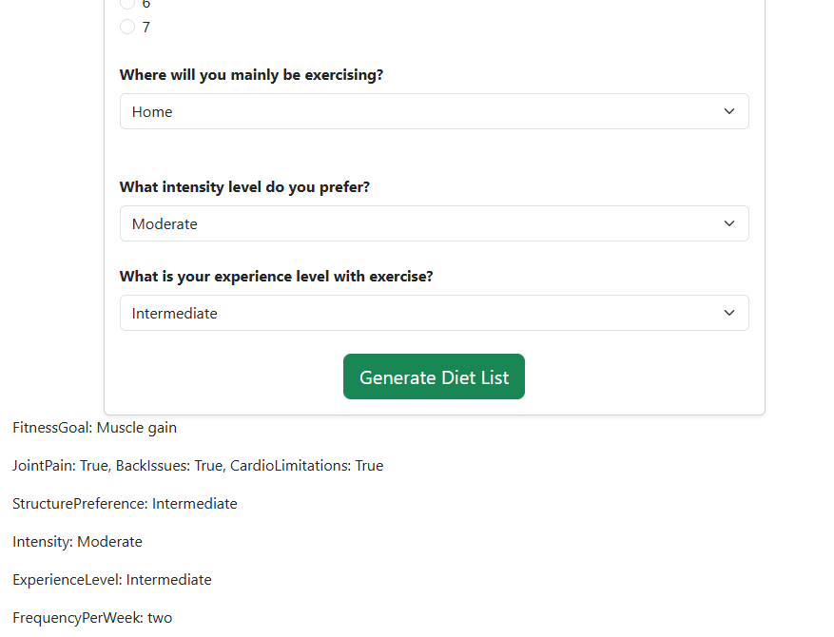

Successfully binds, forgot to add experience question so did that.

Code for question:

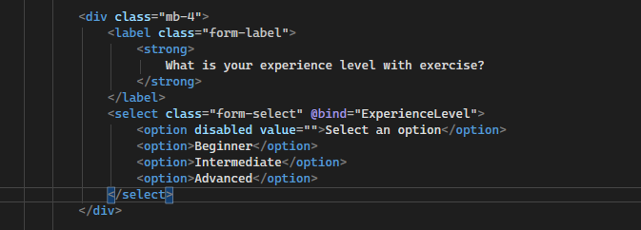

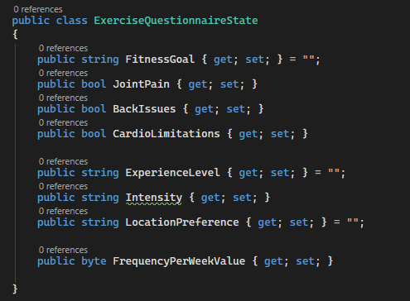

Set up exercisequestionnaire state calss, same functionality as its diet counterpart.

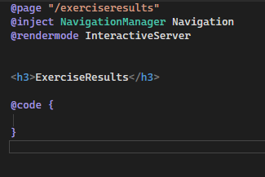

Created exercise results page.



Had to give the class scope.

Note: the logic for the exercise results page is identical to the diet results page so I will not cover the logic for it again.

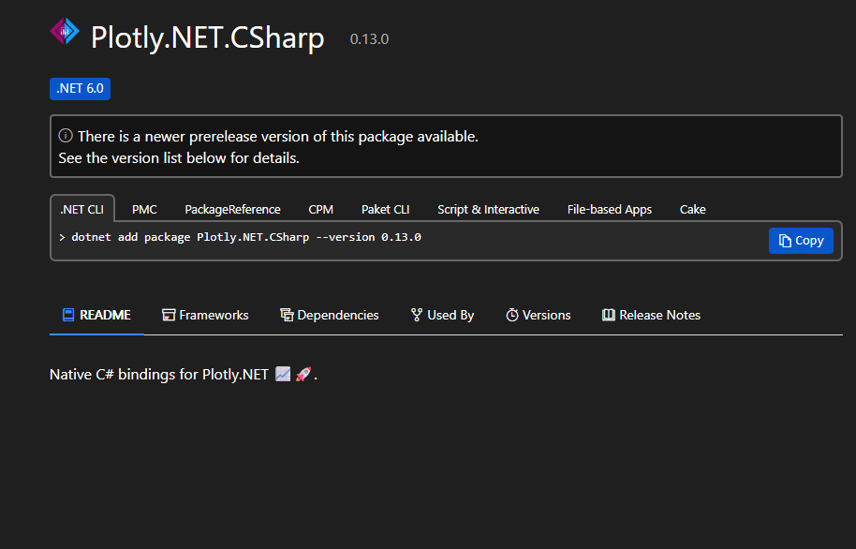

Had to add a nugget package to my codespace in order to utilise graphs for my graphs page.

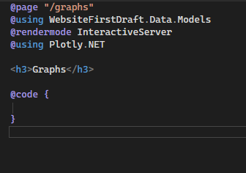

Created the graphs page

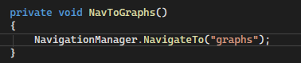

Added a method on the home page to navigate to this new page.

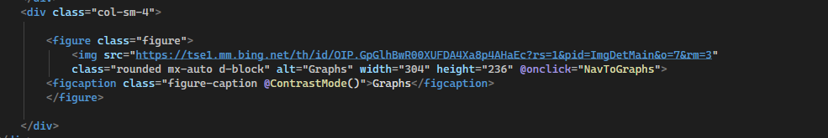

Bound the link to the graphs image.



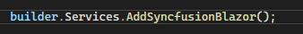

Added onto program.cs file.



Added script with javascript.



Added license key for legal reasons.

Sample chart for testing purposes:

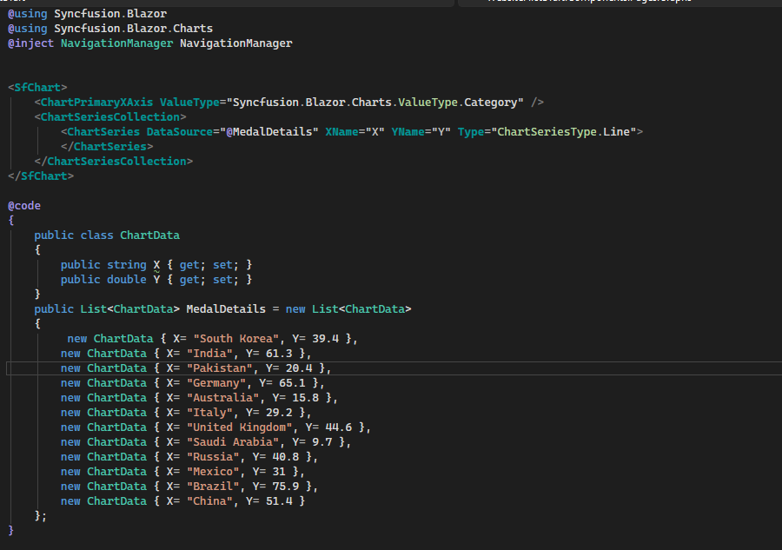

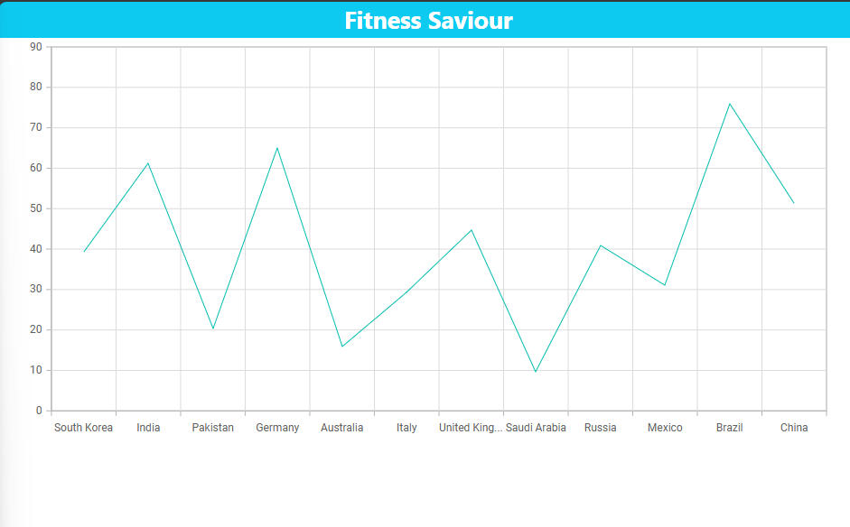

Alternative approach using blazor components:

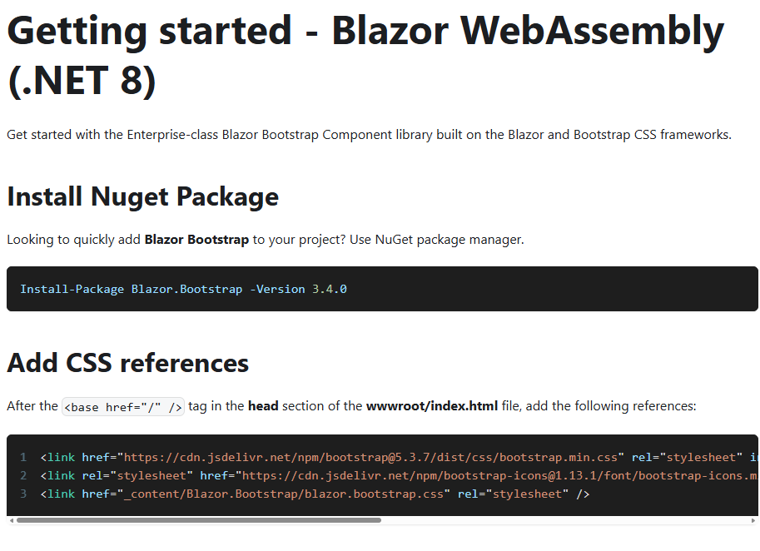

Following guide to get set up.

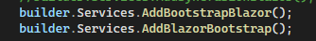

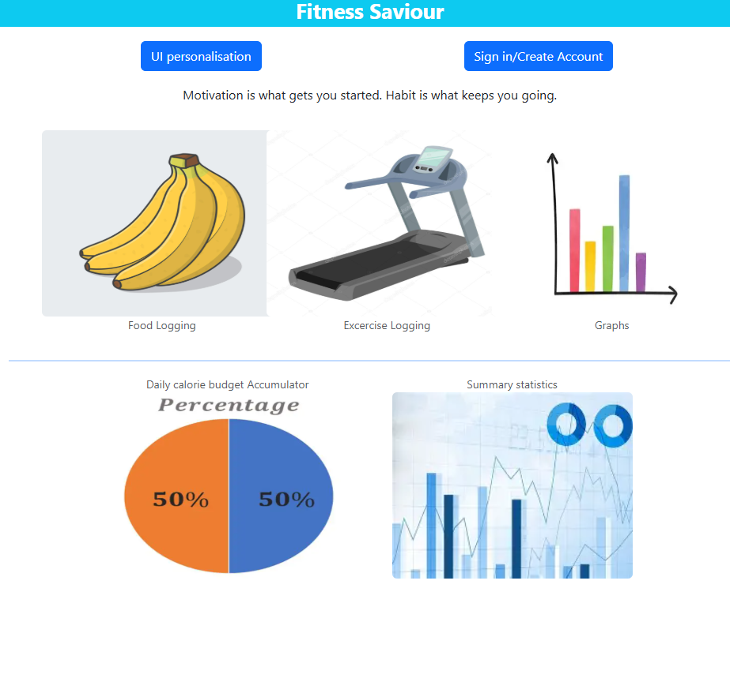

On my homepage, you have to click on the images in order to navigate to the pages. I will add buttons instead.

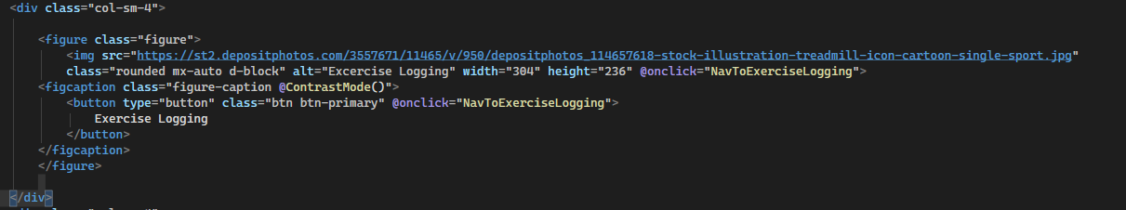

For every image, I am adding a button to the figcaption element so that the text is replaced by a button.

Results:

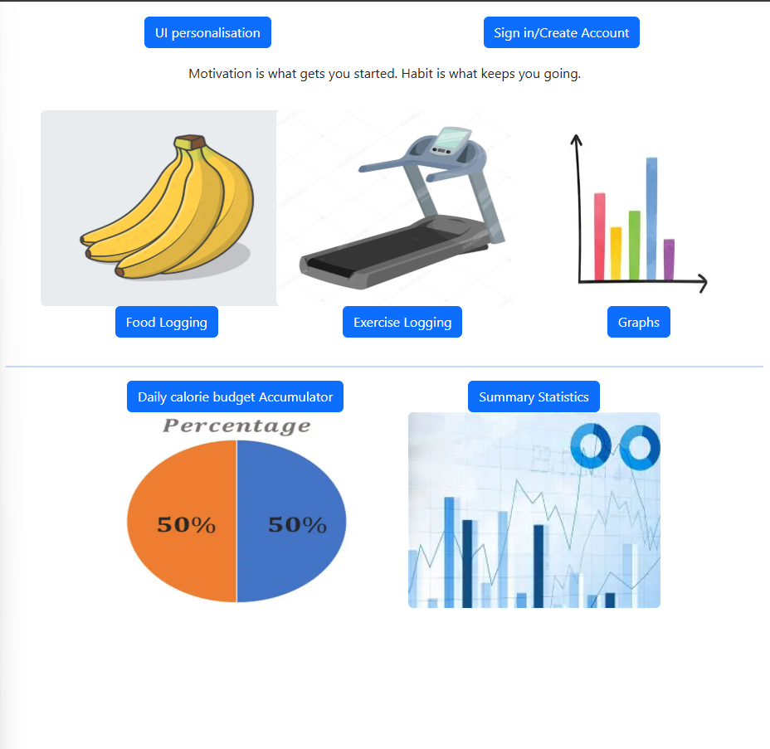

At the bottom of the homepage I want to add a row of buttons that will each take the user to one of the questionnaires that were originally located on the food logging and diet logging pages. I want to reduce the amount of navigation required.

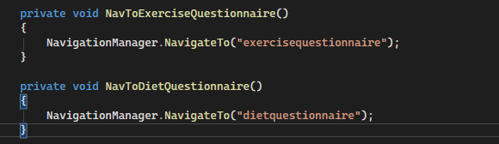

Added methods that allow navigation to each of the respective pages.

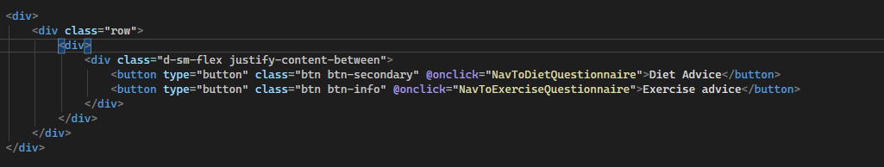

Added buttons to bottom of page.

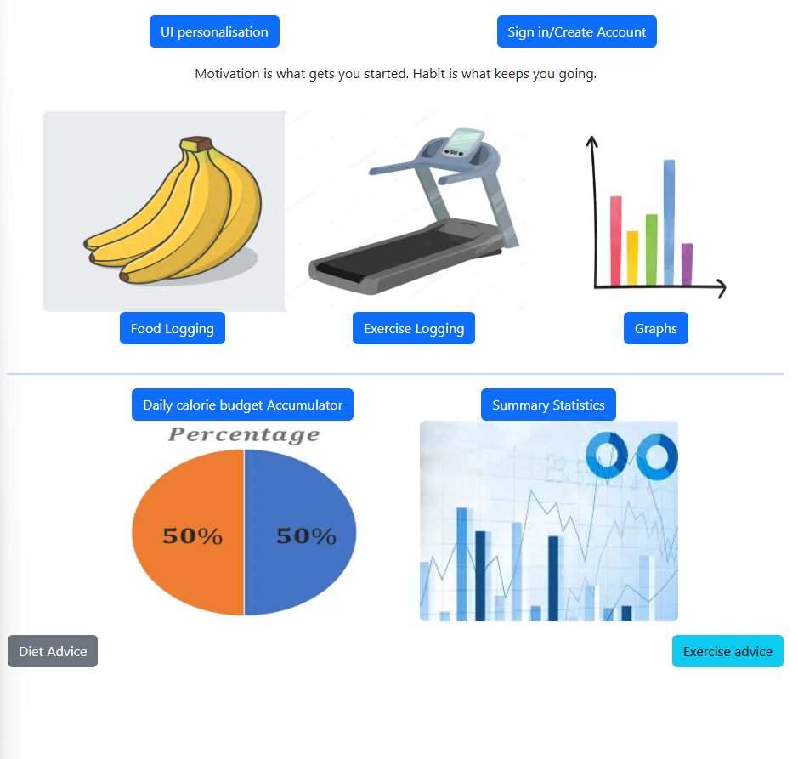

I need a paragraph explaining their uses.

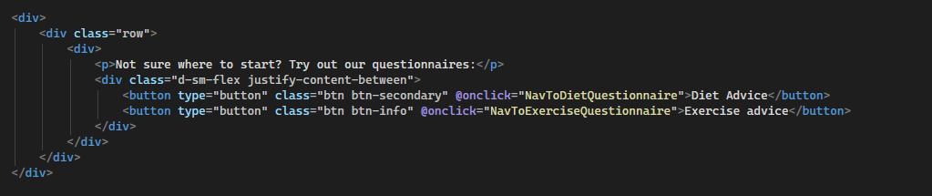

Added p element.

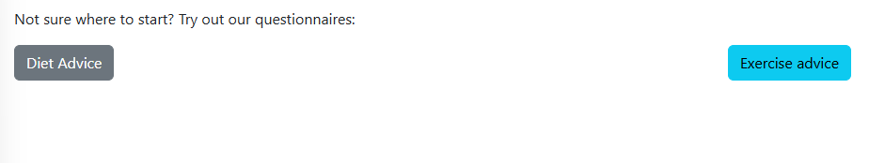

Make buttons same colour by giving them the primary class.

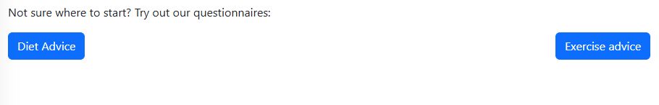

Daily calorie budget accumulator on the homepage needs to be an interactive pie chart displaying carbs, fats and protein consumed for the day.

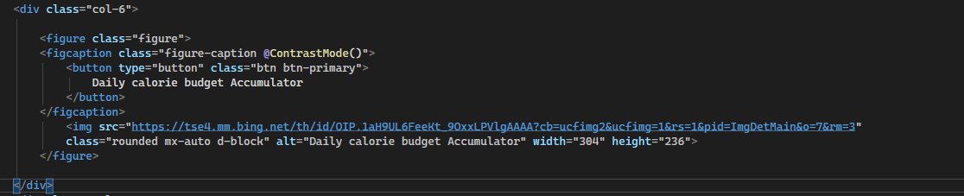

Getting rid of code inside div (ill comment it out for now)

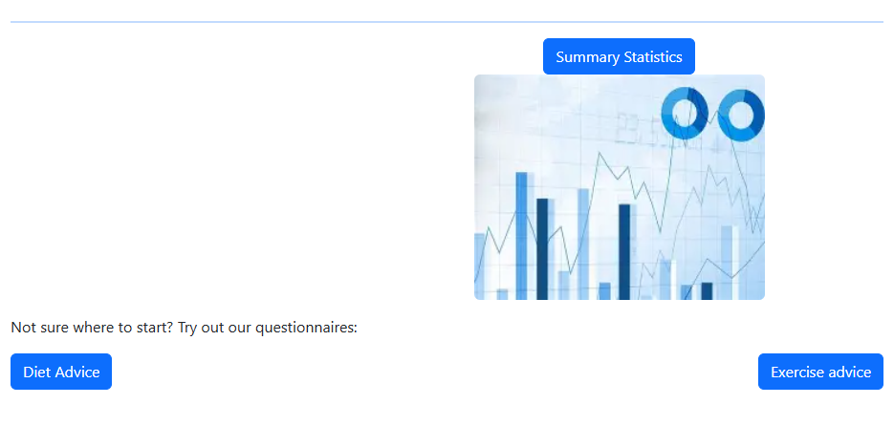

Removed summary statistics image

I worked on making a pie chart to display o the homepage.

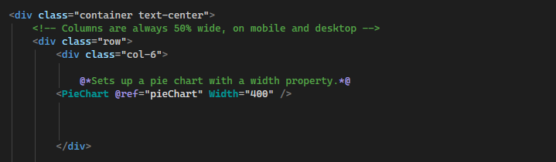

This uses the component from the Blazor.Bootstrap nugget package that I had to install for data visualisation features on blazor.

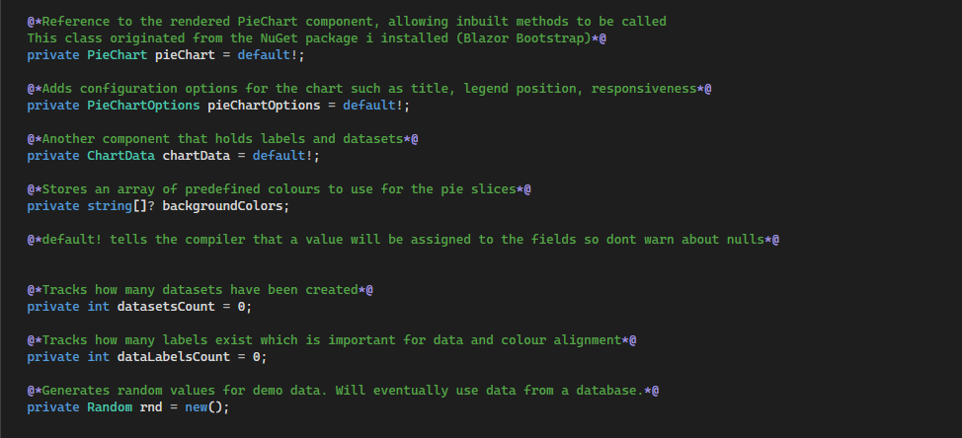

This is the code with comments explaining their function. This is needed for the pie chart component to display with data.

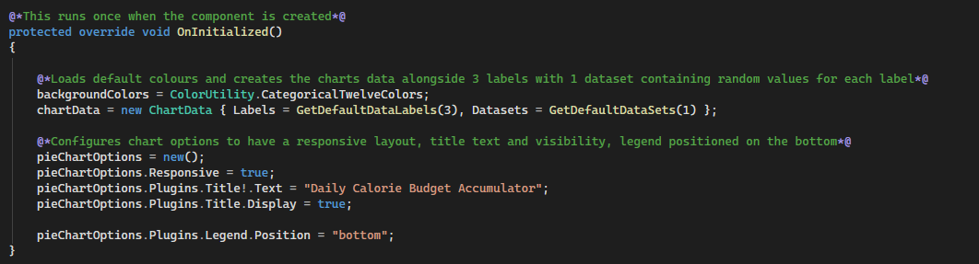

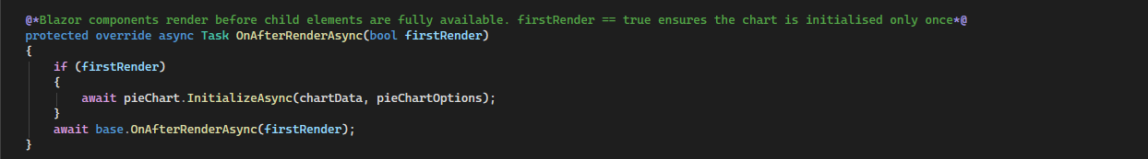

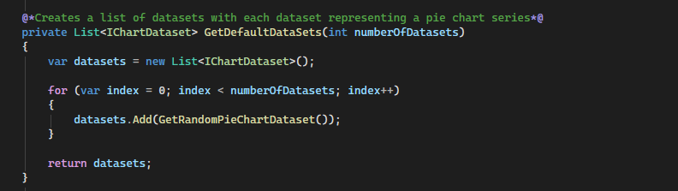

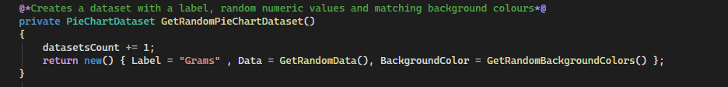

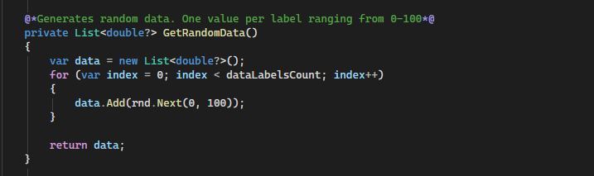

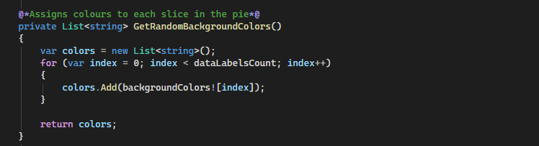

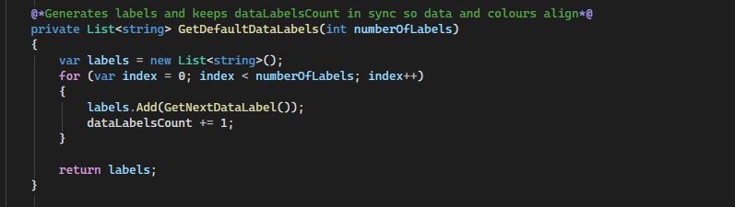

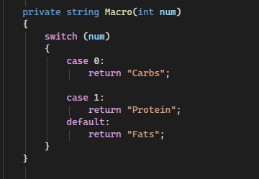



The way this works is, the label will have the name carbs, protein or fats depending on the datalabelsCount value. I coded a switch statement to ensure the correct string is returned from the method.

Pie chart now rendered on page:

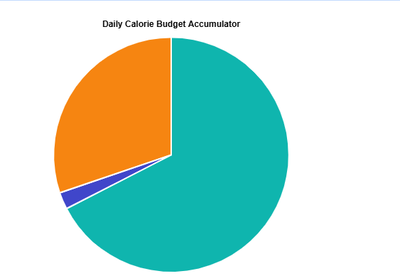

Now I set up summary statistics:

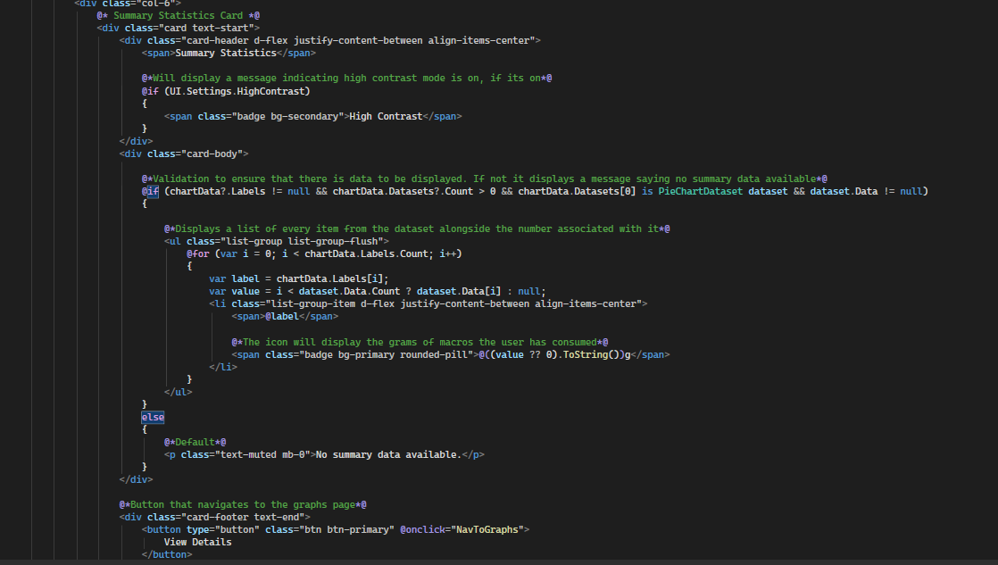

Result:

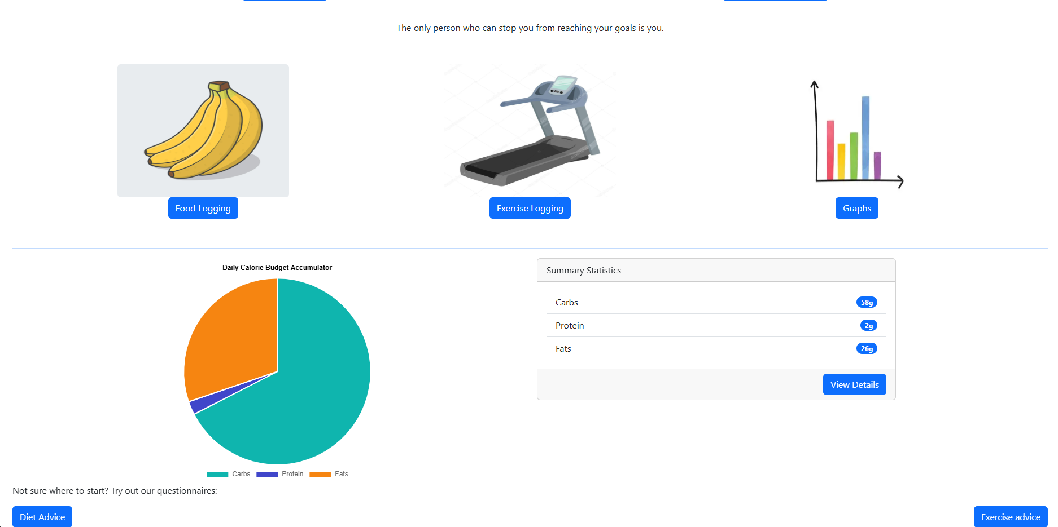

Graphs page:

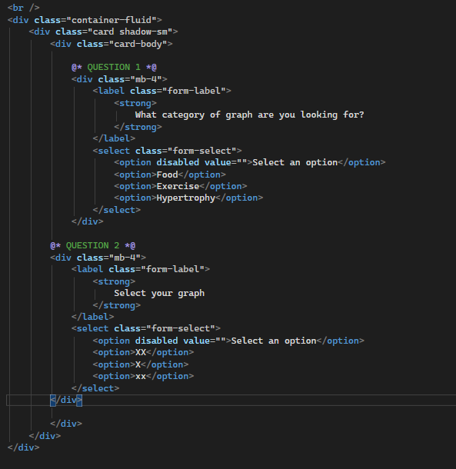

Added 2 questions

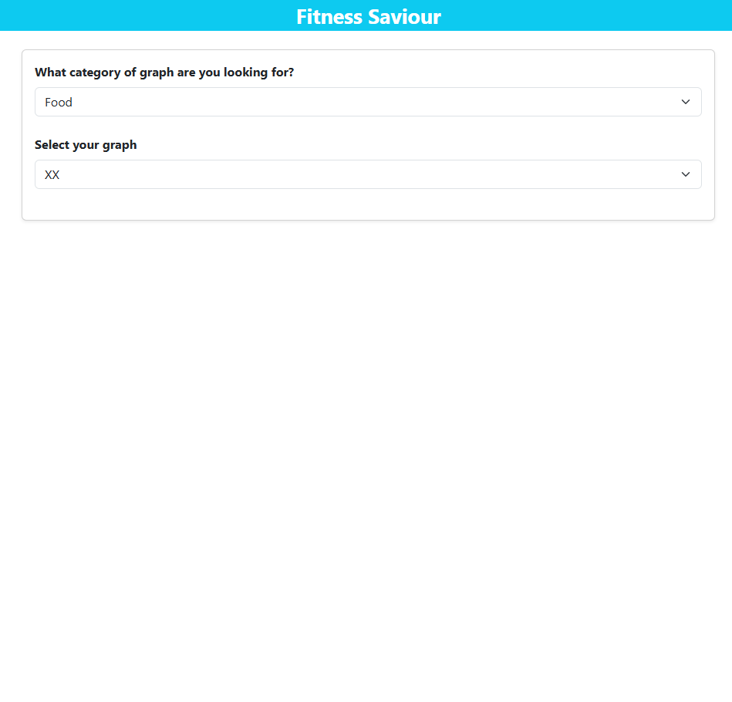

Area underneath is where I want my graphs to be.

//BACKEND

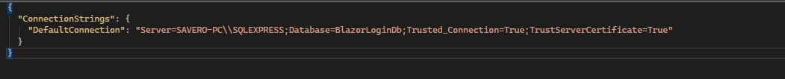

Added connection string onto my JSON file to connect to the SQL server databases I will be creating.

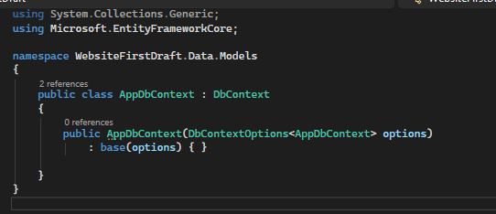

This allows for connection to a database and working with data from the database on the front end.

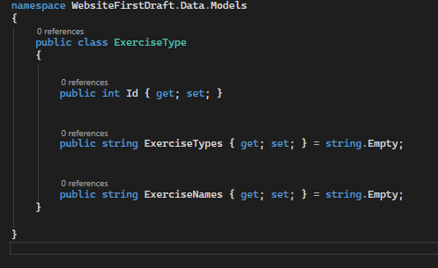

Set up a class to represent the model of exercise type and gave it some relevant attributes that it will have in the database.

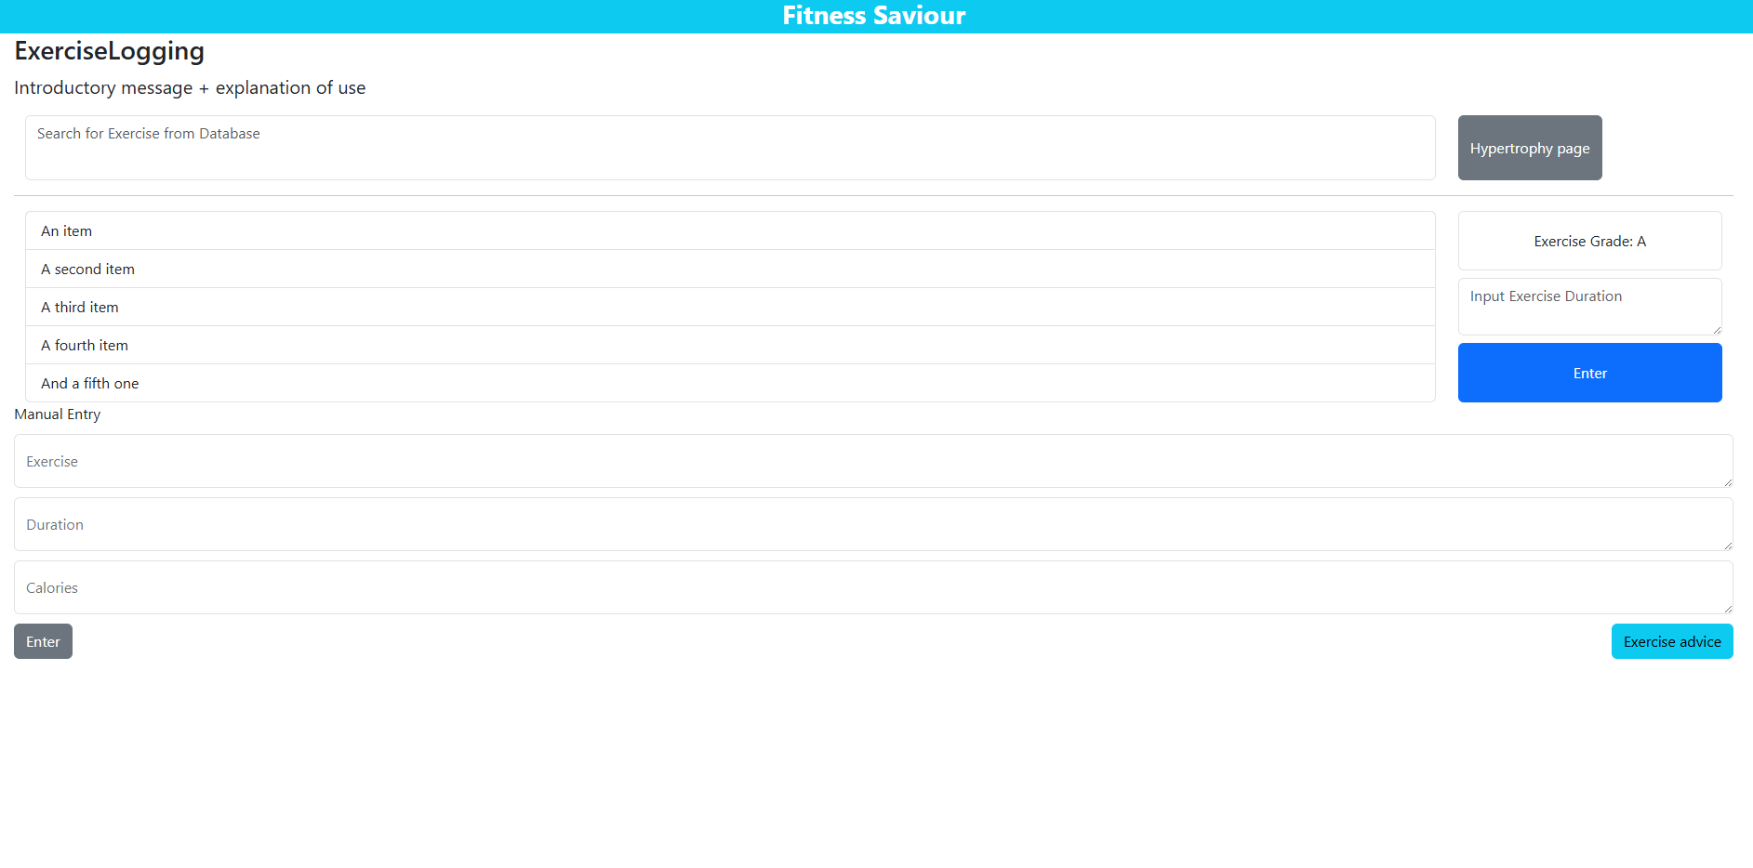

Making changes to exercise logging page

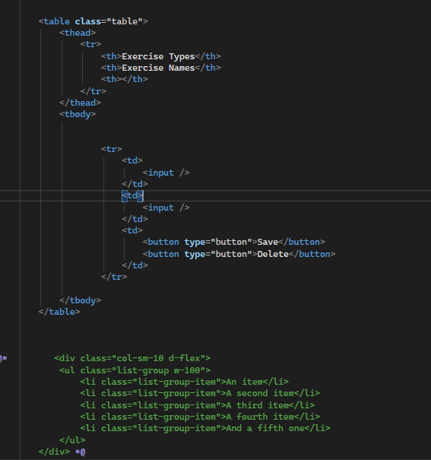

Replaced placeholder list with a table.

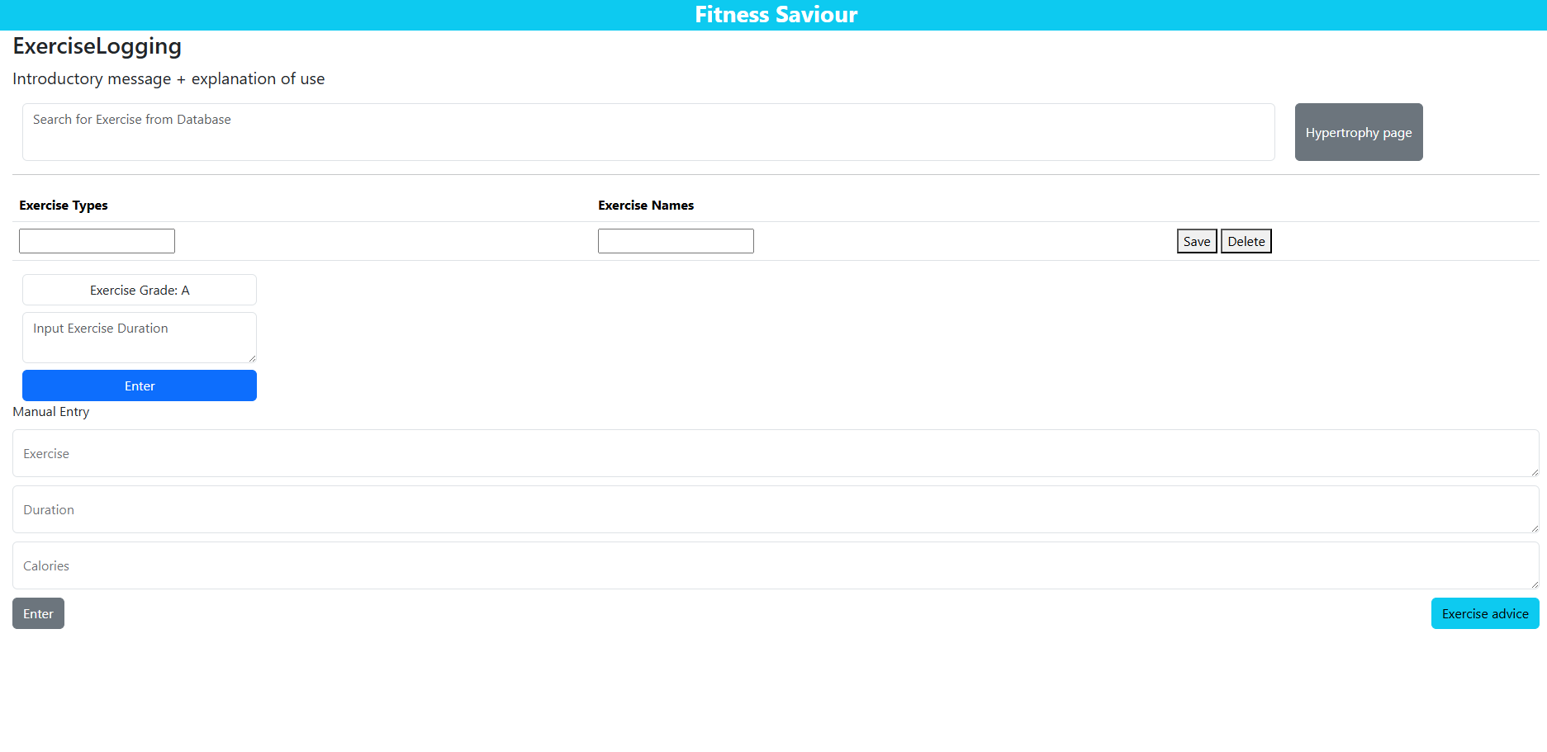

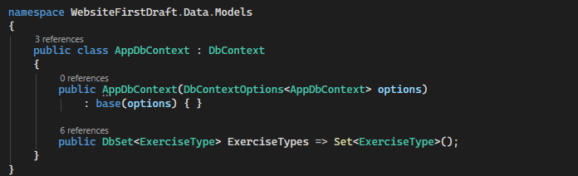

Added a database set of exercise type object.

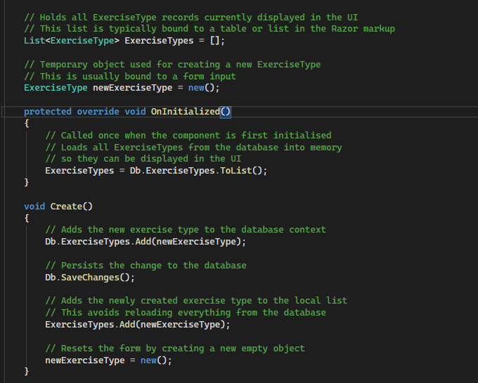

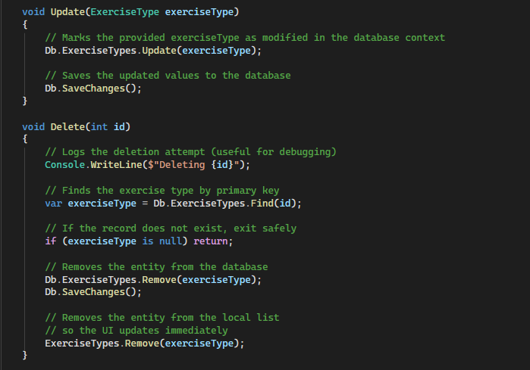

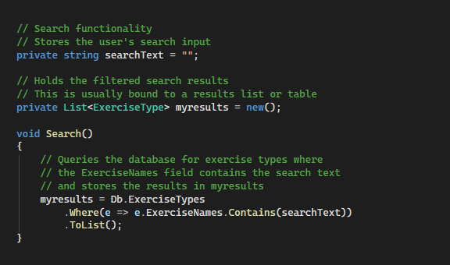



Connects to SQL server

On sql server:

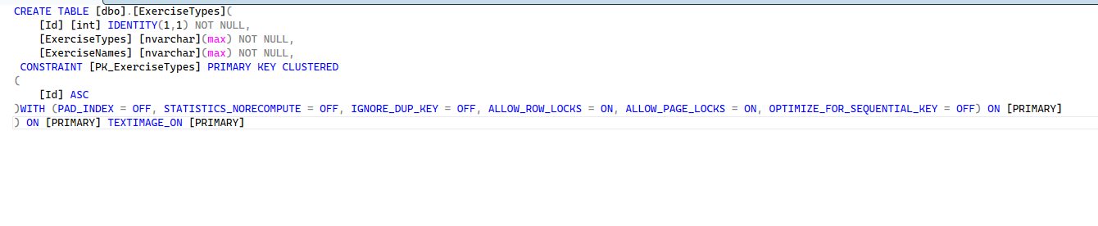

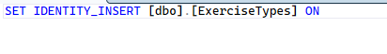

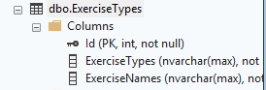

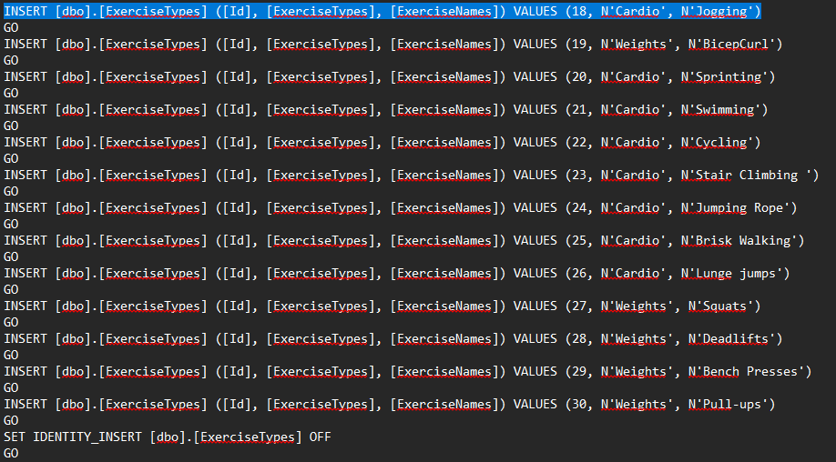

Sample data

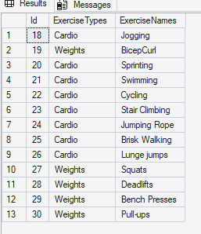

Now back to the exercise logging page:

Adding links to database to the table. Before:

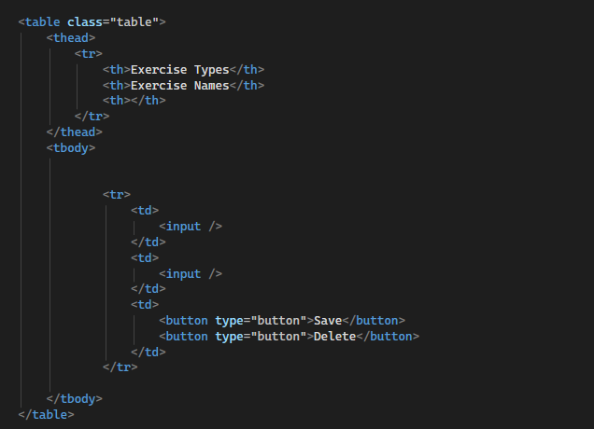

After:

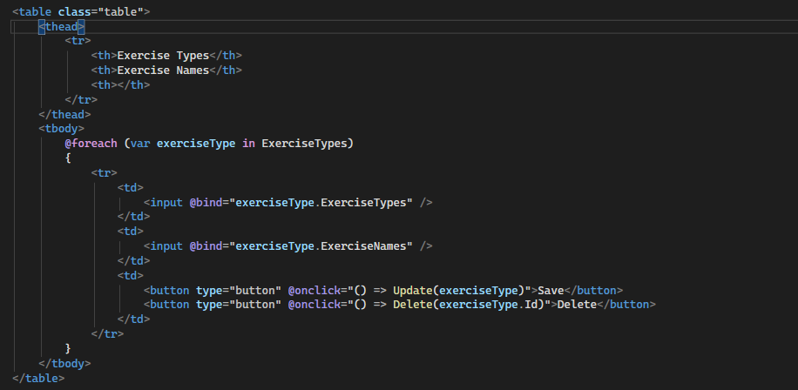

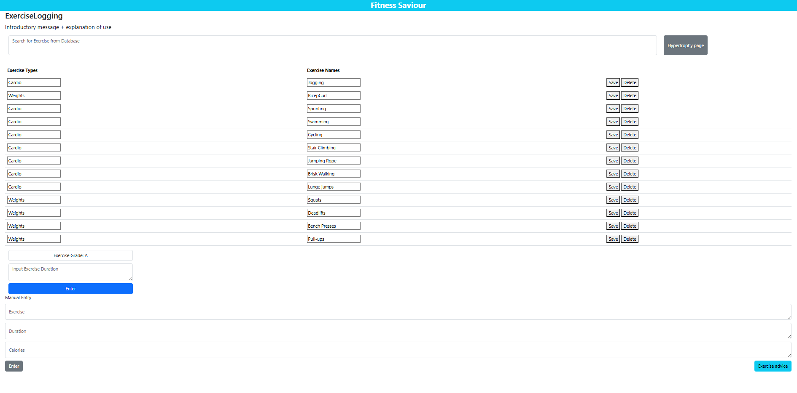

Allows user to add and delete records where they see fit.

Now I no longer need the manual entry section, so I will comment this out.

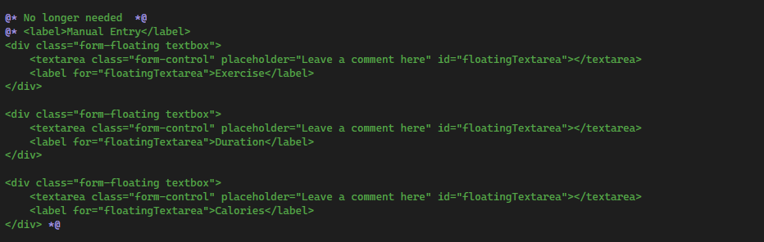

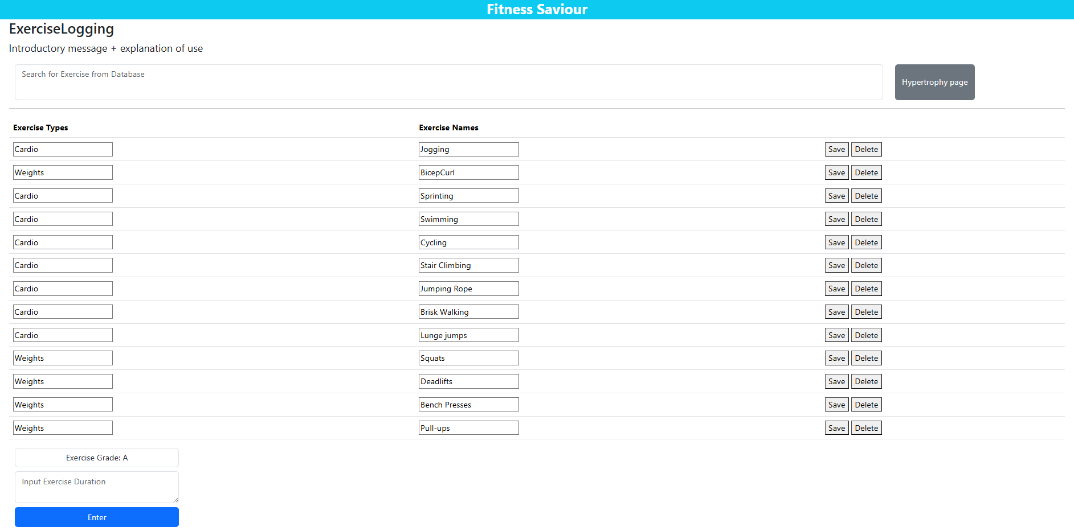

I want the exercise Grade and input exercise duration to be part of the table.

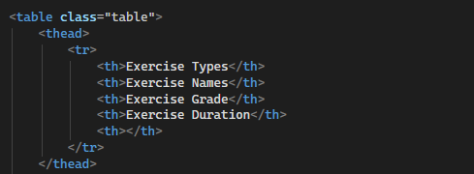

Added the column names.

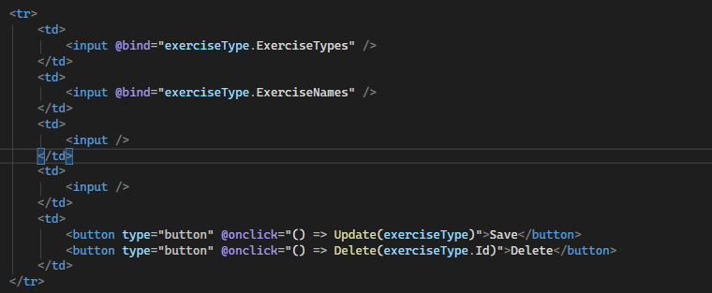

Added 2 more empty cells.

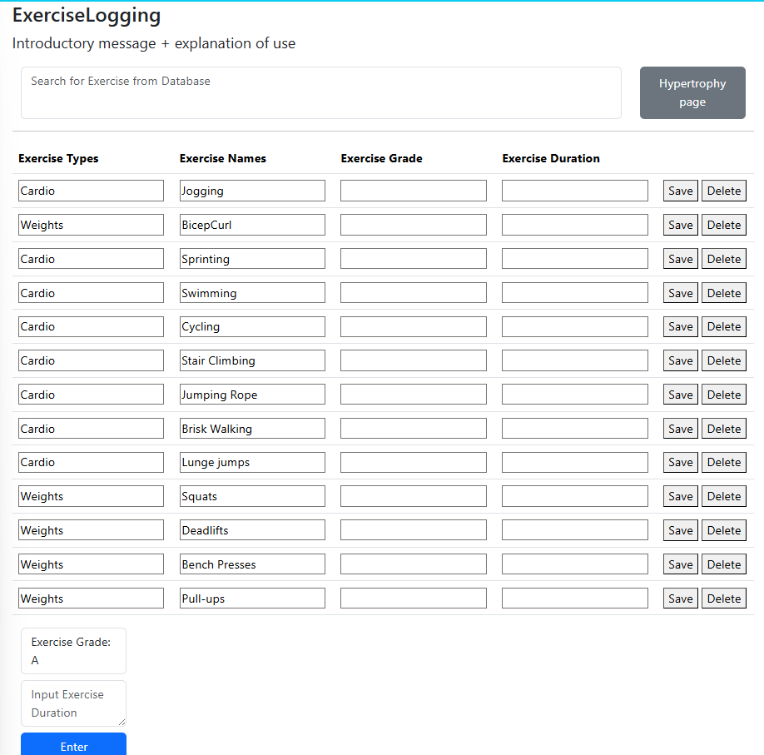

Now I can remove stuff at bottom (commented this out)

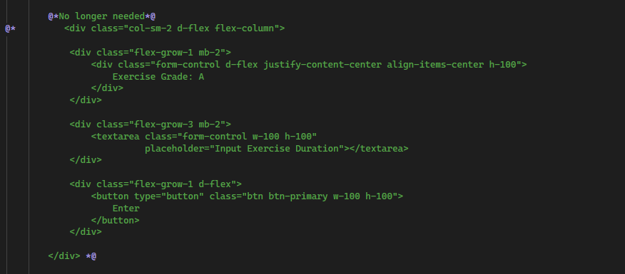

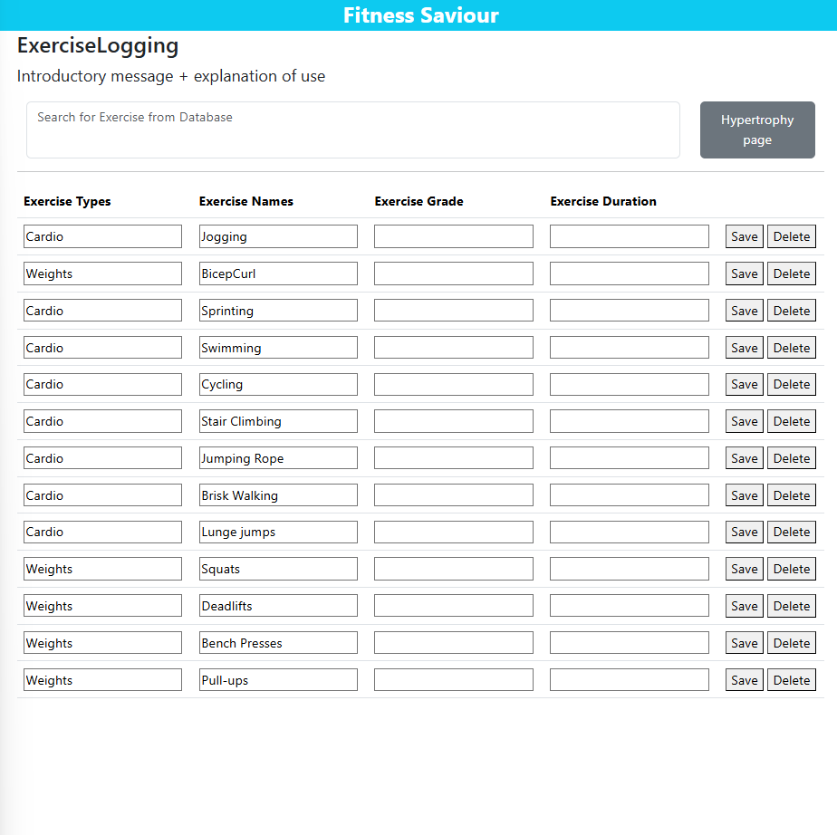

Will add an actual introductory message



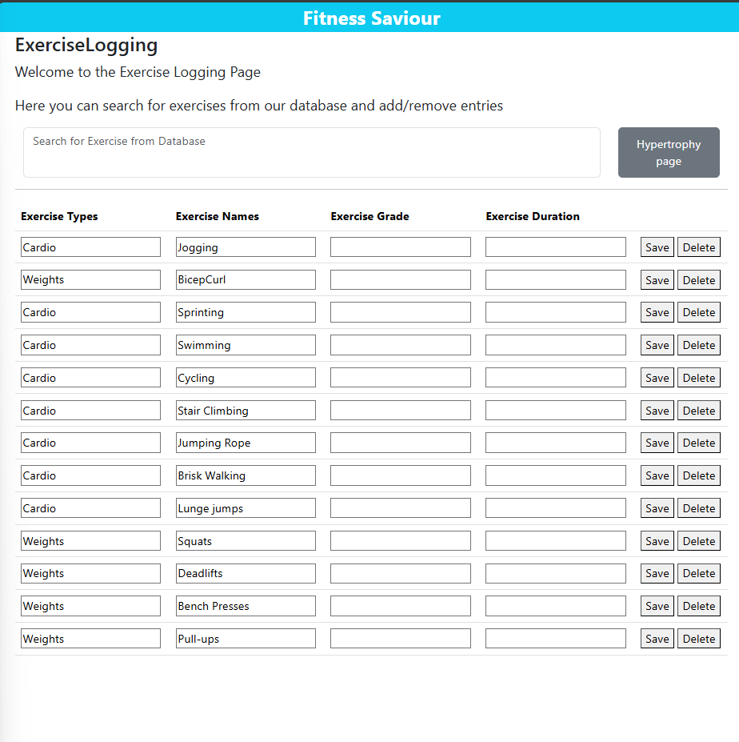

Graphs page:

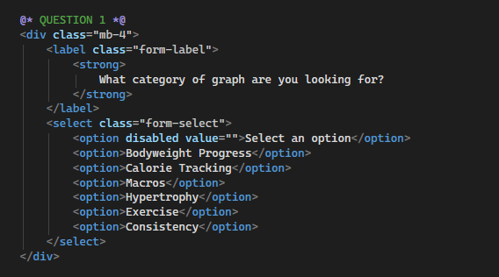

Added all the necessary options for the first question.

Result:

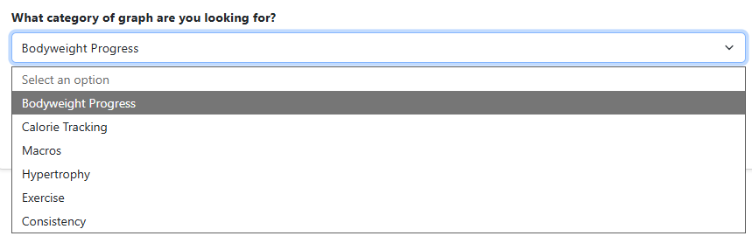

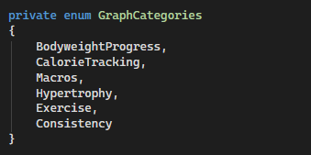

Created an enum of graph categories to bind to the input.



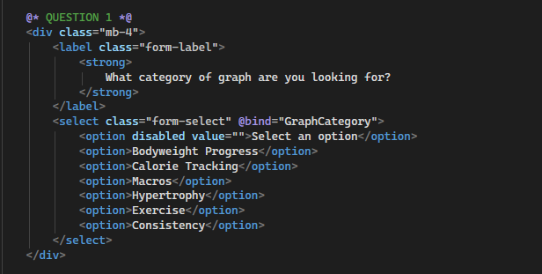

Bound the selection to the graphcategory enum.

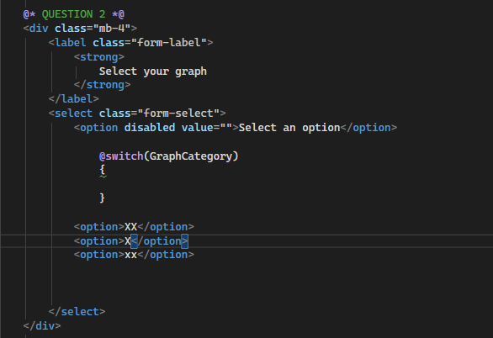

Switching graph category so that it shows a different dropdown for each selection.

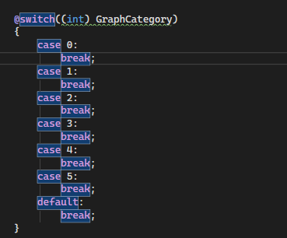

Casting it as an int and providing the template for all cases where the default will catch errors.

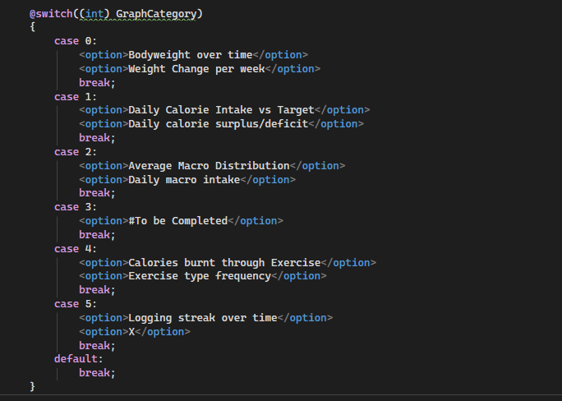

Added in the values.

When I tried to run, it gave me an exception as it the enum must have a value at compile time. I fixed this by adding in a check.

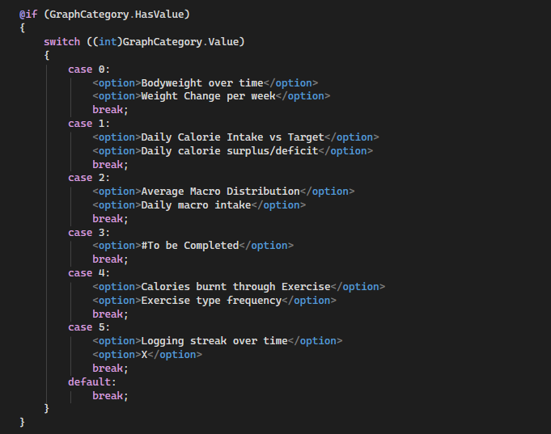

It worked for all except the first 2.

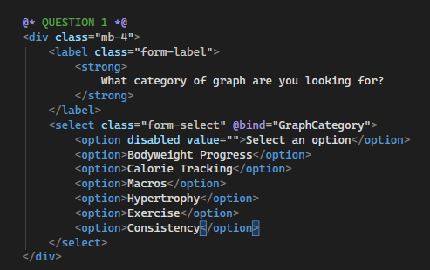

This is because they have spaces in their names so the binded value is not equivalent to the enumerated value.

So I removed the space in the options.

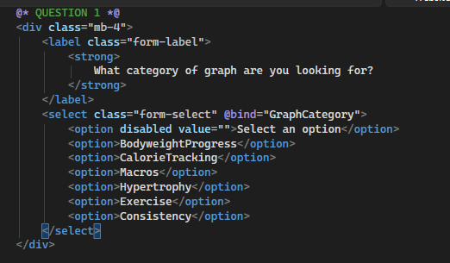

And it now works.

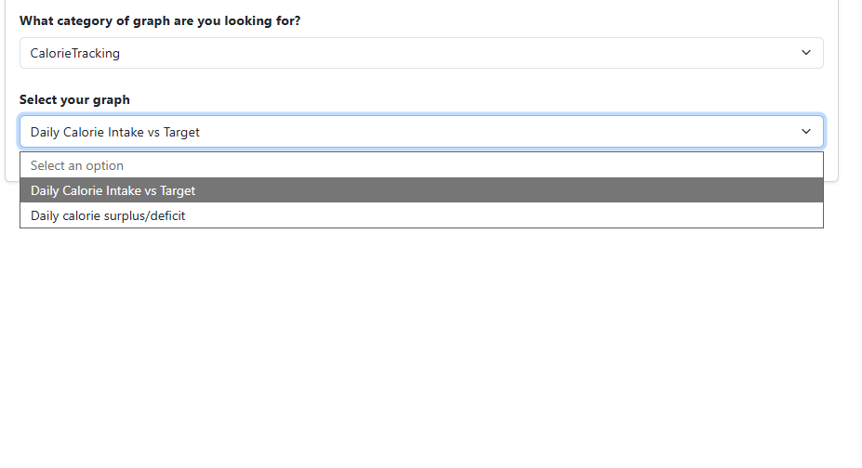

Now to work on what actually happens when the secondary option is selected. But first I need to set up a graph visualisation container on the middle-bottom of the page.

Weight change per week graph:

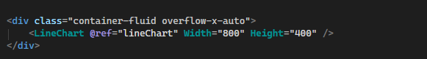

Added a line chart at the bottom of the page and set it to default width and height properties.

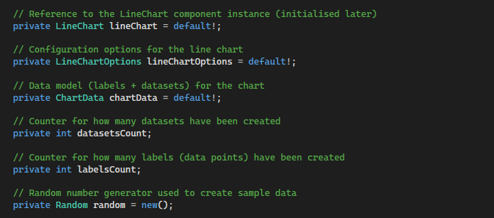

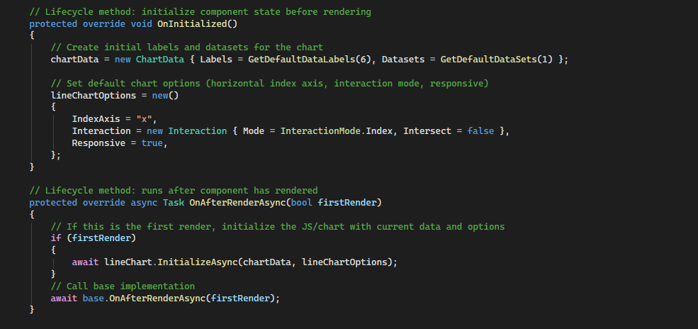

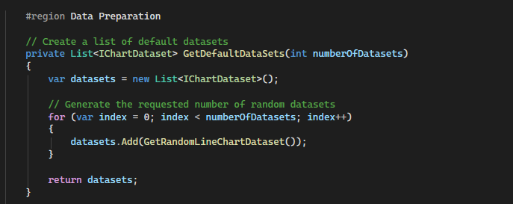

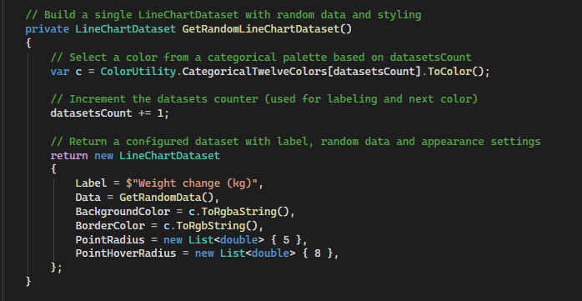

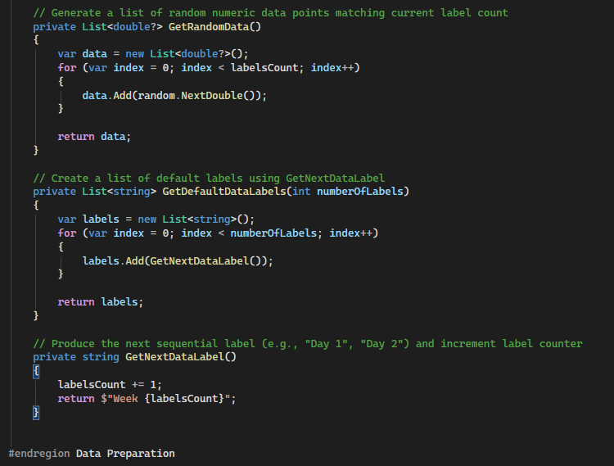

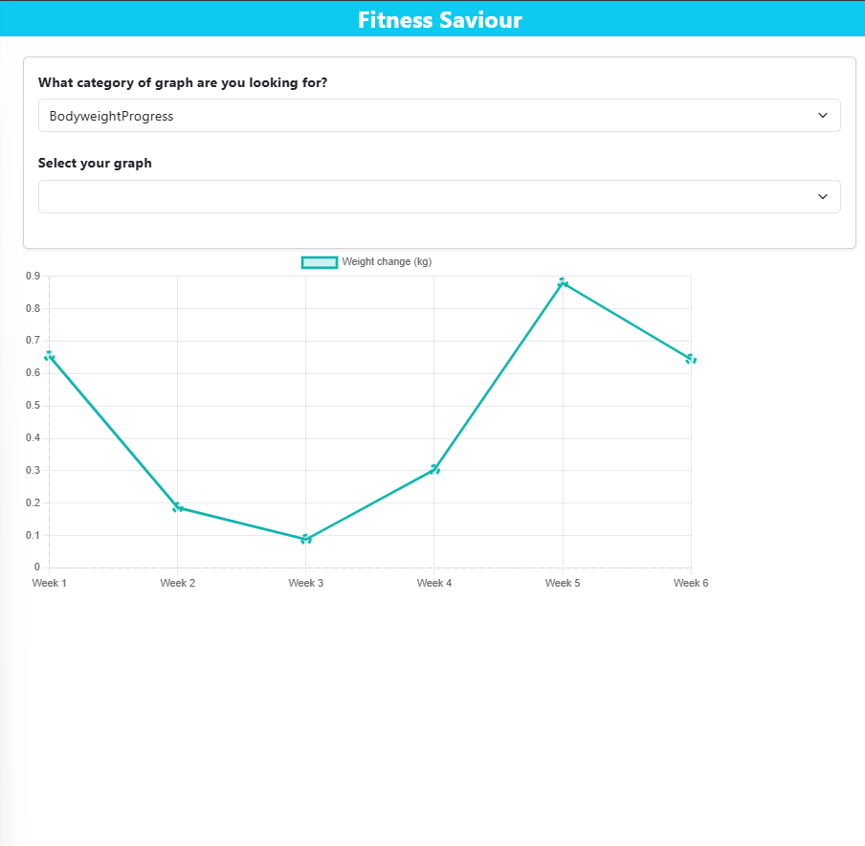

Issue is weight change can be positive or negative so I need to create a negative y axis component.

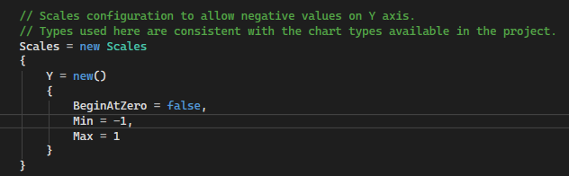

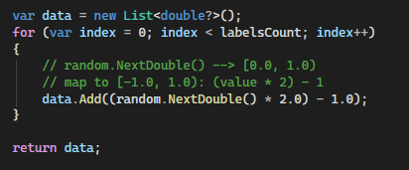

The maths behind this is that it will generate random numbers from -1 to 1.

Result:

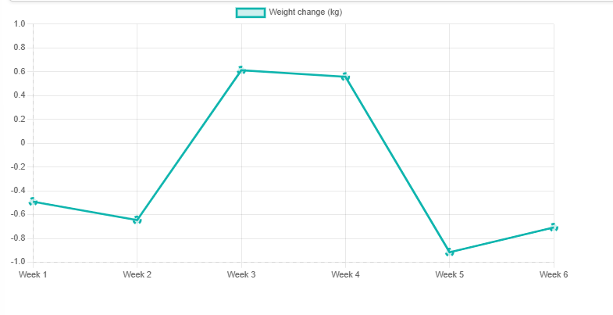

I want a line on the 0 mark to indicate baseline.

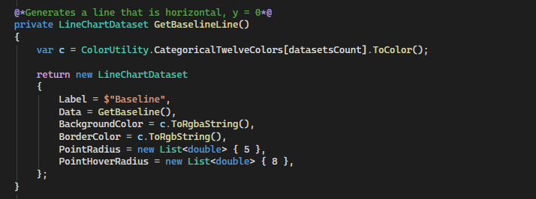

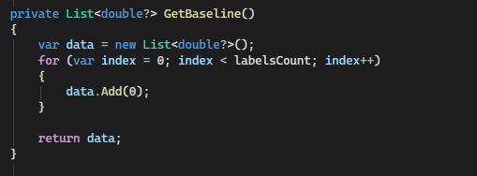

Ensures every x axis coordinate has a y axis value of 0

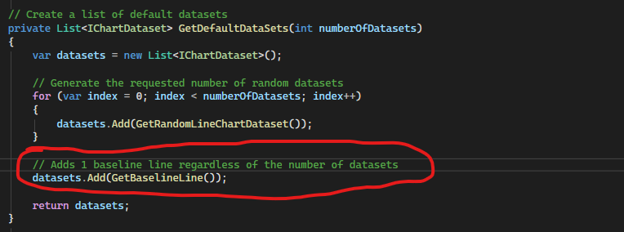

Added this

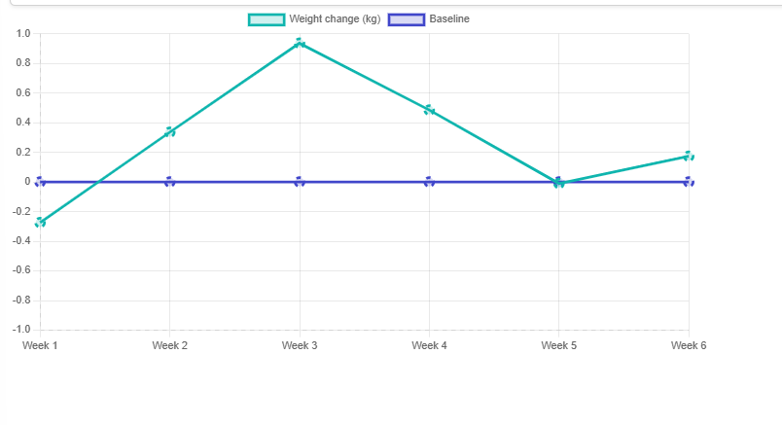

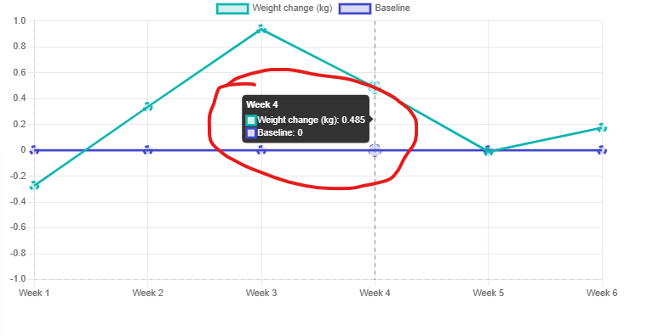

I want the baseline tooltip to also display the (kg).

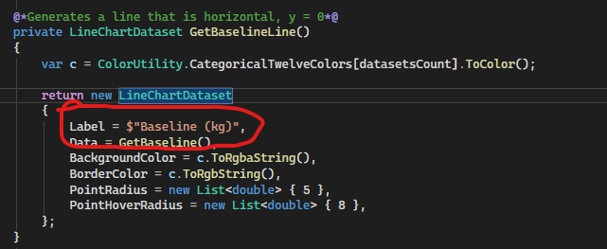

Made the change

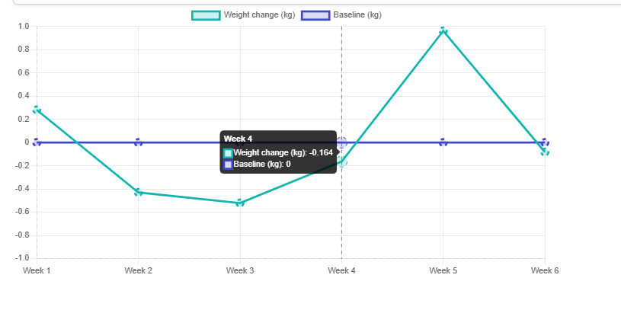

Right now my graphs page is going to have a lot of cs code which will make it hard to maintain, so I will migrate the logic to another file.

I made a class called Graphs.razor.cs, and visual studio automatically indented it under the graphs page.



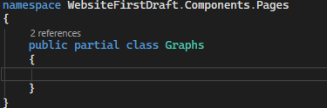

I had to make this a partial class as it shared the name of the razor component.

From here I copied all my coding logic from the code block of my razor page, and deleted the code block.

It worked as normal.

From here I did the same process for other pages that I felt the c# code was quite a lot.

For some of the pages I had commented with @**@ syntax (razor component comments) instead of the // that c# uses, these generated errors which I had to manually change.

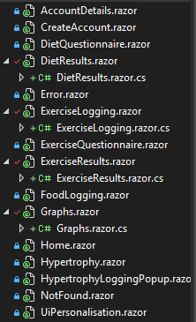

The changes made to the pages.

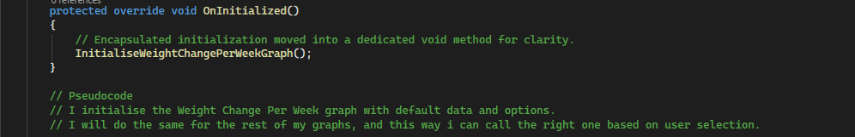

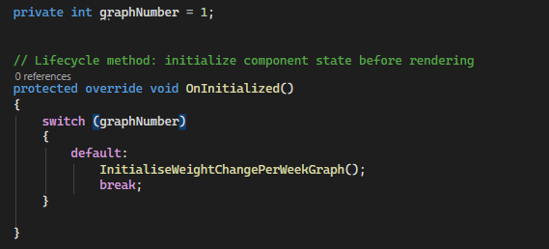

Created an integer graphNumber that will be related to user input, and a switch statement will traverse every possible user selection to call the correct method for that graph, Here I set the default as the only graph ive set up.

Coding bodyweight over time graph:

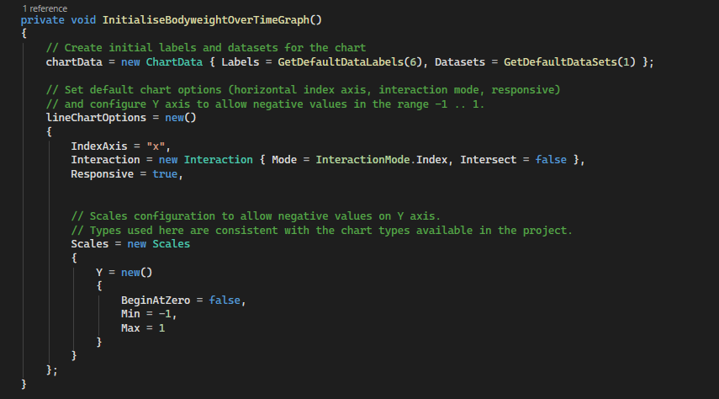

Copied and pasted code from previous graph into a new method I have named InitialiseBodyweightOverTimeGraph.

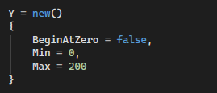

Set a new min and max for the y axis as weight cant be below 0 and its highly improbable for an individual to be over 200 kg.

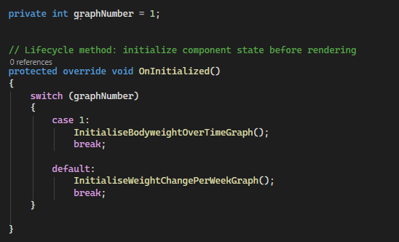

I have hard coded the switch statement so that it will always display the graph im currently working on.

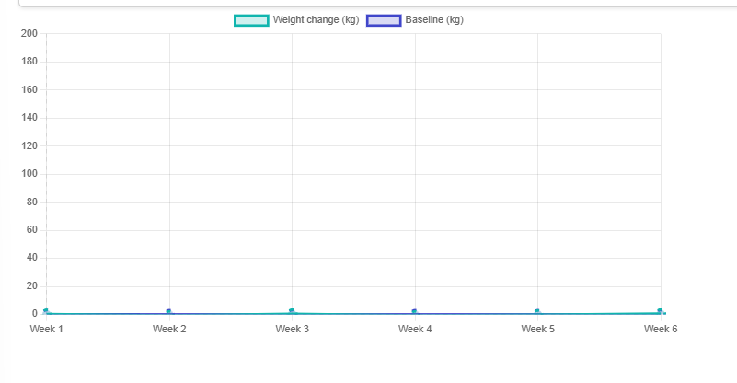

Now I need to remove the baseline label and rename the other label to bodyweight in kg.

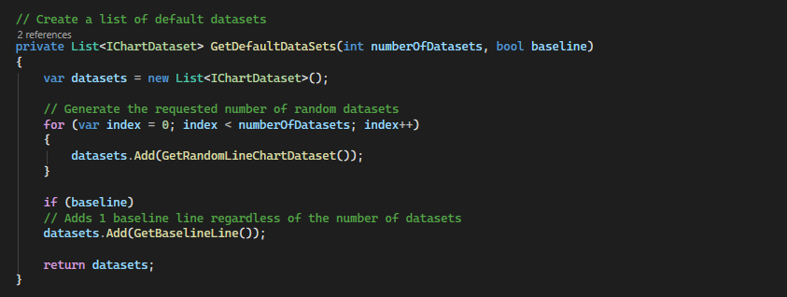

I added another parameter on my method that generates the datasets. This is a Boolean called baseline that will generate a baseline line if true.

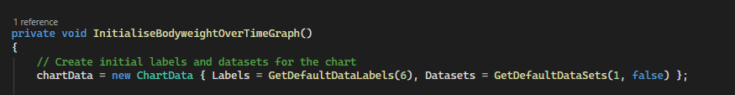

False for bodyweight over time graph



True for weight change per week graph.

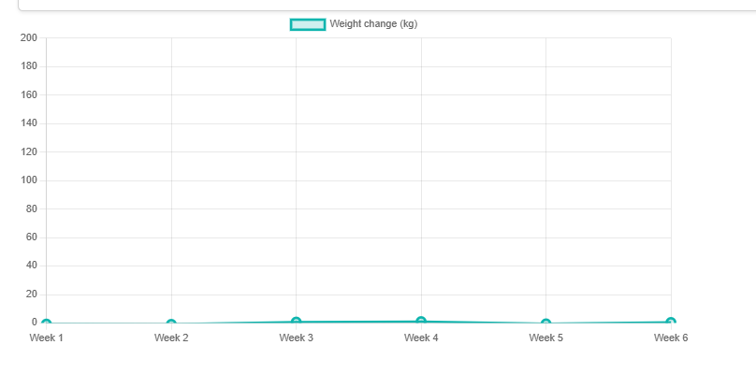

Result: no baseline.

Now to change the label

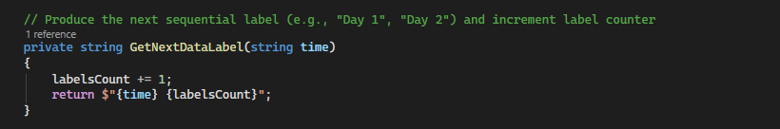

Added a parameter to this method.

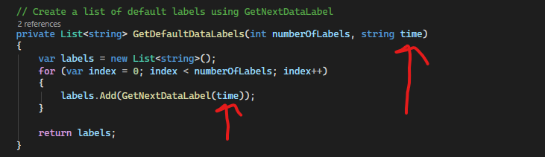

Added a parameter to this method and called the value of that parameter into the getnextdatalabel method.

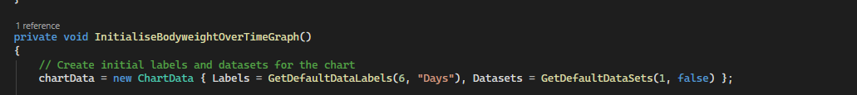

I pass the string “Days” into the bodyweight over time graph



And I pass “weeks” into the weight change per week graph.

Changed these to day and week as I realised the redundancy of plurality.

Result:



Graph works but values are really low due to using the same range of datapoints as the graph before it that only took values from -1 to 1.

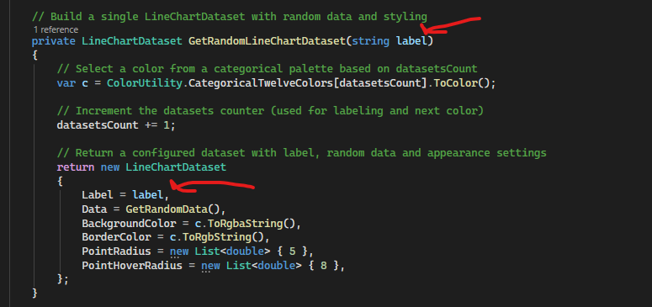

Pass a string label as a parameter into this method and assign it to the attribute Label to hard code the label for each graph.

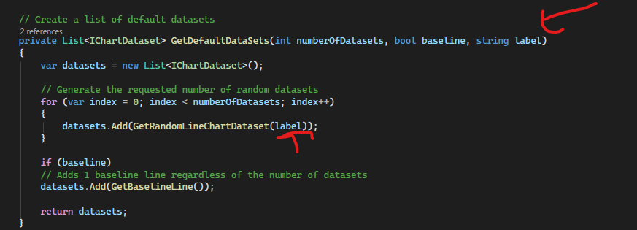

Did the same over here.

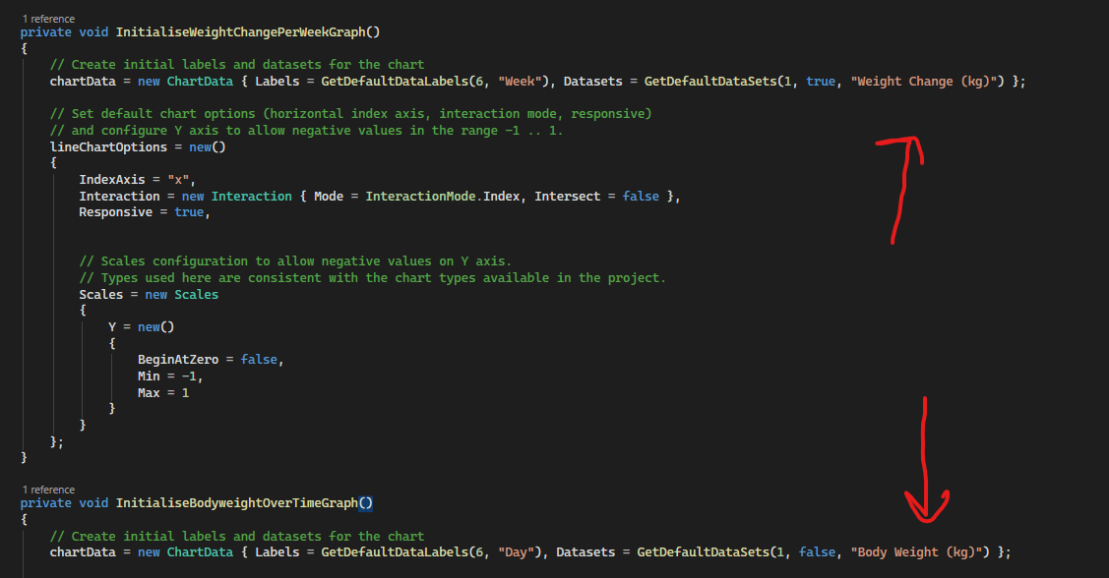

Pass in these new parameters for both of my graphs

Result:

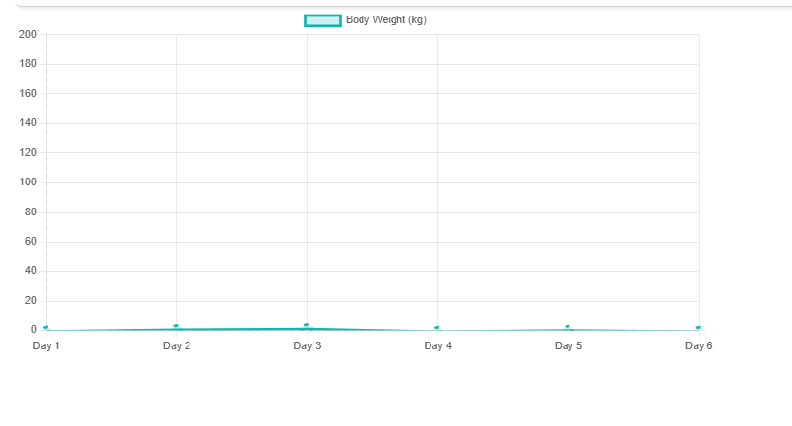

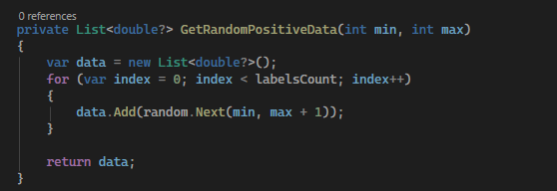

Created a method that will generate a random list of positive data points from a specified range as parameters.

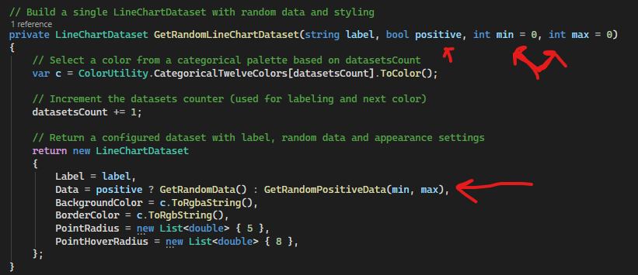

Added 3 parameters to the method that generates the dataset. Added a Boolean that will be true if the dataset only accepts positive values. The other 2 parameters specify the range of data points.

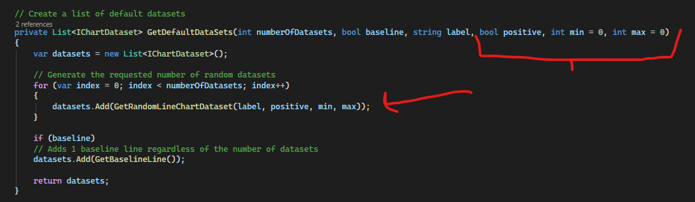

Make changes to this method to reflect the extra parameters.



The weight change per week graph doesn’t need the min and max parameters passed as it is not an exclusively positive graph.



Added in the extra parameters to the body weight graph.

Results:

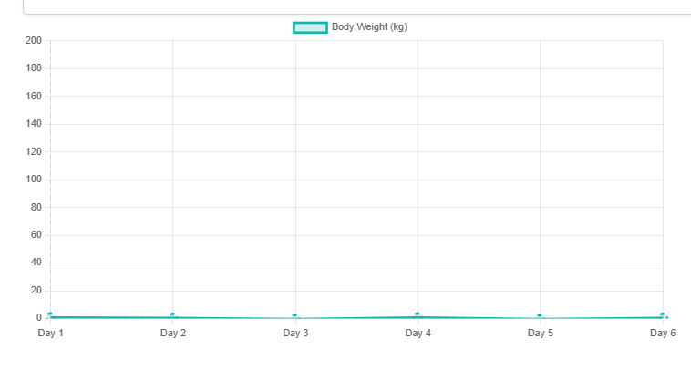

Didn’t work.

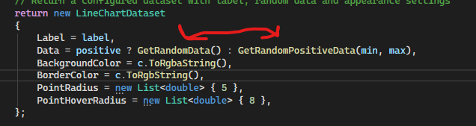

Issue is here, these are the wrong way round. When positive is true, Data is assigned the non-positive method.

Result:

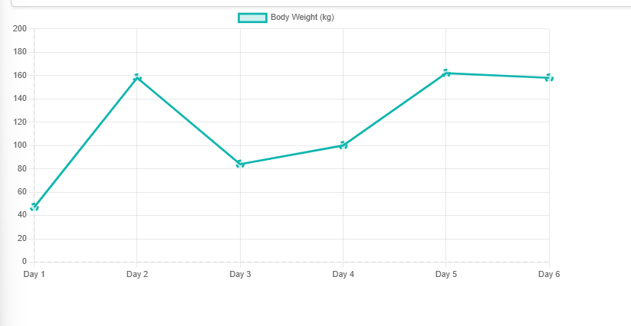

Success

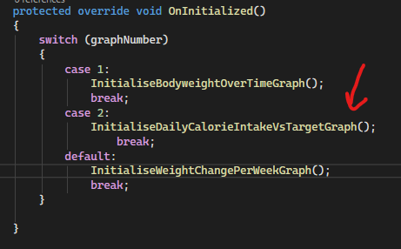

New graph method

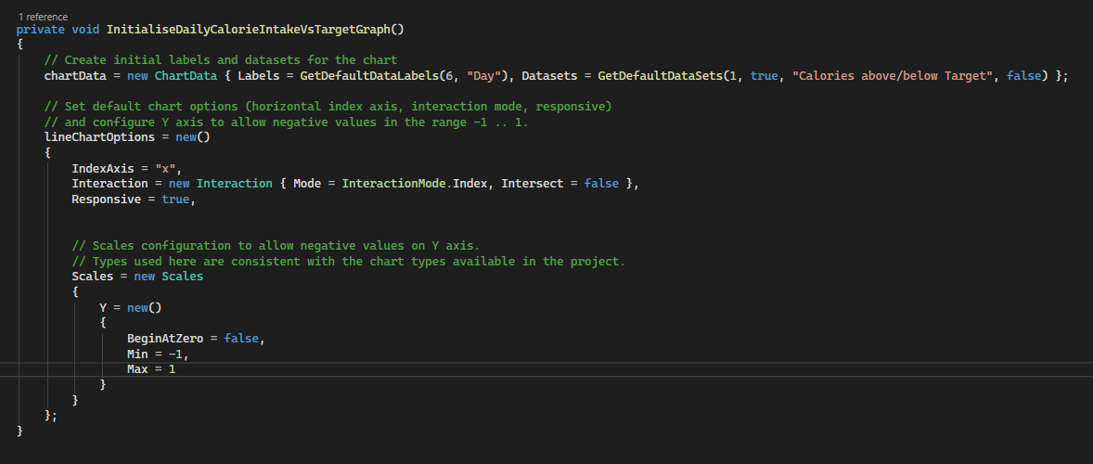

Initialised with a baseline and negative values.

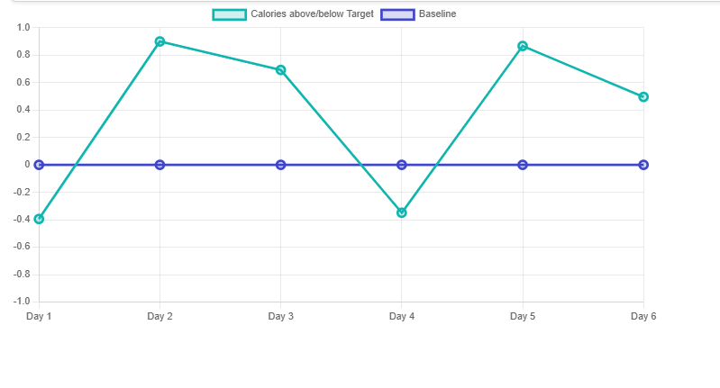

Result.

Now I want to bind these graphs to user input.

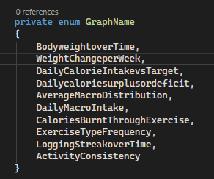

Created an enum of graph names, with every graph I intend to make.



Created an instance of the enum

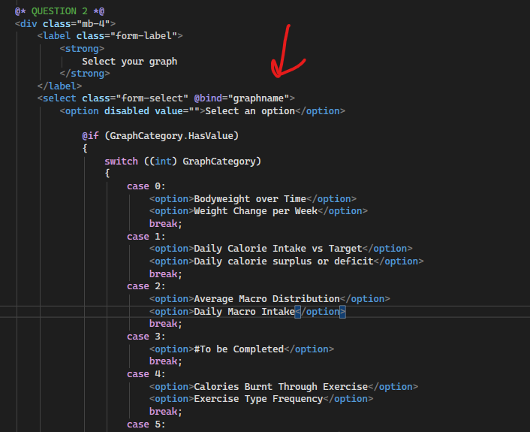

Bound the enum to the form so that it is assigned a value from user input.

The graphname enum was not successfully binding to the form. I did some research and realised the method I was using with my other forms was inefficient, and the framework I was using (blazor) has a built in enum input component.

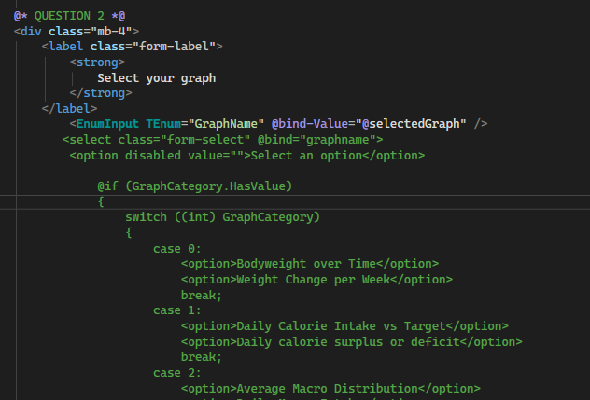

Commented out the code for my second question and added an enum input

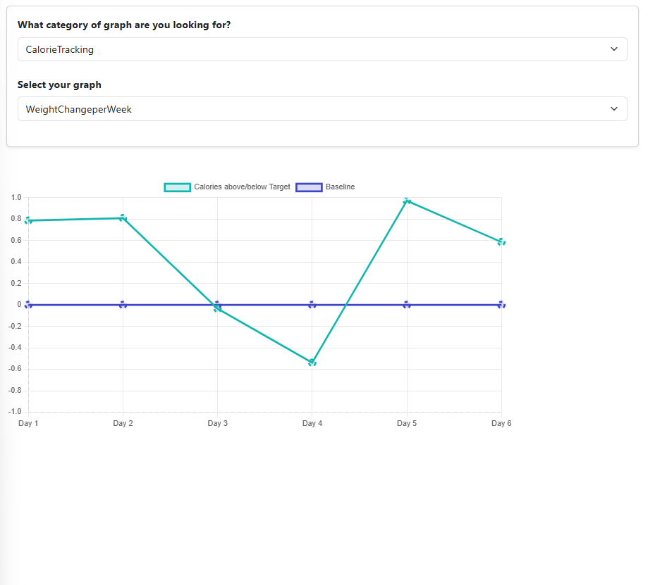

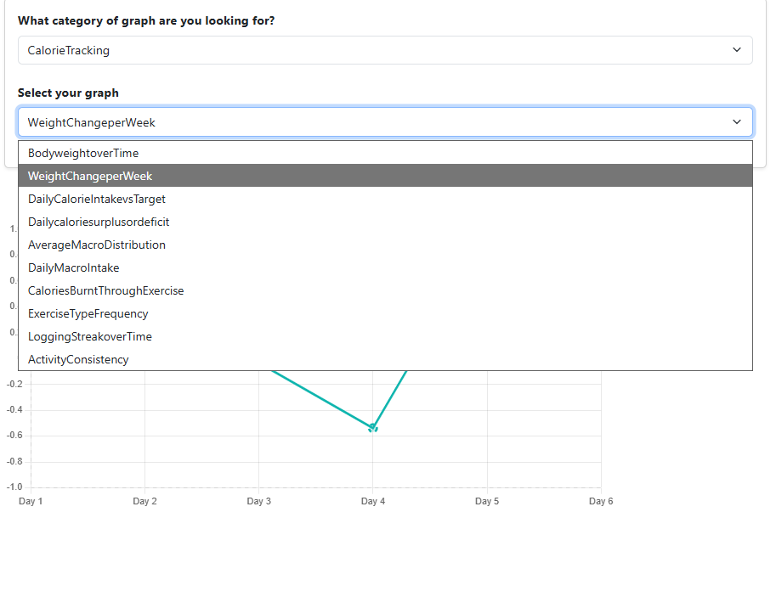

Displays all the graphs.

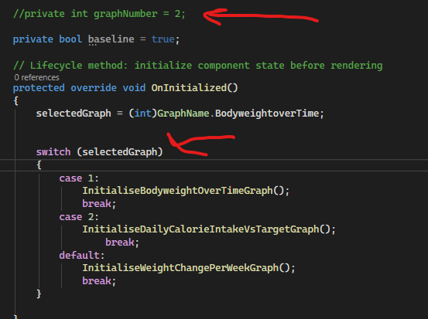

Commented out hardcoded int, and now the switch statement inside the method is bound to the enum input.

It didn’t change the graph

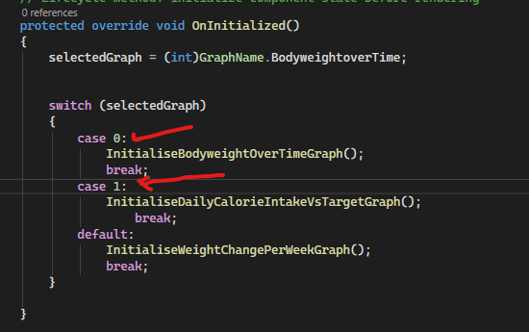

Changed numbers on switch statement to match correctly but it still didn’t work. Issue is it only loads the graph based on the value of the enum when its initialised and doesn’t update dynamically.

Working on users backend:

Issue I found is that SQL server does not support Boolean data type which a few of my fields required. Instead you use BIT where a value of 0 is false, 1 is true and null is unknown.

Another issue was the data type double which doesn’t exist. Instead I had to change this to Float(53) which is the equivalent.

The query I used to create my tables:

CREATE TABLE [Food_items] (

[food_id] integer PRIMARY KEY,

[food_name] nvarchar(255),

[food_type] nvarchar(255),

[calories_per_gram] FLOAT(53),

[carbs_per_gram] FLOAT(53),

[protein_per_gram] FLOAT(53),

[fat_per_gram] FLOAT(53)

)

GO

CREATE TABLE [users] (

[user_id] integer PRIMARY KEY,

[username] nvarchar(255),

[password_hash] nvarchar(255),

[encrypted_email] nvarchar(255),

[encrypted_phone_number] nvarchar(255),

[role] nvarchar(255),

[created_at] timestamp,

[login_streak] int,

[daily_calories] int,

[daily_carbs] int,

[daily_protein] int,

[daily_fat] int,

[weekly_calories] int,

[weekly_carbs] int,

[weekly_protein] int,

[weekly_fat] int,

[total_calories] int,

[high_contrast_mode] BIT,

[dyslexia_font] BIT,

[reduced_animations] BIT,

[larger_text_size] BIT,

[tracking_preferences] nvarchar(255),

[visual_rewards] BIT,

[progress_data] BIT,

[minimal_interface] BIT

)

GO

CREATE TABLE [users_food_items] (

[users_food_item] INT PRIMARY KEY,

[user_id] integer,

[food_id] integer

)

GO

CREATE TABLE [exercise_types] (

[exercise_id] integer PRIMARY KEY,

[exercise_name] nvarchar(255),

[exercise_type] nvarchar(255),

[calories_burnt_per_minute] FLOAT(53),

[intensity] nvarchar

)

GO

CREATE TABLE [hypertrophy_exercises] (

[h_exercise_id] integer PRIMARY KEY,

[body_part] nvarchar(255),

[calories_burnt_per_rep] FLOAT(53),

[exercise_id] integer

)

GO

CREATE TABLE [graphs] (

[graph_id] integer PRIMARY KEY,

[graph_category] nvarchar(255),

[graph_type] nvarchar(255)

)

GO

CREATE TABLE [food_items_graphs] (

[food_items_graph] INT PRIMARY KEY,

[food_id] int,

[graph_id] int

)

GO

CREATE TABLE [exercise_graphs] (

[exercise_graph] INT PRIMARY KEY,

[exercise_id] int,

[graph_id] int

)

GO

CREATE TABLE [user_graphs] (

[user_graph] INT PRIMARY KEY,

[user_id] int,

[graph_id] int

)

GO

ALTER TABLE [exercise_types] ADD FOREIGN KEY ([exercise_id]) REFERENCES [hypertrophy_exercises] ([exercise_id])

GO

ALTER TABLE [users_food_items] ADD FOREIGN KEY ([user_id]) REFERENCES [users] ([user_id])

GO

ALTER TABLE [users_food_items] ADD FOREIGN KEY ([food_id]) REFERENCES [Food_items] ([food_id])

GO

ALTER TABLE [food_items_graphs] ADD FOREIGN KEY ([graph_id]) REFERENCES [graphs] ([graph_id])

GO

ALTER TABLE [food_items_graphs] ADD FOREIGN KEY ([food_id]) REFERENCES [Food_items] ([food_id])

GO

ALTER TABLE [exercise_graphs] ADD FOREIGN KEY ([graph_id]) REFERENCES [graphs] ([graph_id])

GO

ALTER TABLE [exercise_graphs] ADD FOREIGN KEY ([exercise_id]) REFERENCES [exercise_types] ([exercise_id])

GO

ALTER TABLE [user_graphs] ADD FOREIGN KEY ([user_id]) REFERENCES [users] ([user_id])

GO

ALTER TABLE [user_graphs] ADD FOREIGN KEY ([graph_id]) REFERENCES [graphs] ([graph_id])

GO

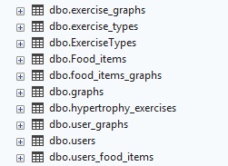

New tables have appeared. Note: exercise types is the one im working with right now and Exercise types was the test one.

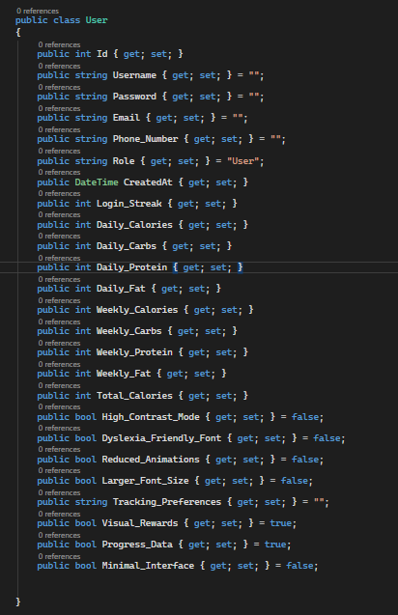

Created a class called User and added all the necessary attributes.

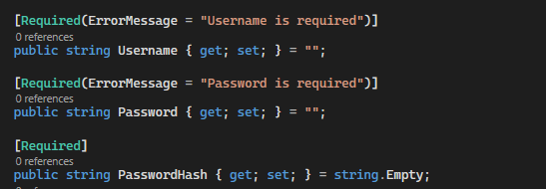

Added new attribute and set these as required with an error message if validation fails.

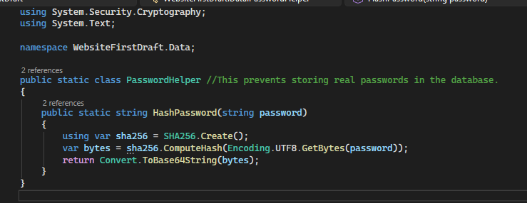

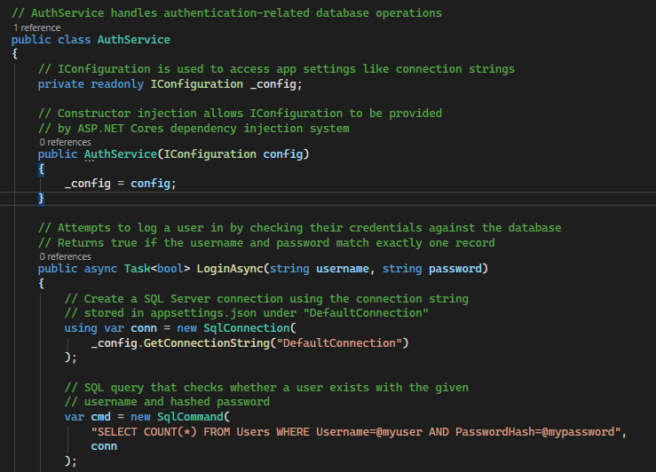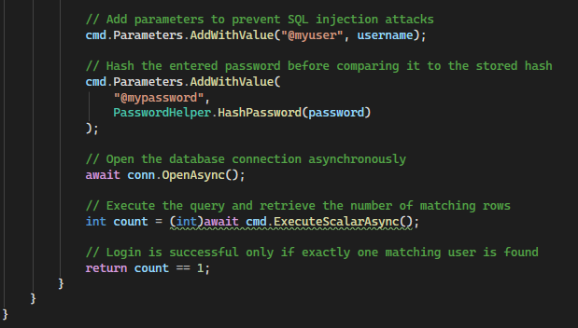



Added to program.cs file

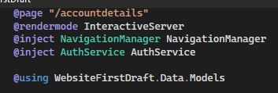

Injected Authservice onto the account details page.

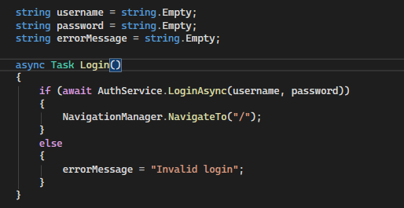

Initialised 3 variables as empty strings. Created asynchronous login method (navigates to home page if successful, displays error message if not).

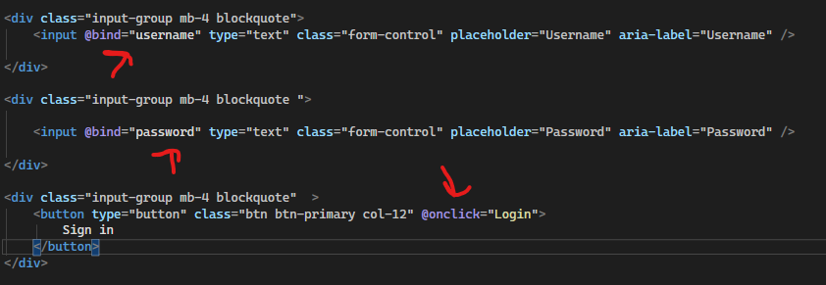

Bound the inputs to username and password, clicking sign in button calls login method.

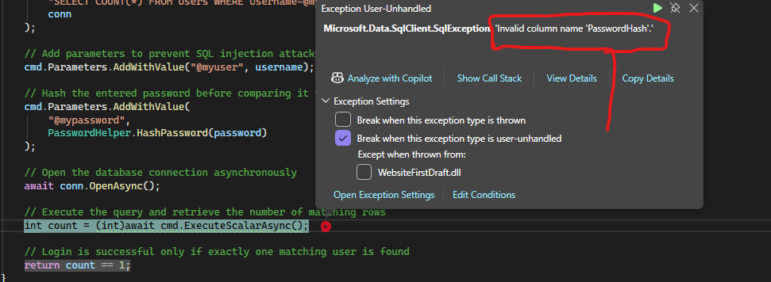

Received exception when I attempted to log in.

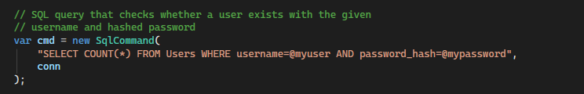

Updated statement, it was case sensitive.

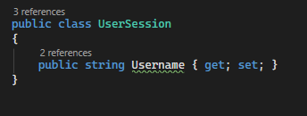

Added this class

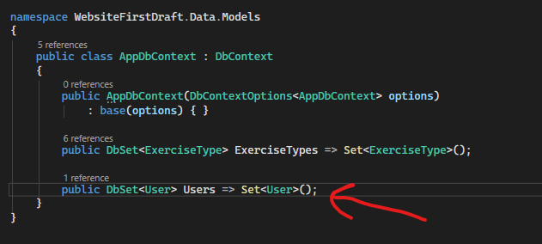

Create account page:

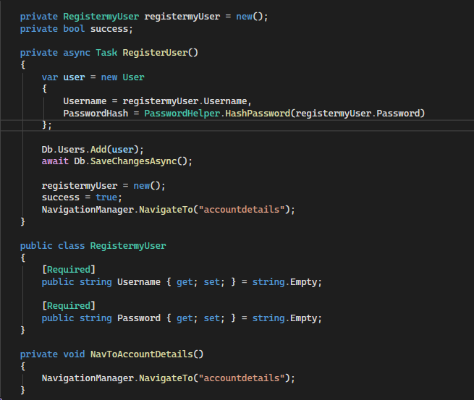

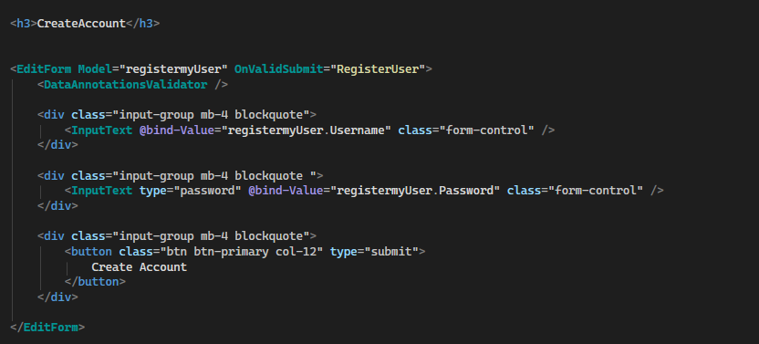

Using blazor bootstrap component editform.

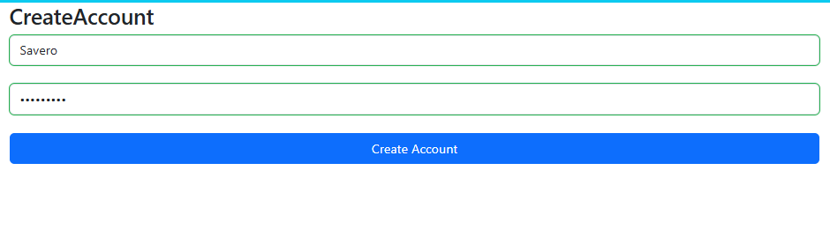

Goes green to indicate its validated.

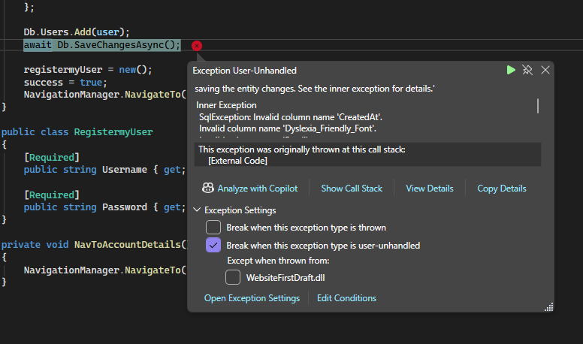

Exception when I clicked button. Need to add entry for every column in table.

I need to store email and phone number encrypted.

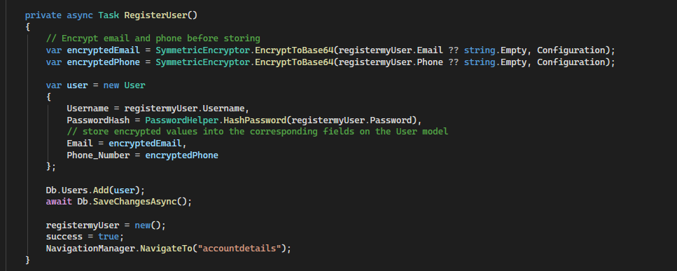

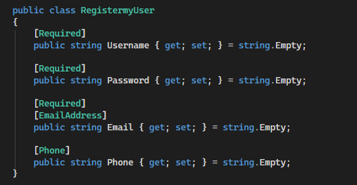

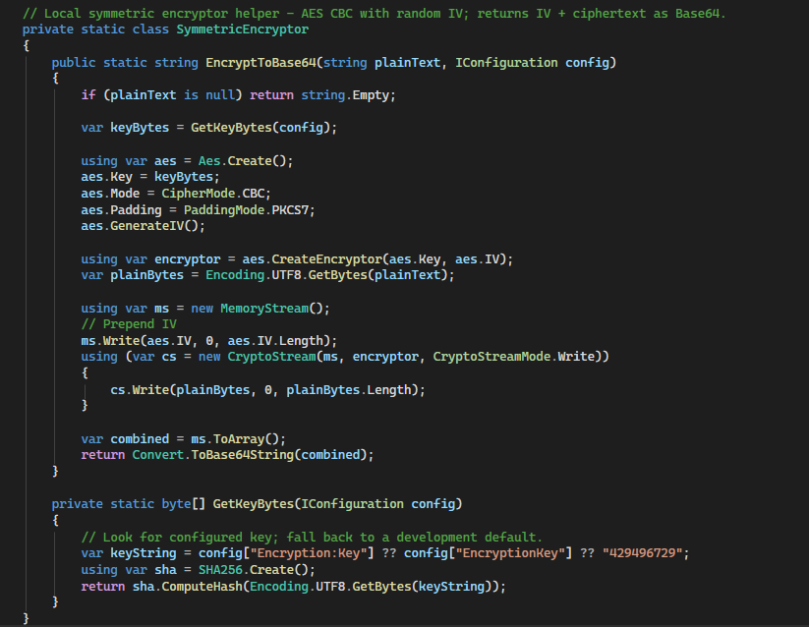

I had to rename the attributes of the user class to match the fields in the table.

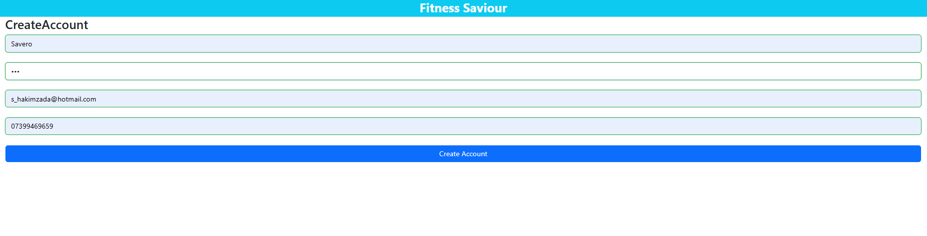

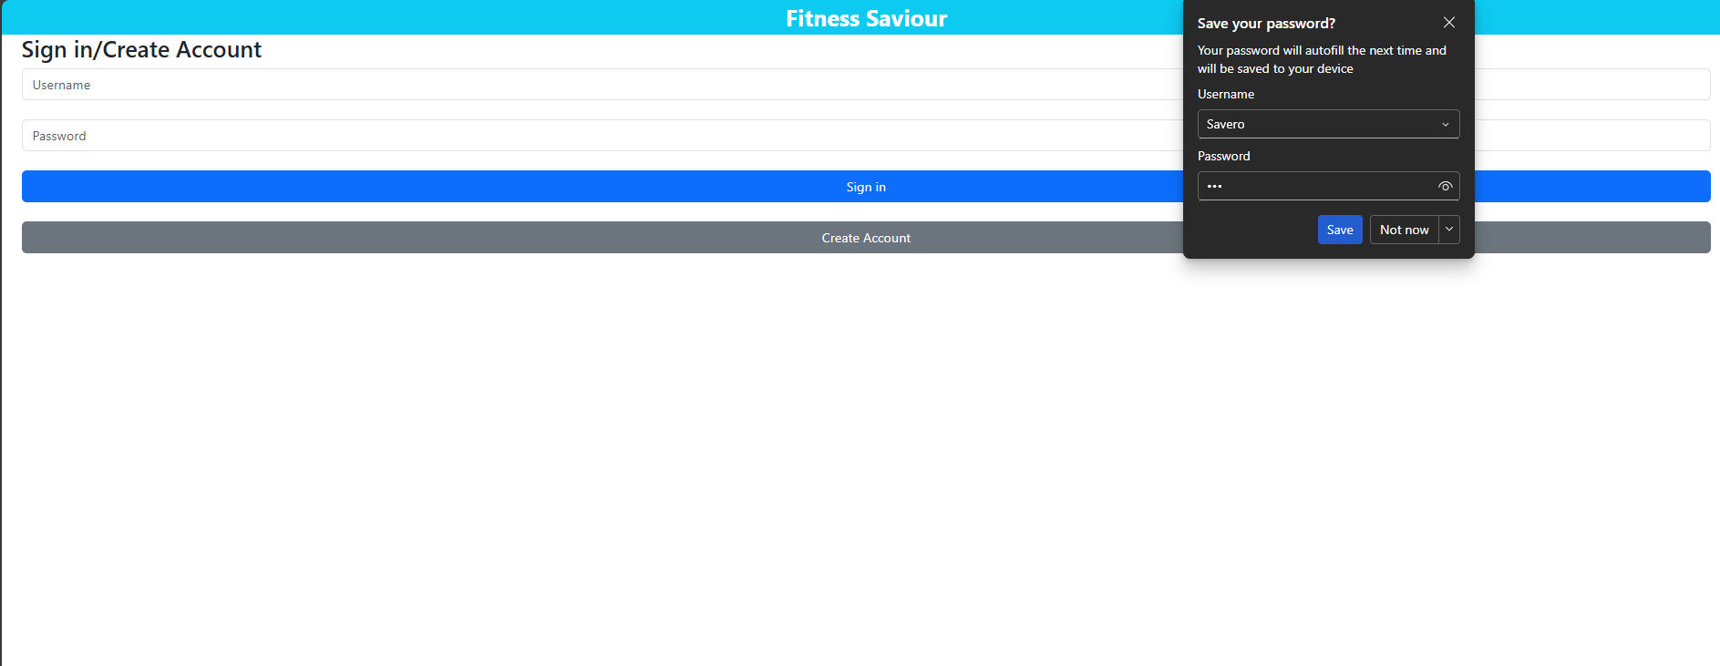

It worked.

Checking databse table:



Information stored successfully. Had to drop created at field as SQL didn’t support insertion into this kind of data type.

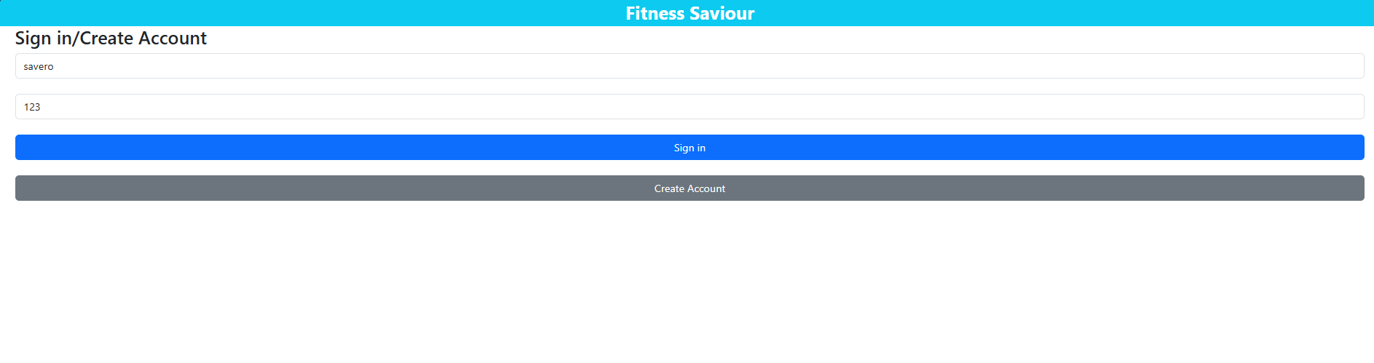

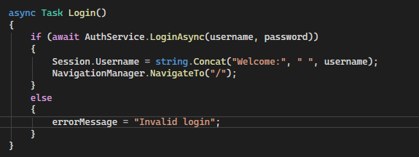

Added pop up message to log in to see if success.

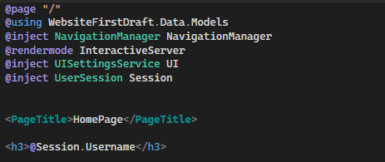

Added heading to home page that pops up if user logs in successfully

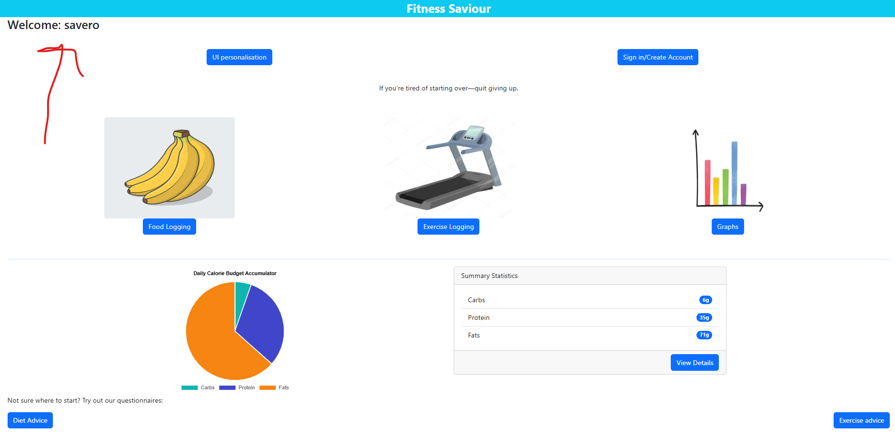

Successful.

Inserting data into tables:

Food items table:

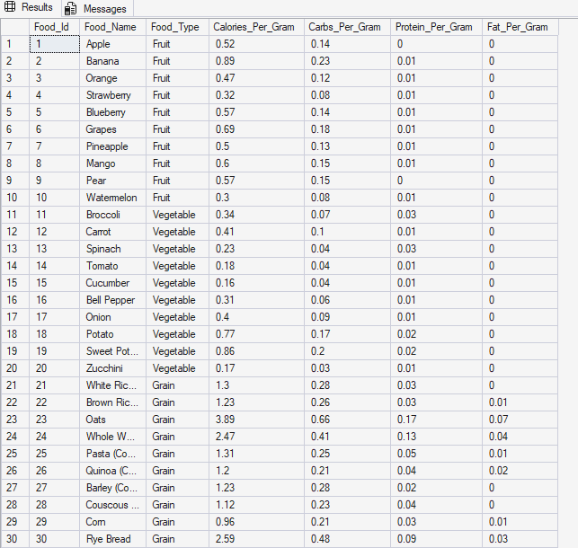

Populated table with 100 food items.

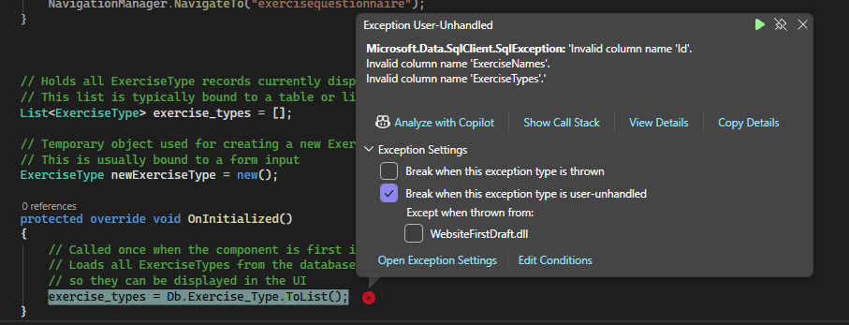

Page doesn’t load due to how the attributes in the class don’t match with the column names in the sql server database. Solution:

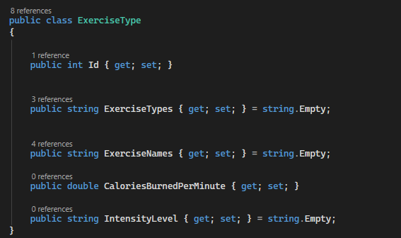

Added new attributes to the exercise type class.

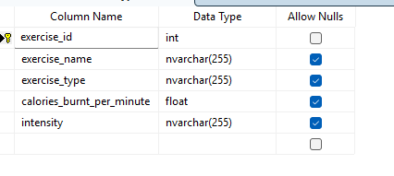

This is my exercise table.

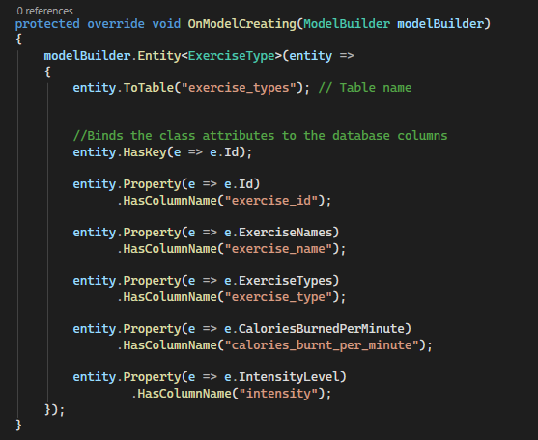

Added this method to the AppDbContext class that maps each class attribute onto database column.

Now it works and shows the page:

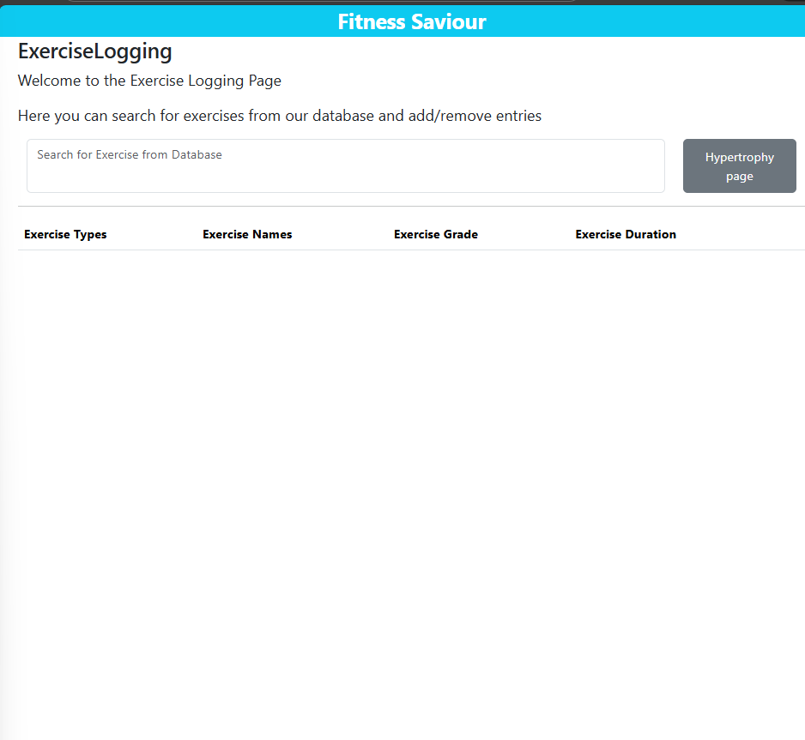

Nothing displayed as there aren’t any exercises inside it right now.



Added an entry

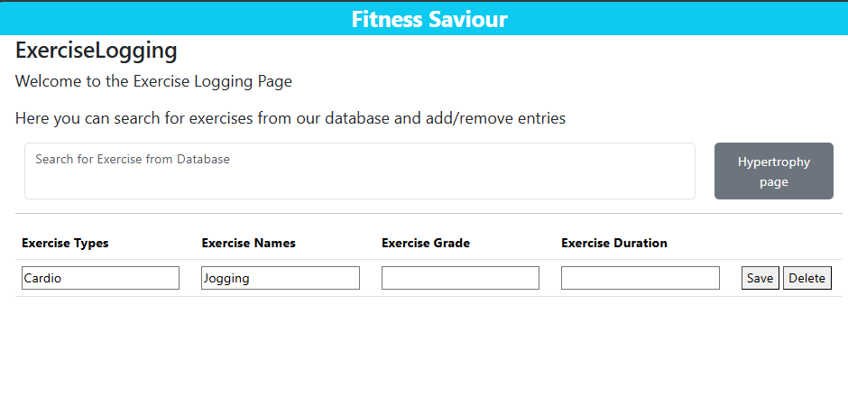

Now the page shows this.

After pressing the delete button, the exercise is successfully removed from the database and from the page.

I want to add an option at the end of the table to add an entry.

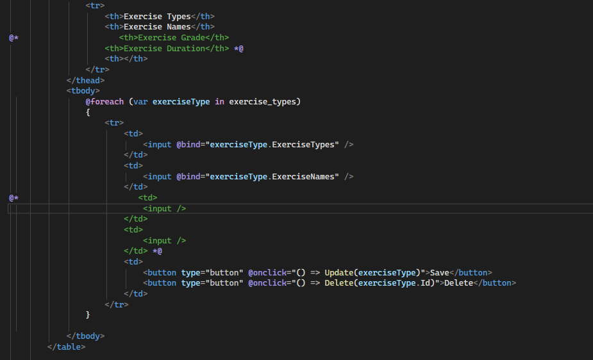

Commented out some features I will focus on later.

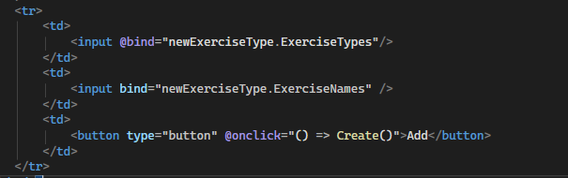

Added this row at the end of the table that will always be displayed even if the table in the database is empty.

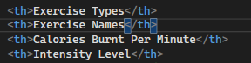

2 new headings so every column in the database table is accounted for.

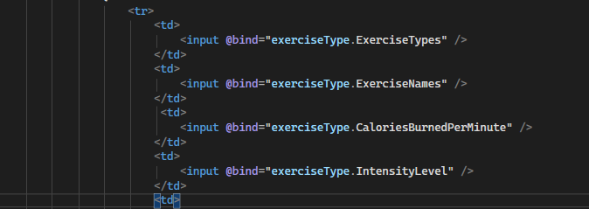

Created 2 new inputs that bind to the corresponding column.

Added 100 rows into the database table.

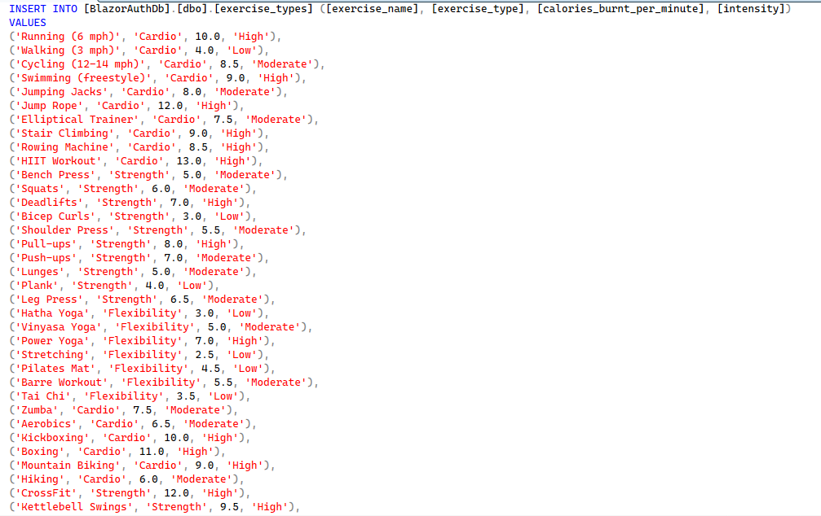

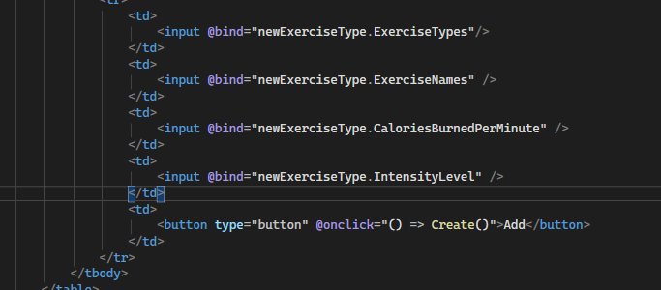

Added the option to add the 2 new columns.

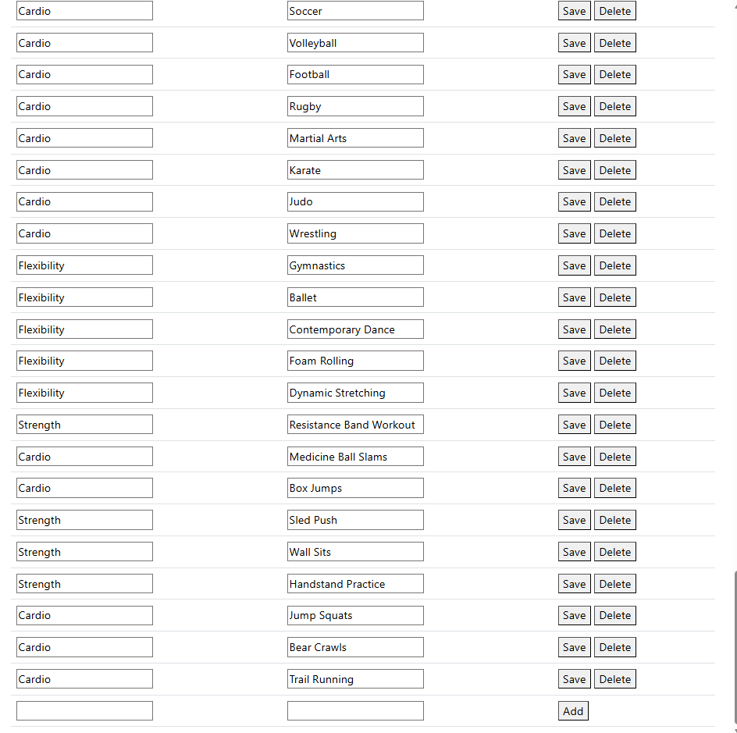

Changes reflected.

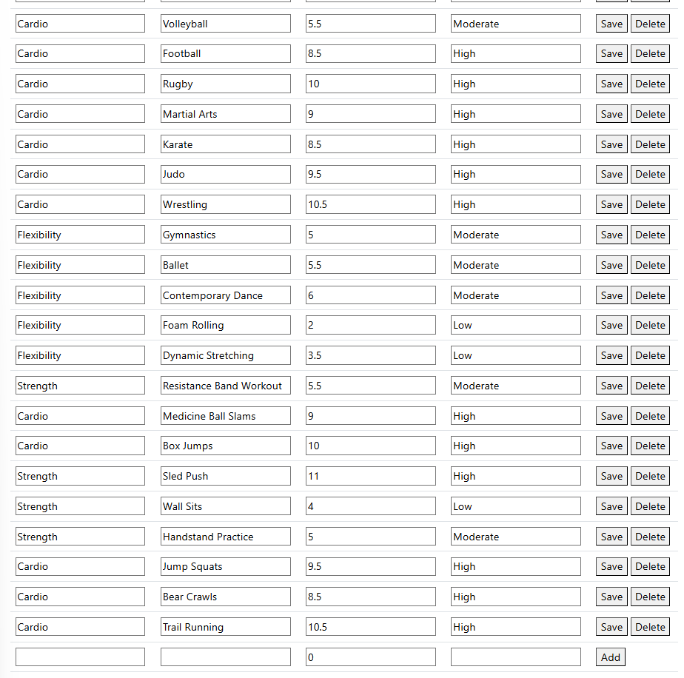

How it looks after adding the 2 new columns.



Test to add a new entry

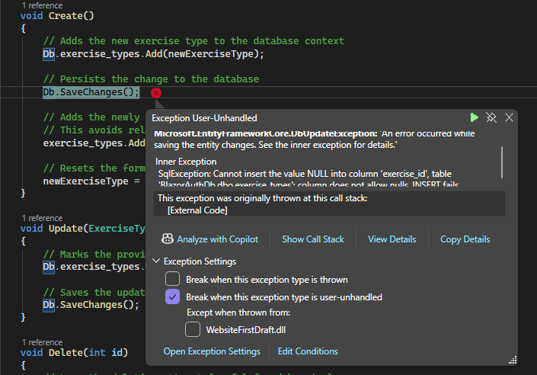

Receive exception related to how I haven’t specified what the primary key value will be for this new entry.

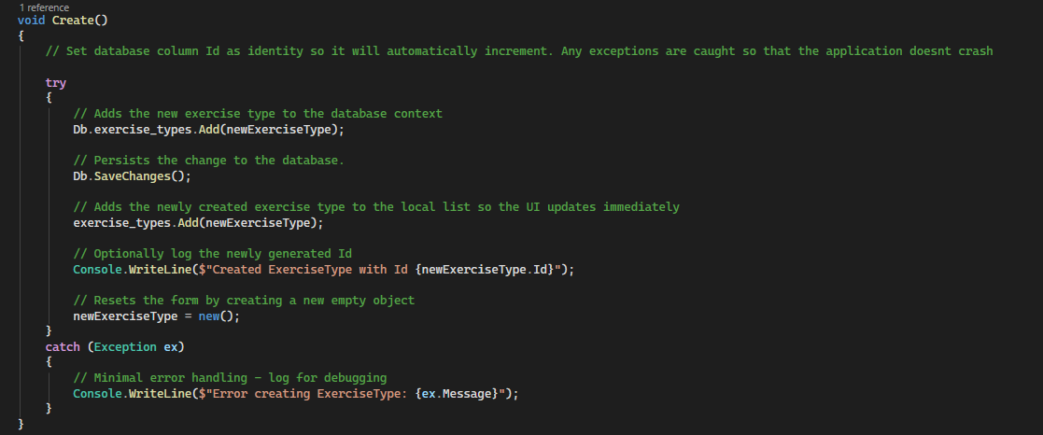

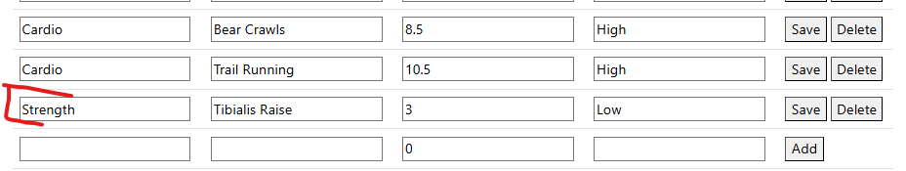

Upon trying again I was successfully able to add this new entry.

Now I will add some CSS styling to this table.

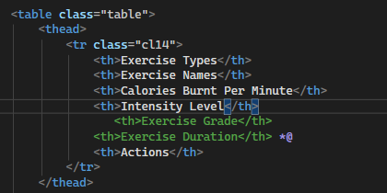

Added actions column

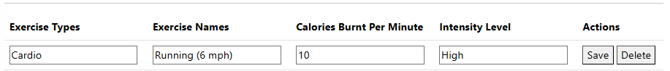

When trying to add styling to my table by adding in css classes, I found that no changes were being made. This is because the table class that I had already assigned to the table had higher css specificity than any of the css stylings I was applying.

For the intensity, I want low intensity to be a green cell, moderate to be yellow and high to be red.

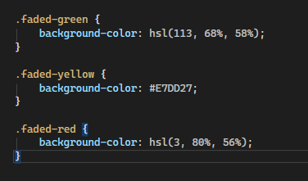

Created 3 custom css classes and made the colours ensuring they weren’t too opaque.

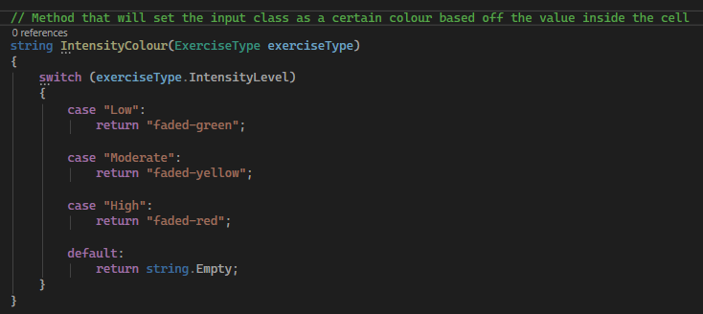



Bound this to the intensity level input column.

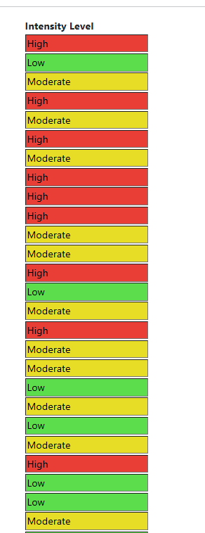

Success.



Changed the buttons to blazor components rather than the button html element for better functionality. Set the colours to match their intended purpose.

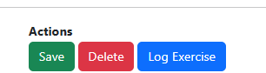

Added button that will open a pop up.

Will reuse same code for hypertrophy logging pop.

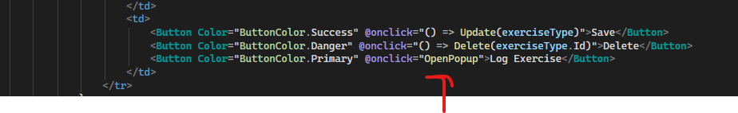

Button will now call the open pop up method.

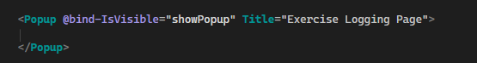

Added pop up component.

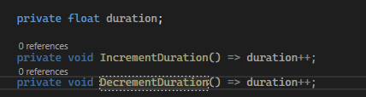

Created duration variable with methods that increment and decrement it.

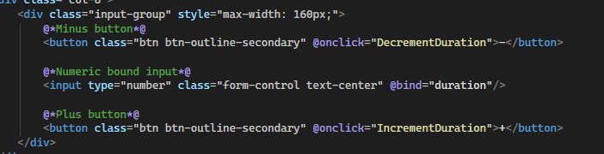

Bound the duration variable to the input field and the methods to the buttons.

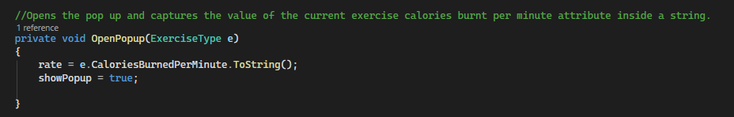

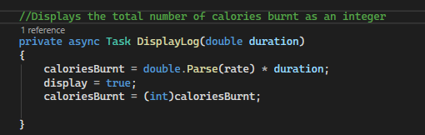

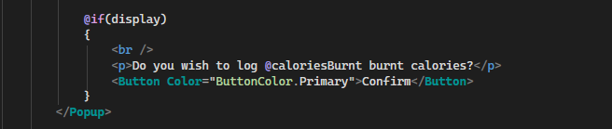

Upon clicking the log button, the pop up will expand and ask for confirmation of logging alongside the number of calories.

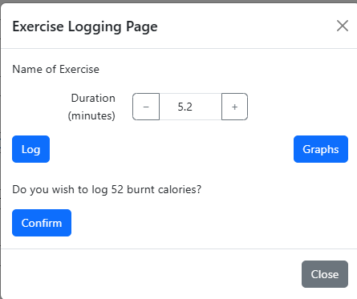

Success.

Centred all titles on the website.

Making workout split generator page.

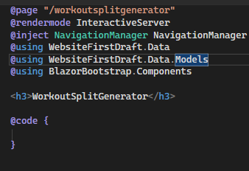

Starting code of page.

Following same template as the diet and exercise questionnaire so I wont detail the process of doing this. Final look:

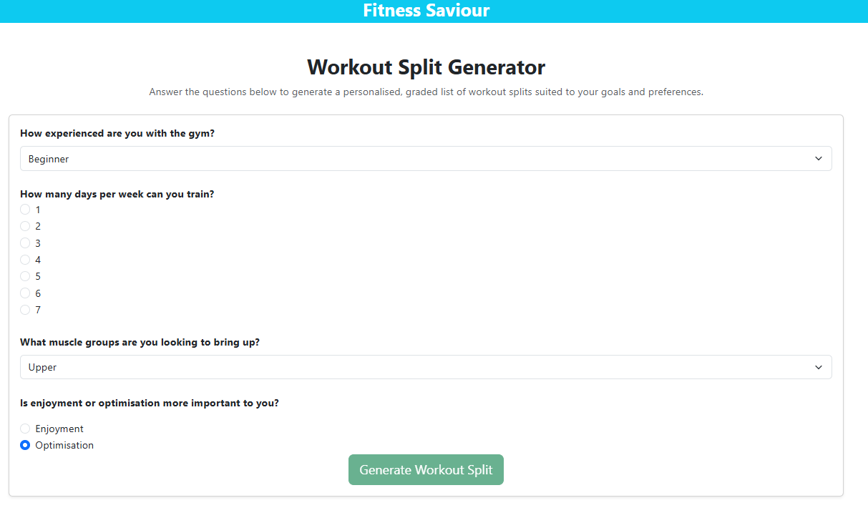

Adding button to home page that will navigate to this questionnaire.

Before: 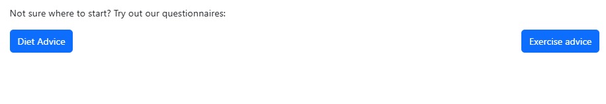

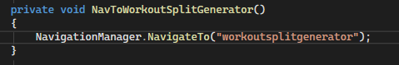

Navigation method.



Added button.

Result:

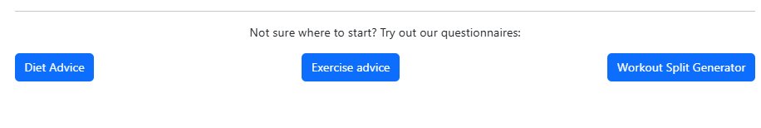

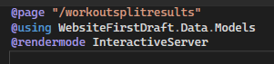

Created results page.

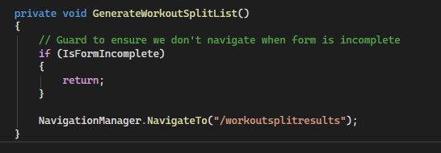

Bound navigation method onto button

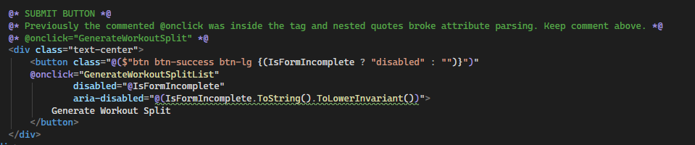

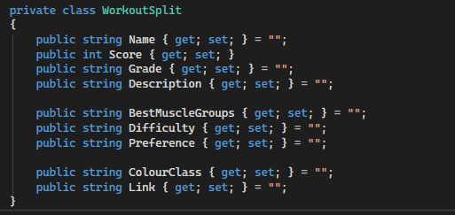

Class model for workout split.

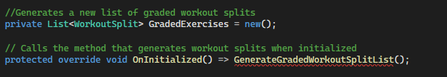

Same concept as exercise and diet but different scoring logic:

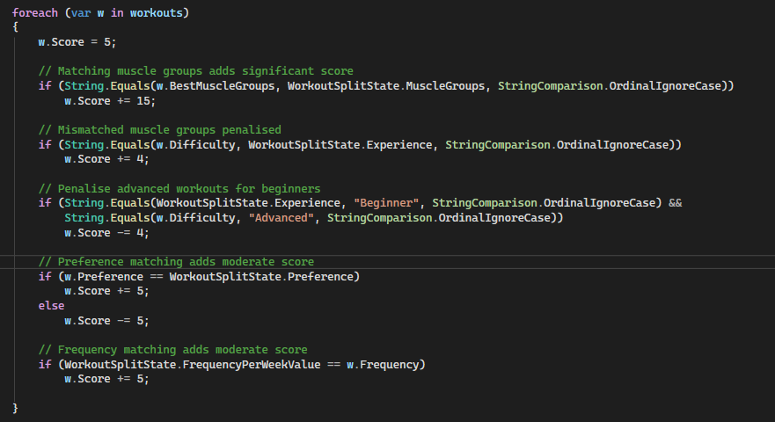

Results:

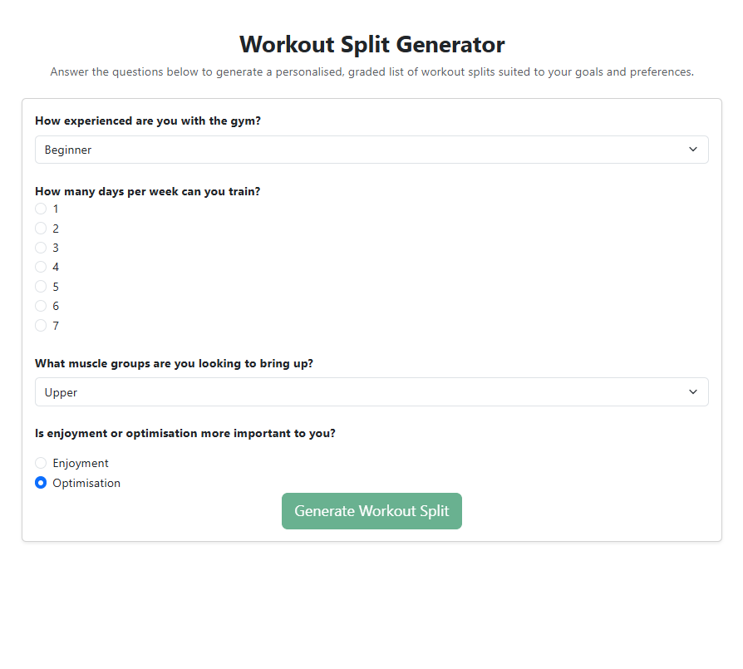

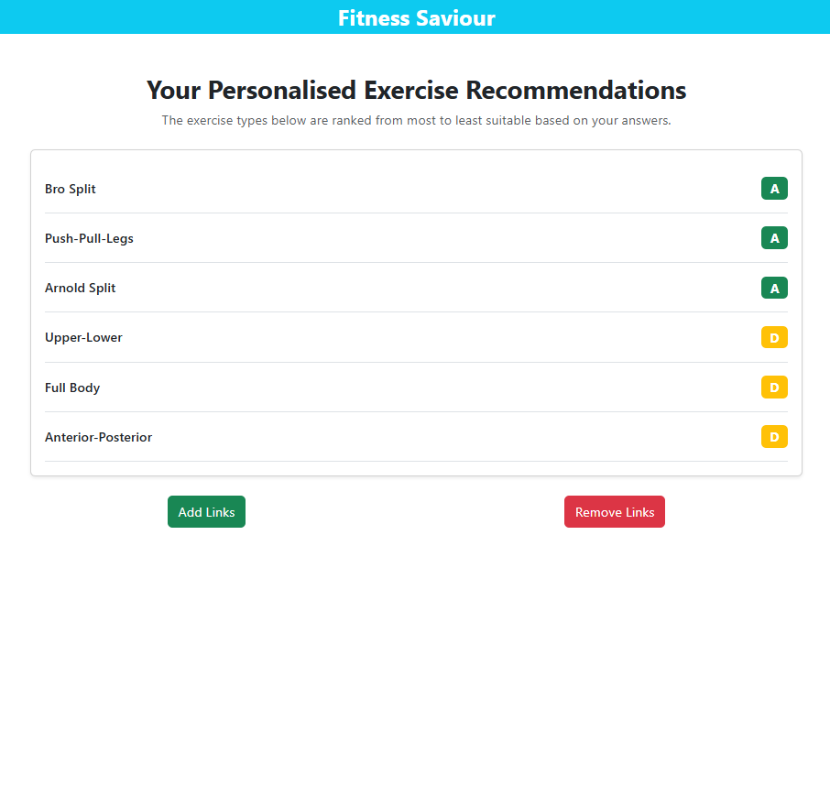

Setting up footer:

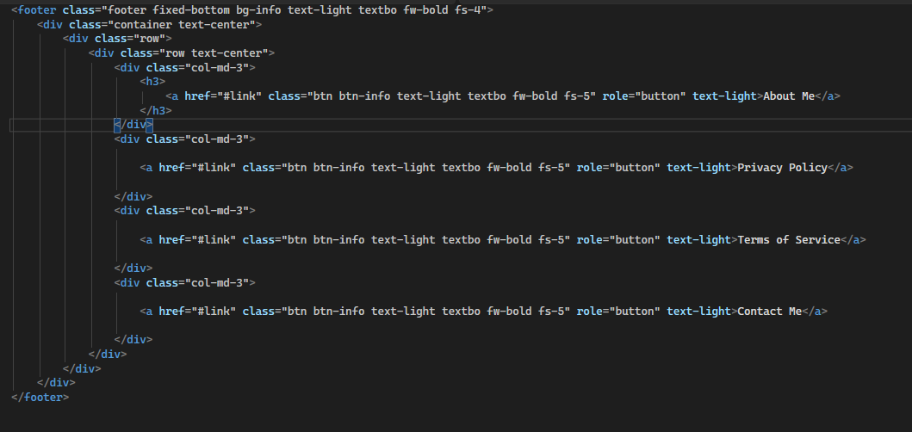

Result:

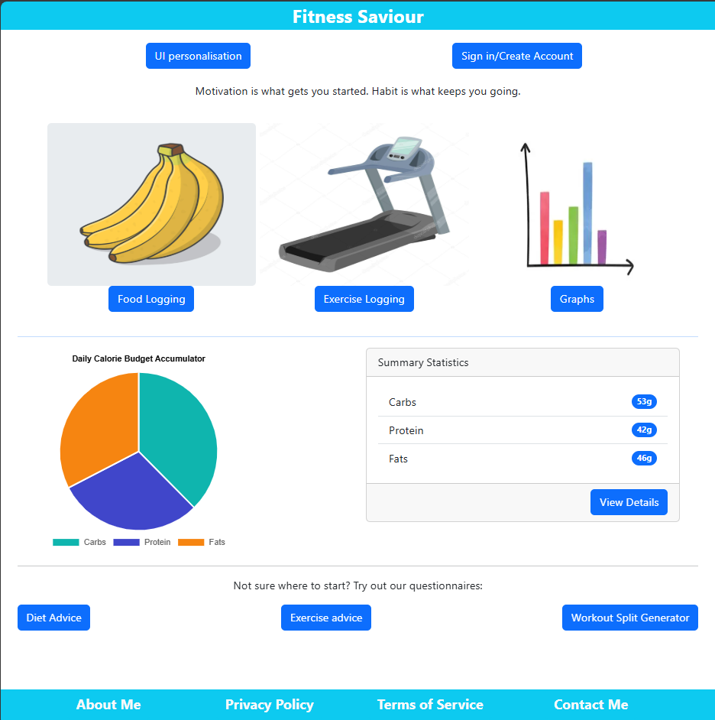

Now I need to set up the links that the pages take the user to.

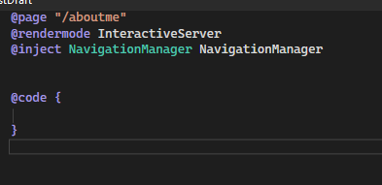

Created about me page that stores information about myself.

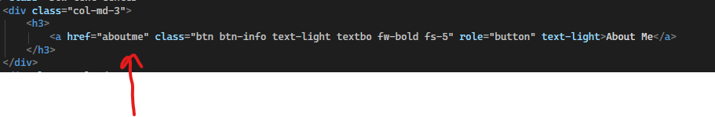

Set the href attribute of the about me button to this new page.

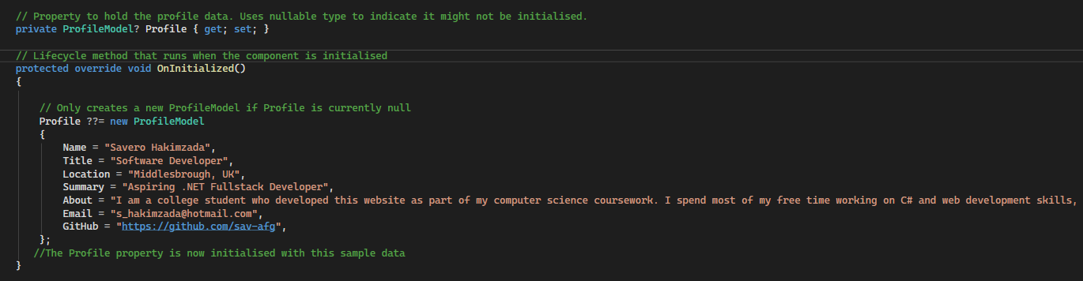

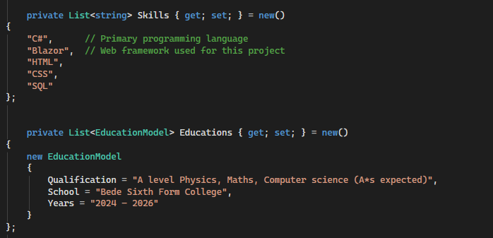

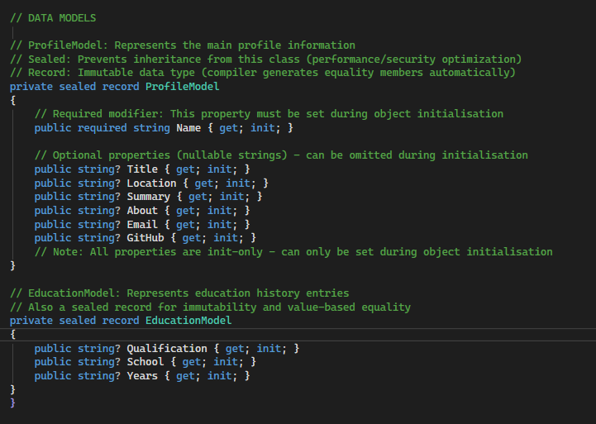

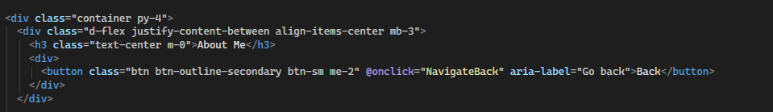

Set up a container div that ensures that there will be 2 sections: one on the left and one on the right (flex box). A button allows navigation back to homepage.

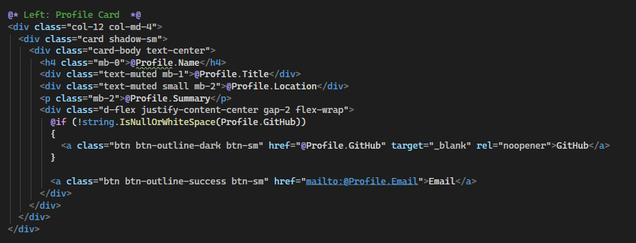

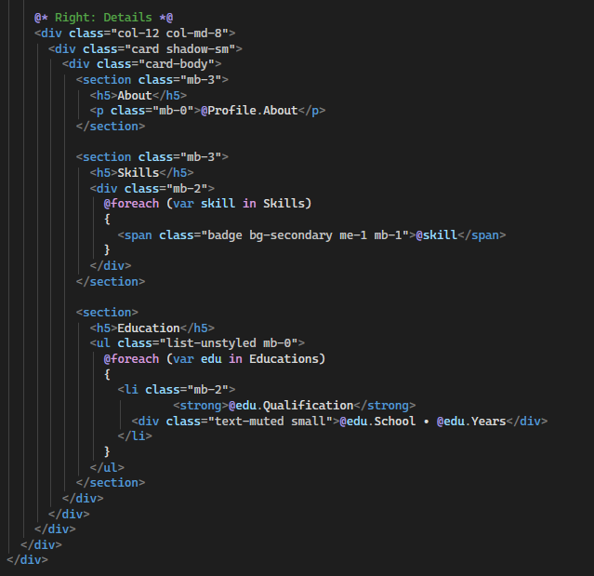

Result:

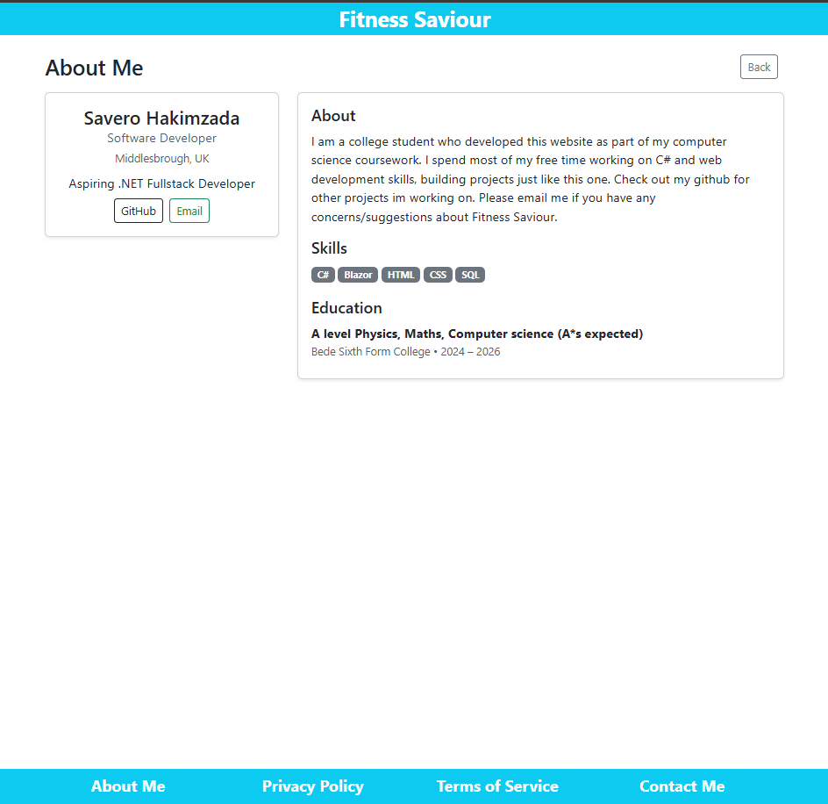

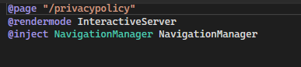

Created privacy policy page.

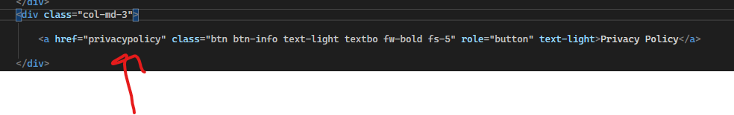

Button on footer now navigates there.

// Validation for user input.